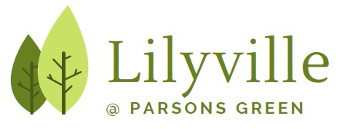

FRIENDS OF LILYVILLE SURGERY
(PATIENT PARTICIPATION GROUP)

May 2025

Dear Fellow Lilyville Patients,


Sunny days are definitely here again! No it’s ‘no mow May’ – but, as I write, the pollen count for London is low, so we hayfever sufferers can go out and enjoy the sun and gardens and the great parks in Fulham – and beyond!!

We are now preparing for our June meeting of the Friends of Lilyville Surgery. This meeting will be held at an earlier time of day than usual – we hope this will enable some who have not been able to come at 5.30 to attend! Friends of Lilyville is for everyone who is a patient at the surgery – and everyone is very welcome to these friendly meetings. Join us – at the surgery on:

THURSDAY 5TH JUNE – 1.30-3.00pm (meet in the waiting area)

A key focus for this meeting will be VACCINATIONS – ARE THEY REALLY IMPORTANT? Doctor Weston-Price will lead the discussion which will focus on:

- Childhood vaccinations – and
- Vaccinations for the rest of us.
Some people worry about vaccines: Are they safe? Side effects? Are they good for our health? Do we really need them? – Come and discuss this in a friendly setting with our lead-GP.

Is Lilyville RESPONSIVE? How well do WE, the patients, think the practice listens to and responds to OUR needs and preferences? What constructive ideas might we have that will help improve how Lilyville listens to and responds to OUR needs and OUR preferences? The Care Quality Commission will discuss this when it inspects the practice.

Do come along and share your thoughts and concerns on these important issues – Tuesday 5th June – 1.30-3.00pm – at Lilyville.

Merril Hammer, Patient and Chair, Friends of Lilyville

Building Trust – within and across our communities

We live in a very diverse, lively and varied part of London with many different communities. This is our strength. But sadly, as well as great wealth there is also much deprivation which leaves many in our communities behind. Just a few figures:
- Did you know that there is a 6.5 year difference in life expectancy for men in the most and least deprived areas of H&F; and for women it is a shocking 9.5 years!!
- H&F is the 6th most densely populated of London’s 33 local authority areas – bringing with it housing pressures and environmental risks.
- More of those who are 60+ experience greater income deprivation than the England average; the mortality rate of those over 65 is higher than in London or in England.

Building Trust, a Council initiative working with local residents and with the NHS after the pandemic, has been looking at how the trust of those disadvantaged groups might rebuild trust in the NHS, together with the wider community. Some of our PPG have been involved in this work.

Everyone is welcome to attend this Health and Well-being event – in our area – at the Sands End Arts and Community Centre – Saturday 31st May – from 12-5pm. Come and join us.

