

FRIENDS OF LILYVILLE SURGERY
(PATIENT PARTICIPATION GROUP)

November 2025

Dear Fellow Lilyville Patients,

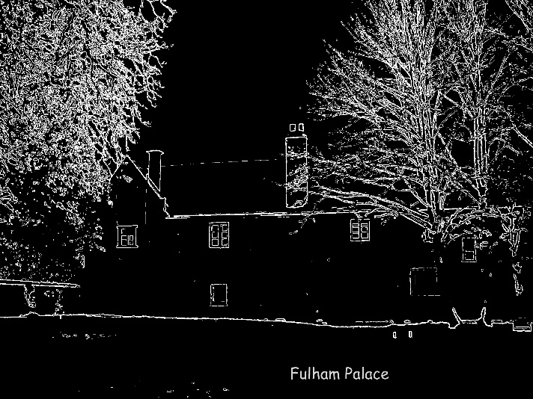
Winter and the festive season are almost upon us – and we’ve already had some very cold weather. As well as enjoying the festive season (and as many Friends of Lilyville will, I hope, join us for our own celebration – see below).

But we are already hearing about high levels of flu – and an increase in covid cases – with winter pressures already starting for our local hospitals. In fact, the flu season got off to an unusually early start this year according to the GP journal, Pulse. They also report that the current vaccine “appears to be providing ‘strong’ protection against severe illness”. So, if you have not already had your flu jab, now is the time to organise this – an essential for your and your family’s protection – and also for all those you want to socialise with at this time of year. Do contact the surgery – or your local pharmacy.

Both flu and covid spread more easily in winter! So if you are eligible for a free covid vaccination (i.e. those 75 and over) and have not yet had your covid jab, why not have this at the same time as the flu jab? It’s important you have both vaccinations every year to reduce your risk of severe symptoms. Protection fades over time and viruses change. Go to www.nhs.uk/wintervaccinations.

WE NEED OUR GPs!

General practice, across England, is under unprecedented pressure. GPs value their patients – and we, as patients, both need and value our GPs. But did you know that your practice receives just £112.50 per year for each patient, whatever their health needs? That’s less than the cost of an annual TV licence.

There is a rising demand for GP services – but not enough GPs to meet rising demand – so many of us have to wait longer than we might like. And, oddly enough, there qualified GPs who cannot find a job because the funding is simply not there to hire them! Worth noting – on average around one and a half million patients have a GP appointment every weekday!

While some more welcome funding has come to GP services, this is only enough to keep practices ticking over. Many practices – including Lilyville – need funding to expand and improve their premises so that they can see more patients in person – but this money is just not available.

At Lilyville, we can already contact the surgery online using PATCHS – but the new contract for the coming financial year is asking GPs to make this service available from 8.00-6.30 every day – an excessive demand when GP practices are already under great stress and one which will mean GPs are responding to electronic messages potentially eating into time for seeing patients face to face.

This pressure on our GP practice is worth remembering when we need to contact staff at Reception, as they deal with incoming calls and demands – by phone, IT or in person. This can be stressful for both staff and patients.

Our December meeting of the Friends of Lilyville Surgery will spend some time – hopefully with some of the Reception staff at the meeting – looking at what problems Reception staff and patients face and at how steps can be taken to improve things.

THURSDAY 4TH DECEMBER – 5.30 – 7.00 pm
At Lilyville (meeting in the waiting area)
Friends of Lilyville is for all Lilyville patients

After this short business meeting we will take time to get to know each other better with some festive season nibbles and other refreshments – very informally! We would love to see you there!

At our festive meeting last year, after important business, we all – GP, practice staff and patients – had a really good time with nibbles, chat and socialising.

Hope to see you on 4th December.

Best wishes, Merril Hammer – Patient and Chair, Friends of Lilyville

