PRACTICE BOUNDARY  We are able to accept new patients who live in the orange area marked on the map below. Already registered patients who move out of the orange area but still within the blue area may be able to remain registered with us.  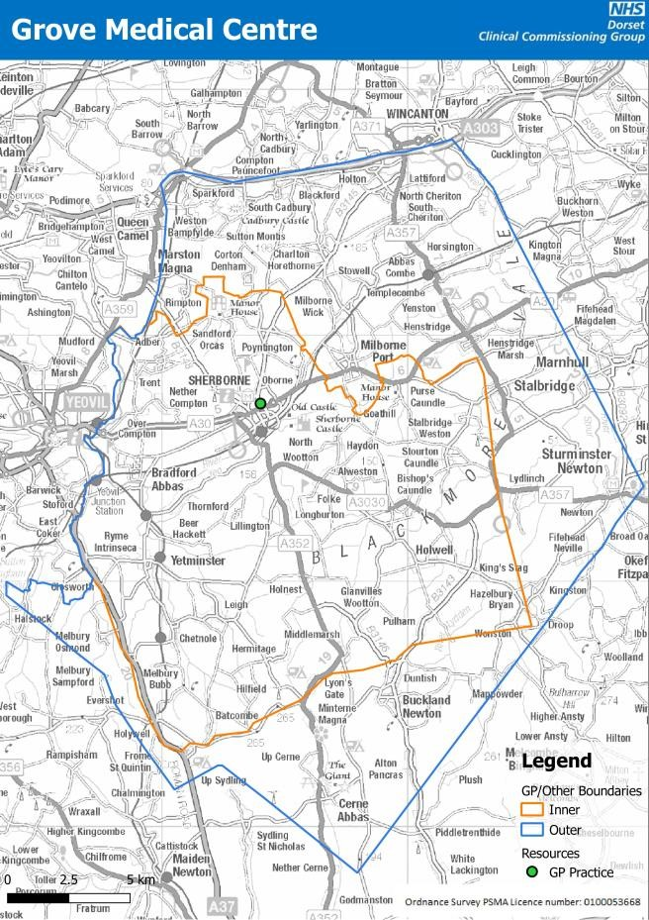 |   Welcome to  The Grove Medical Centre  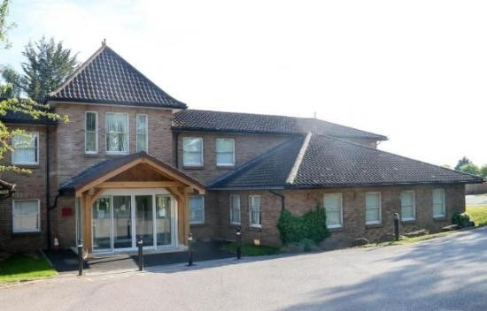  Wootton Grove Sherborne Dorset  DT9 4DL  Telephone:  01935 810900  Option 1 – Patient Services Option 2 – Dispensary Option 3 - Administration Website:  www.thegrovemedcentre.co.uk  Email:  tgmc.reception@nhs.net

WELCOME  About Us  Welcome to The Grove Medical Centre. We are a large practice with around 13,000 patients currently registered. We are lucky to have a team of over 80 people on site, plus external teams that we regularly liaise with – community matron, district nurses, midwife, and health visitors, just to name a few.  We hope you find this information booklet useful, if you come across something you feel we should include, please do let us know.  OUR STAFF  Managing Partner  Mrs Alexandra Kimber  BSc PGDip  GP Partners  Dr Aimee Barnes Dr Nicholas Berry  BMBS MRCGP BMBS MRCGP Dip Sports Med  Dr Sally Dangerfield Dr Ruth Lawes  MB MRCGP DRCOG DFFP DFSRH MB MRCGP ChB DRCOG  Dr Elizabeth Long Dr Rebecca Lye  BMBS MRCGP DFFP DRCOG MBChB MRCGP  Dr Matthew Phelan Dr Chris Pearce  BMBS MRCGP Dip Palliative Care MBChB BSc DFSRH DGM MRCGP  GPs  Dr Lucius Covell – Salaried GP Dr Charles Middle – Girls School  BMBS MRCGP BMBS MRCGP Dip Sports Med  Dr Katie Thomas – Girls’ School  BMBS MRCGP DFFP DRCOG | ZERO TOLERANCE POLICY  The Practice takes it very seriously if a member of staff or one of the doctors or nursing team is treated in an abusive or violent way.  The Practice supports the government's 'Zero Tolerance' campaign for Health Service Staff. This states that GPs and their staff have a right to care for others without fear of being attacked or abused. To successfully provide these services a mutual respect between all the staff and patients has to be in place. All our staff aim to be polite, helpful, and  sensitive to all patients’ individual needs and circumstances. They would respectfully remind patients that very often staff could be confronted with a multitude of varying and sometimes difficult tasks and situations, all at the same time. The staff understand that ill patients do not always act in a reasonable manner and will take this into consideration when trying to deal with a misunderstanding or complaint.  However, aggressive behaviour, be it violent or abusive, will not be tolerated and may result in you being removed from the Practice list. In extreme cases, the Police will be contacted.
1 | 14

CLINICAL STAFF
COMMENTS, COMPLIMENTS & COMPLAINTS

We try our best to provide great care and to offer you the best possible services and welcome any suggestions to improve these. There is a friends and family test that you can access via our website. Alternatively, you can ask at reception for a feedback form.
If you have a complaint you would like to make, please write to Sarah Mackrell, Patient Services Manager. You will receive an acknowledgement within 3 working days, and a more detailed response once the complaint has been fully investigated.
Should you remain dissatisfied with this response you can contact either of the following two official bodies:

NHS Dorset | Dorset Advocacy Service
01305 368900 | 0300 343 7000
County Hall, Colliton Park,
Dorchester, DT1 1XJ | www.dorsetadvocacy.co.uk
customercareteam@nhsdorset.nhs.uk | referrals@dorsetadvocacy.co.uk

OUT OF HOURS SERVICE
If you require medical attention or advice with the surgery is closed, please contact the NHS 111 service.
This is the NHS non-emergency number. Call 111 to speak to a highly trained adviser, supported by healthcare professionals. They will ask you a series of questions to assess your symptoms and immediately direct you to the best care. NHS 111 is available 24 hours a day, 365 days a year and calls are free from landlines and mobile phones.
IN A MEDICAL EMERGENCY PLEASE CALL 999

Nursing Team

Practice Nurses  Advanced Nurse Practitioner and Clinical Nurse Lead  Lisa Considine – ANP  Senior Nurse  Danielle Moncrieff –RGN  Julie Brown – RGN  Mel Goodenough -RGN  Harriet Mallon - RGN  Victoria Morris - RGN  Alex Weldon - RGN | Healthcare Assistants  Sara Holder – Senior  Lucy Baker  Emily Goodall Julie Nutland Claire Pounde  Vicky Rogers  Klaire Whittle  Helen Paine – Clinical Pharmacist & Diabetes Specialist

We have a highly skilled clinical team who are able to assist in the treatment and management of many conditions including:

- Diabetes  - Asthma  - COPD  - Wound Care  - Travel Health/Vaccinations  - Prostate and B12 Injections  - Cervical Smears  - Family Planning & Contraception | - Blood Tests  - Blood Pressure Checks  - Catheter Changes  - Dementia Reviews  - Fragility Checks  - Anticoagulation Monitoring  - ECGs  - Minor Surgery

13 2

NON-CLINICAL STAFF  Management Team  Debbie Perkins -Operations Manager  Sarah Mackrell – Patient Services Manager  Hayley Jenkins – Quality Assurance Manager  Management Support  Chloe O’Brien – Business Support Administrator  Patient Services  Tash – Team Leader  Eleanor, Ellie, Hayley, Helen, Lottie, Louise, Maxine, Mel, Sharyn, Sue  Dispensary  Tracey – Team Leader  Aime, Clare, Emily, Judie, Rachel,  Sarah - Dispensers  Victoria – Dispensary Assistant  Administration  Nikki – Team Leader  Amy, Jan, Laura, Mel, Vanessa  Care Co-Ordinators  Jas, Lewis & Mandi | MINOR INJURIES UNIT  Our local Minor Injuries Unit is located at the Yeatman Hospital in Sherborne.  They are able to assess and treat a number of minor injuries such as:  - Injuries to upper and lower limbs  - Broken bones, sprains, bruising and wounds  - Bites – human, animal and insect  - Abscesses and wound infections  - Minor head injuries  - Broken noses and nosebleeds  - Foreign bodies in the eyes, nose and ears.  Please phone the NHS 111 service for an assessment and they can help direct you to the right support or treatment as quickly as possible. If you turn up to the unit unannounced then you will still be assessed but you may be directed elsewhere or given an appointment for either later that day or the following day.  The unit is open Monday to Thursday from 09:00-18:00 and Sunday 10:00-16:00  PATIENT PARTICIPATION GROUP (PPG)  We have a fantastic PPG, led by Chairman Roger Marsh, who regularly hold meetings in the interests of helping the practice to work as well as possible for patients and staff. We are always happy to accept new members, for more information please contact our Patient Services Team via email at tgmc.reception@nhs.net. They will pass on your details to the PPG who will be in touch.
3 | 12

ACCESS TO RECORDS

Individuals have the right of access to their personal data from any health and care organisation that holds records on them under UK GDPR.
This right is commonly referred to as ‘subject access’
If you wish to make a subject access request (SAR), please let us know and we will provide it to you within one month.
Whilst a SAR gives you the right to obtain a copy of your personal data, most patients can now request access to their GP record online. Excessive requests for duplicate data will incur a fee. The easiest way to view your data is via the NHS app – you can also download it to your device.

TRAINING PRACTICE

The Grove Medical Centre is a training practice therefore we will sometimes have medical students and GP trainees sitting in with our GPs to help them continue their training.
You will always be told before your appointment if a student or trainee is present. If you would prefer not to have them there, please tell reception or the person that you are seeing.

ACCESS TO THE SURGERY
We have our own private car park which contains disabled parking spaces. All consulting and treatment rooms of the building are fully accessible, and we can also provide a wheelchair if necessary.

PRIMARY CARE NETWORK (PCN) TEAM
These staff members work across the three practices that make up the Sherborne Area Primary Care Network, The Grove Medical Centre, The Apples Medical Centre and Yetminster Health Centre.

Operational Manager
Sarah Webster

Digital Care Co-ordinator
Emma Grunnill

Pharmacy Team
Brian Charlton – Senior Clinical Pharmacist Lucy Powell – Clinical Pharmacist
Sarah Roper – Clinical Pharmacist
Kylie Godden – Pharmacy Technician
T Schwanethal – Pharmacy Technician Debbie Heals – Pharmacy Technician

Mental Health Team
Hannah Broad – Mental Health Practitioner Julie Phillips – Mental Health Practitioner

Frailty Team

Emma Willett – Frailty Nurse

Wendy Darkins – Frailty Nurse

Social Prescribing Team Vicky Morland – Social Prescriber
Ellis Ford – Social Prescriber
Jill Warburton – Social Prescriber

11 4

OPENING HOURS

Patient Services

Monday | 08:00-18:30
Tuesday | 08:00-18:30
Wednesday | 08:00-18:30
Thursday | 08:00-18:30
Friday | 08:00-18:30
Weekend | Closed  Extended access is available by appointment only:  07:30-08:00 Monday-Wednesday  18:30-19:00 Monday-Thursday
The telephone line closes at 18:30 each day.

Dispensary

Monday | 08:00-18:30
Tuesday | 08:00-18:30
Wednesday | 08:00-18:30
Thursday | 08:00-18:30
Friday | 08:00-18:30
Weekend | Closed

Please note that the dispensary telephone line for ordering repeat medications is open from 08:30-12:00 and that it takes 3 working days to process medication requests.
If you have online access, then the easiest way to order your medication is via the login page on our website or your online account on the NHS app. You can do this 24 hours a day. You can also come in and order in person during our opening hours.

You are legally entitled to make a complaint about health services.

You have a right to confidentiality. Personal information about your health is confidential and should only be disclosed to those who need that information to provide you with effective treatment.

Guideline Rights

You are entitled to have reasonable access to high quality service and facilities.

You are entitled to information on what is wrong with you and the treatment options available.

You are entitled to ask for a second opinion on your diagnosis or treatment.

You can ask to have someone with you at any time.

Human Rights

It is your right to be treated as a human being by another human being and as they would wish to be treated themselves.

Consent

Anyone looking after your health has to have your agreement before they can examine or treat you. This includes both children and adults.

Patient Responsibilities

Keeping appointments: Please try to arrive on time. If you are unable to attend, please let us know as soon as possible.

Personal details: Please let us know of any changes (address, telephone number, etc.)

Treat all healthcare staff in a reasonable, courteous manner.

Take care with medicines, they are for one person only and should not be shared. Keep them away from children.

CANCELLING AN APPOINTMENT

Please give as much notice as possible if you need to cancel an appointment so that we are able to offer it to somebody else. If you have a mobile number you will receive a confirmation and reminder text, you can cancel your appointment via this.
We do monitor missed appointments and patients who continually abuse the system may be asked to register at another surgery.

5 10

DOCTORS  All patients are allocated a usual GP to manage their prescriptions and chronic illnesses, as well as read and action hospital letters. Our Patient Services Team can tell you who your named GP is if you are unaware. You are able to choose who is your allocated GP if you have a preference.  Where possible we will aim to book your appointments with your usual GP for continuity of care. Our GPs are grouped into teams so if you are unable to see your allocated GP, you should hopefully be able to see someone in their team to limit the amount of different GPs you are seeing.  GP appointments are 10 minutes so you may receive a double appointment if you wish to discuss more than one issue.  Once you reach 75 you will be sent a letter informing you of your named GP who will be coordinating your care.  PATIENT RIGHTS & RESPONSIBILITIES  Patients have 10 guaranteed, legislated rights:  - You are entitled to receive health care on the basis of clinical need, regardless of income.  - You are entitled to be registered with a medical practice. You should be given a written decision if a practice is unwilling to take you on their list. You are entitled to change your practice at any time and do not need to give a reason.  - You are entitled to accept or refuse treatment. This includes examinations, tests, diagnostic procedures, medication, operations, etc.  - You can refuse to be examined in the presence of medical students.  - You can refuse to be involved in research trials.  - You are entitled to equal treatment regardless of race, gender, age or disability.  - You have a right to information on GP practices in the area and the services they provide. All practices must provide an information leaflet. | CONFIDENTIALITY & MEDICAL RECORDS  Our practice complies with the UK General Data Protection Regulation Act (GDPR) 2018. Identifiable information about you will be shared with others in the following circumstances.  - To provide further medical treatment for you e.g. district nurses and hospital services  - To help you get other services e.g. from the social work department. This requires your consent.  - When we have a duty to inform others e.g. in child protection cases.  - anonymised patient information will also be used at local and national level to help the Health Board and Government plan services e.g. for diabetic care.  If you do not wish anonymous information about you to be used in such a way, please let us know.  Patient services and administration staff require access to your medical records in order to do their jobs. These members of staff are bound by the same rules of confidentiality as the medical staff.  TEST RESULTS  Blood, Urine and Stool Samples  You will not be contacted routinely if your results are normal, or if you have a follow up appointment booked. If you have online access to your record then your results can be viewed there, either through SystmOnline via our website or the NHS app.  If you wish to confirm your results, we ask could you please call the surgery in the afternoon as the mornings tend to be very busy. Please allow 5 working days for results unless you have been advised otherwise.  Our surgery staff will contact you directly if there is an abnormal result that needs addressing.
9 | 6

REGISTERING AT THE SURGERY  In order to register at the practice, please visit the join the practice section of our website. Please make sure that you live within our practice boundary as unfortunately we cannot register anyone living out of our boundary area. (See map on back page for our boundary) Alternatively you can pick up a registration pack from reception.  If you have repeat medication, we ask if possible that you provide us with your medication list when you register to ensure you do not run out.  TEMPORARY RESIDENTS  We are able to offer appointments for temporary residents, subject to appointment availability, for illnesses that require immediately necessary treatment.  If you are away on holiday within England please contact your registered GP who can send a prescription electronically to a pharmacy local to where you are staying.  PRIVATE WORK  Our NHS work takes absolute priority, but we do undertake a selection of private services. These include:  - Non-NHS travel vaccinations and medication  - Medical assessments  - Medical reports  - Insurance forms  The charges for these services can be requested at reception. | APPOINTMENTS  Patient Triage  Our Practice uses AccuRx Patient Triage. Patient Triage is a web-based online consultation tool that allows patients to submit a short medical or admin query directly to the Practice. You can request sick notes, GP letters, test results and repeat prescriptions, as well as ask a question or get an update on a referral. If you have a medical query your triage will be assessed by a GP and depending on the urgency, you will receive a response within 2 working days.  Patient Triage is accessible on our website between 08:00 and 18:30 Monday-Friday. Patients can also complete a triage form in the Practice at reception, or phone in and a member of our Patient Services Team will fill the form in on your behalf.  All patients requesting an appointment or phone call will need to complete a triage form, regardless of how you contact us. Where possible, we encourage patients to complete this form online so that phonelines are kept free for patients who cannot use online services. Patients who do need to phone will be asked the same set of questions by our Patient Services Team and they will fill in the form on their behalf.  HOME VISITS  We can provide home visits daily for patients who are housebound and unable to come to the surgery. We request that where possible you contact the surgery before 11am for a home visit as we try to carry them out after morning surgery.
7 | 8

