HOME BLOOD PRESSURE CHART
Name: | Date of Birth:
FAO Testvale Surgery | SCAN TO NOTES OF PATIENT:  SCAN TO DOCMAN OF CLINICIAN :
- Measure from the upper arm using an accurate device. It is very important that your arm is supported on a table, with a small cushion if necessary and that the cuff around your arm is at the same level as your heart.
- Take your blood pressure a quiet place whilst seated, wearing short sleeved or loose fitting clothing with your arm and back supported, legs uncrossed and whilst you are not talking -talking and crossed legs increase blood pressure.
- Always use the same arm.
- Take two readings, at least a minute apart, morning and evening for 7 days recording the lower of the two readings onto the BP log sheet. If you need to, write any useful comments in the box provided.
- Once you have completed 7 days of measurements and added your name and date of birth, please hand to your doctor or reception.

 |  | SYSTOLIC (Upper number) | DIASTOLIC (lower number) | COMMENTS |  | SYSTOLIC (Upper number) | DIASTOLIC (lower number) | COMMENTS
1 | AM |  |  |  | PM
2 | AM |  |  |  | PM
3 | AM |  |  |  | PM
4 | AM |  |  |  | PM
5 | AM |  |  |  | PM
6 | AM |  |  |  | PM
7 | AM |  |  |  | PM
AVERAGE | AM |  |  |  | PM
COMMENTS:

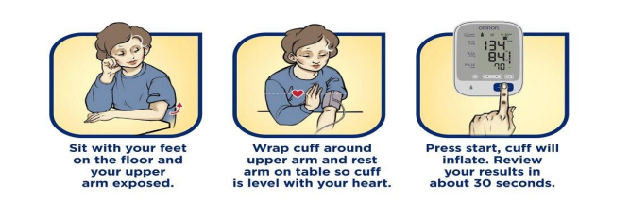
Blood Pressure Targets

Primary Hypertension | ≤ 140/90 (≤ 135/85 HBPM)  If aged over 80 years: ≤ 150/90
CVD | ≤ 140/90
Diabetes | ≤ 140/80  If eye, kidney or cerebrovascular complications: ≤ 130/80
CKD | 120 – 139/≤ 90 If ACR ≥70: 120 – 129/≤ 80

