

EXTENDED ACCESS
Site Guide and Contact Information

Contents
- Overview of Extended Access 2
  - What is Extended Access? 2

- Directions and Bus Information for the Hub
1. Overview of Extended Access
a. What is Extended Access?
Extended Access is the provision of core GP services outside of the current ‘standard’ GP hours (8am to 6:30pm).
The government’s mandate to NHS England sets out:
“To ensure everyone has easier and more convenient access to GP services, including appointments at evenings and weekends”.
The Extended Access project aims to deliver core GP services at evenings and weekends for patients across Bradford from centralised hubs covering an area rather than having each practice deliver Extended Access individually.

b. Current Available Services
The Extended Access project is designed to be as fluid and adaptive as possible, and as such the services offered will change to reflect patient’s preferences.
From 5th July 2021, the Extended Access Service will operate from eight hubs.
- Shipley Medical Practice - North hub
- Bingley Medical Practice - North hub
- Moorside Surgery - North hub
- Picton Medical Centre - Central hub
- New Otley Road Medical Practice - Central hub
- Park Grange Medical Centre - Central hub
- The Ridge Medical Practice - South hub
- Bowling Hall Medical Practice - south hub

The services offered from each hub may vary.
All services can be booked into directly by all practices in Bradford

2. Directions and Bus Information for the Hub
Picton Medical Centre
Picton Medical centre
Westbourne Green Community Health Centre
Heaton Road
Bradford BD8 8RA
Tel: 07542 856917 (from 6:30pm to 9:30pm & 10am-1pm Saturday, Sunday & bank holidays)
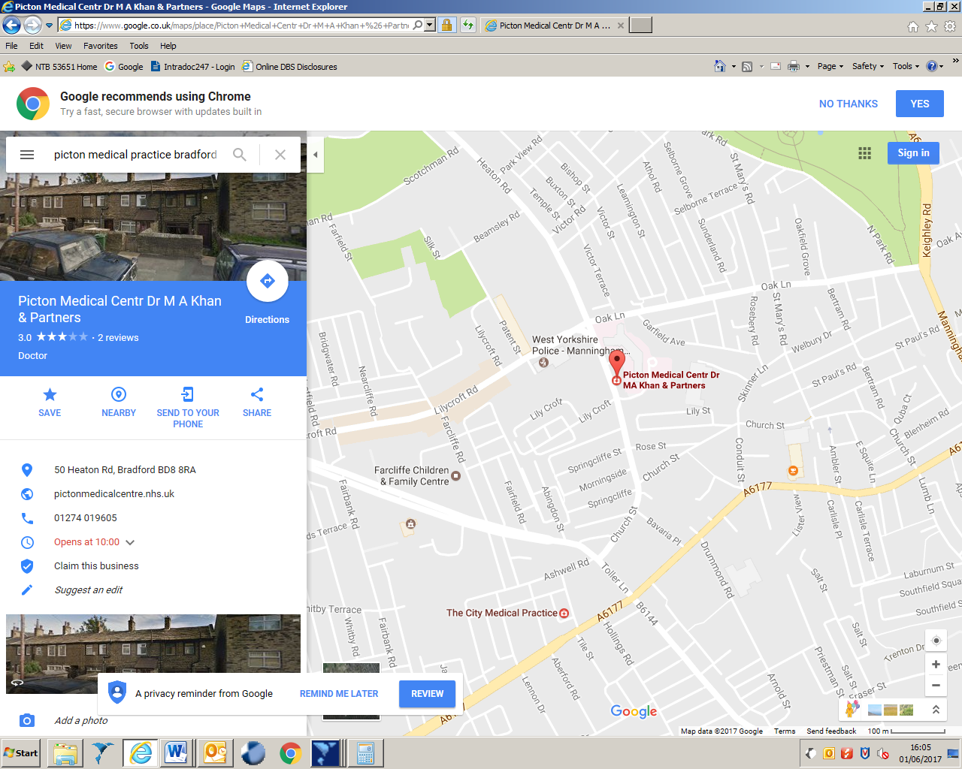
Map

Picton Medical Centre is located at Westbourne Green Community Hospital on Heaton Road in North West Bradford, close to Oak Lane and west of Manningham Lane.
Bus Routes
The 680 bus travels from Bradford Interchange along Manningham Lane, and stops on Oak Lane at around 20 past the hour, with a 5 minute walk along Heaton Road to Picton Medical Practice.
The 620 bus travels from to Oak Lane via Toller Lane, Lilycroft Road and Church Street. It runs every 10 minutes.
https://moovitapp.com/index/en-gb/public_transportation-The_Ridge_Medical_Practice-Yorkshire-site_34108692-2109

Shipley Medical Practice
Shipley Medical Practice
Alexandra Road
Shipley
West Yorkshire
BD18 3EG
Tel: 01274 539838 (from 6:30pm to 9:30pm)
Map
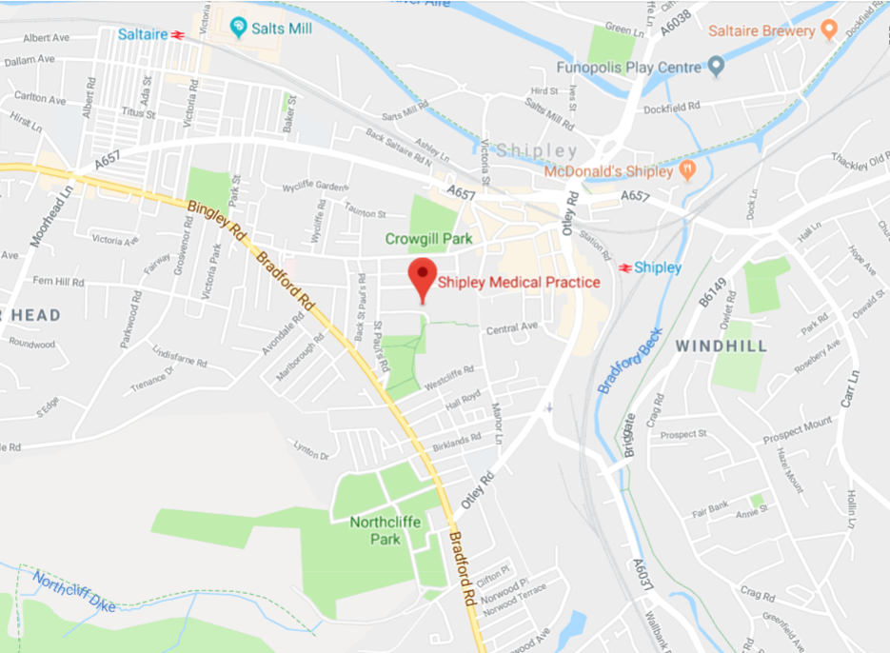

Shipley Medical Practice is located on Alexandra Road in North Bradford, close to Bradford Road and Shipley Park.
Bus Routes
The 662 bus travels from Bradford Interchange along Bradford Road.
The 623 bus travels along Kirkgate, which is just North of Shipley Medical Practice.
https://moovitapp.com/index/en-gb/public_transportation-The_Ridge_Medical_Practice-Yorkshire-site_34108692-2109

The Ridge Medical Practice at Cousen Road
The Ridge Medical Practice
Cousen Road
Bradford
West Yorkshire
BD7 3JX
Tel: 01274 425657 (from 6:30pm to 9:30pm)
Map
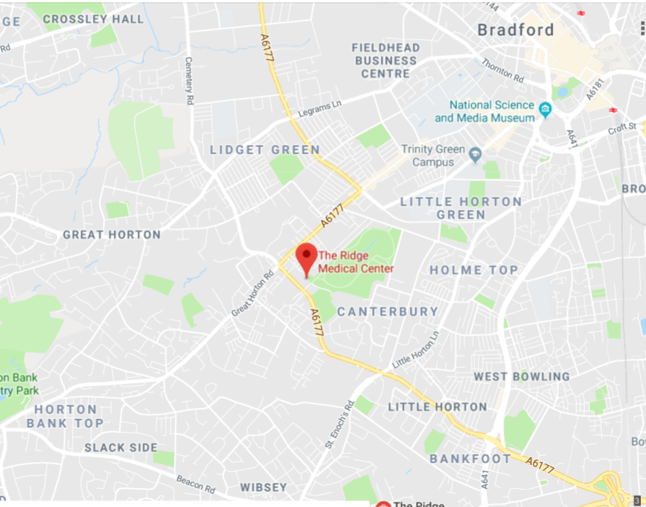

The Ridge Medical Practice is located on Cousen Road, close to Great Horton Road and Horton Park.
Bus Routes
The 573, 613 and 614 buses travel from the centre of Bradford along Great Horton Road.
https://moovitapp.com/index/en-gb/public_transportation-The_Ridge_Medical_Practice-Yorkshire-site_34108692-2109

Moorside Surgery
Moorside Surgery
370 Dudley Hill Road
Bradford
BD2 3AA
No Number available
Map
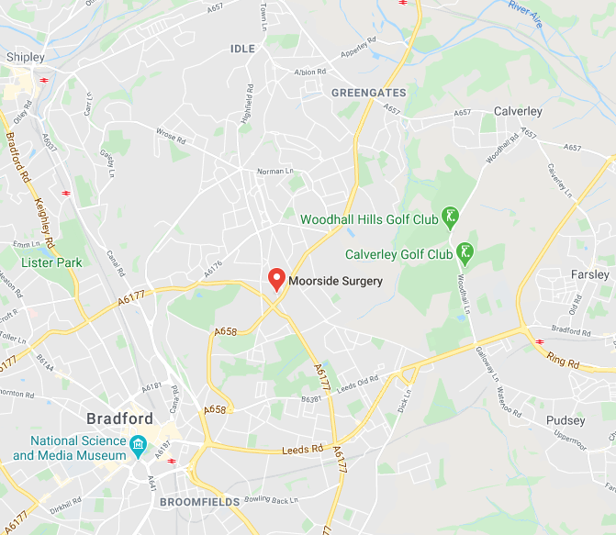
https://moovitapp.com/index/en-gb/public_transportation-The_Ridge_Medical_Practice-Yorkshire-site_34108692-2109

Bowling Hall Medical Practice
Bowling Hall Medical Practice
Rooley Lane
Bradford
BD4 7SS
No Number Available

Map

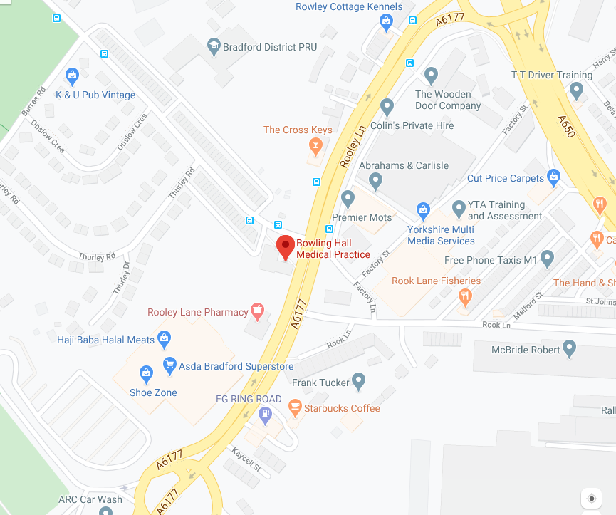

https://moovitapp.com/index/en-gb/public_transportation-The_Ridge_Medical_Practice-Yorkshire-site_34108692-2109

Bingley Medical Practice
Bingley Medical Practice
Canalside Healthcare Centre
Kingsway
Bingley
BD16 4RP
No Number Available

Map
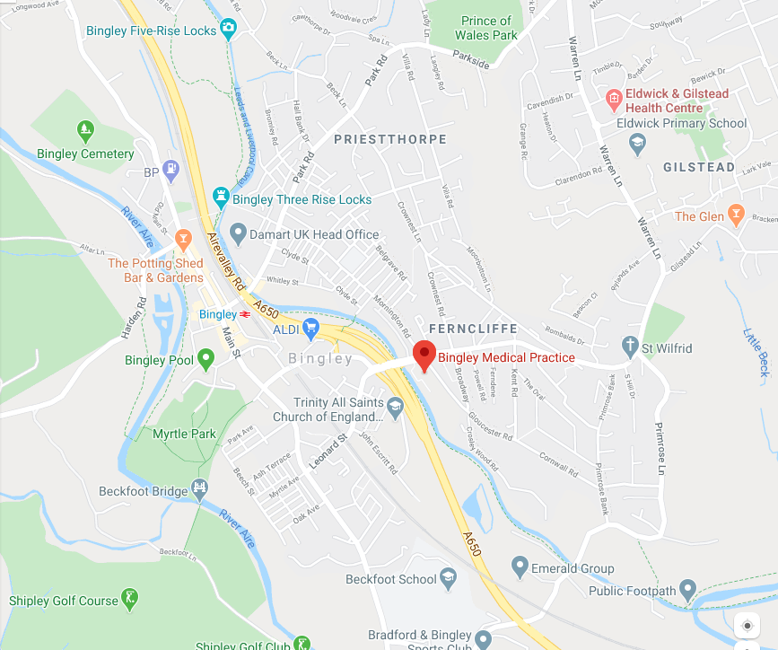
https://moovitapp.com/index/en-gb/public_transportation-The_Ridge_Medical_Practice-Yorkshire-site_34108692-2109

Park Grange Medical Centre
Park Grange Medical Centre
141 Woodhead Row
Bradford
BD7 2BL
01274 087272

Map
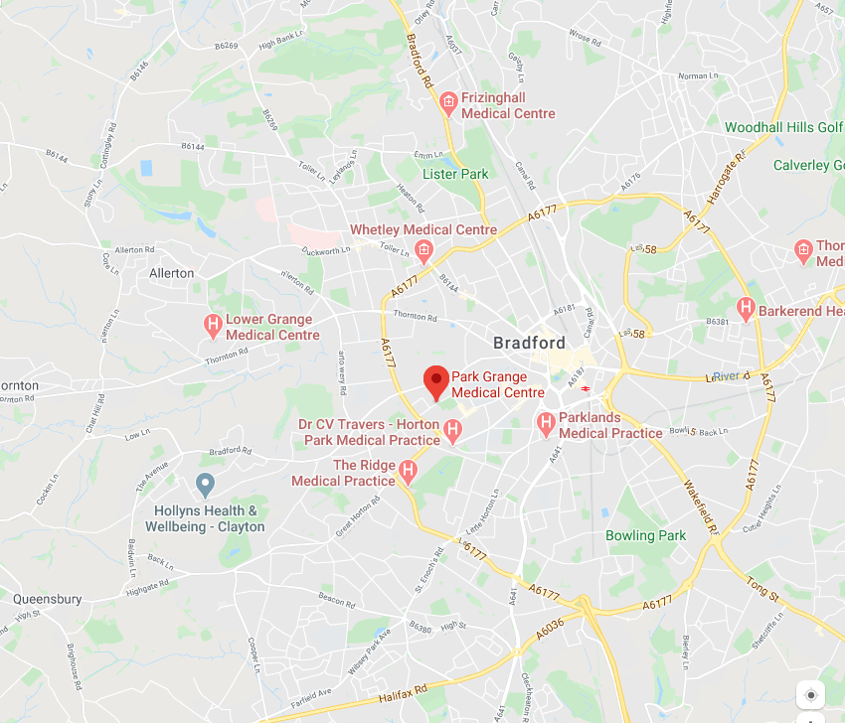
https://moovitapp.com/index/en-gb/public_transportation-The_Ridge_Medical_Practice-Yorkshire-site_34108692-2109

Hillside Bridge Surgery
New Otley Road Medical Practice
4 Butler Street West
Bradford
BD3 0BS
01274033883
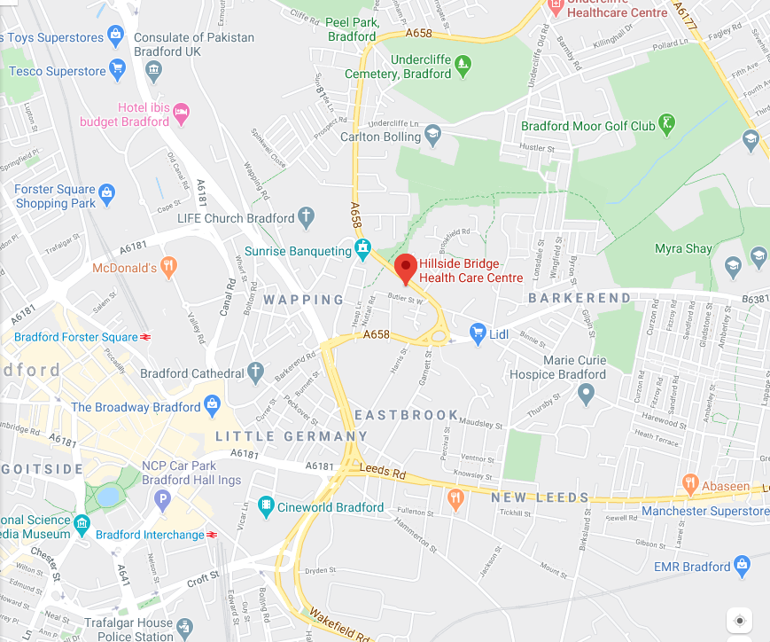
Map

https://moovitapp.com/index/en-gb/public_transportation-The_Ridge_Medical_Practice-Yorkshire-site_34108692-2109

