The NHS aims to provide the right care, at the right time and in the right place.
We welcome your feedback, both positive and negative, to help us to understand what is working well and what we can improve on.
Sometimes your expectations may not be met, and you may be unhappy with the care or treatment you have received. Whilst we hope this is not the case, if this does happen then we encourage you to discuss your concerns with the Practice Manager at your GP practice.
The NHS takes all feedback seriously and, where possible, should learn from the experiences of patients, carers, relatives and make changes to improve services.
Your future care and treatment will not be affected in any way, should you wish to make a complaint if you are unhappy.
What is a complaint?
A complaint is a statement that something has not met your expectations, or you are unhappy with the standard of service you or someone else has received.
How can you make a complaint about your GP practice?
You can make a complaint by speaking to the Practice Manager at your GP practice, who will provide you with a written account of your concerns, or you can write to your GP practice. The Practice Manager or a staff member should be able to help you to resolve your issues that you are unhappy about. You can find the Practice Manager’s contact details on your GP practice’s website, or by asking staff at your GP practice.
If you do not want to make your complaint directly to your GP practice, you can instead make a complaint to the NHS England Customer Contact Centre using the following contact details:
Write to: PO Box 16738, Redditch, B97 9PT
Telephone: 0300 311 22 33
Email: england.contactus@nhs.net
All NHS organisations follow the Local Authority Social Service and National Health Service Complaints (England) Regulations 2009.
Your complaint should be acknowledged by the GP practice either verbally or in writing within 3 working days.
As part of this acknowledgment, you should be informed about the length of time it will take to investigate your complaint. You should also discuss an agreeable date that you will receive your complaint response, either verbally or in writing. During the investigation you should be kept up to date with the progress of your complaint.
When can you complain?
A complaint should be made within 12 months from the date the issue occurred or when it came to your attention. In some cases, if there is good reason why you could not complain sooner, and it is still possible to investigate your complaint, then the time limit may be changed.
Who can complain?
Patients, carers, or their relatives can complain about the care or treatment they have received, or on behalf of another person.
If you are complaining on behalf of someone else, the consent of the patient will be required to investigate the complaint. Please discuss this with the Practice Manager or with the NHS England Customer Contact Centre.
What is Consent?
Consent is a patient giving the permission for something to happen or a patient agreeing that someone else can act on their behalf.
Confidentiality
All complaints are dealt with confidentially and information about your complaint will not be shared without your knowledge or consent. In compliance with the General Data Protection Regulations (GDPR), the Data Protection Act 1998 and the Caldicott principles, all staff employed by the NHS are bound by a Code of Confidentiality, which covers both manual and electronic data.
What are the Caldicott principles?
Every proposed use or sharing of your personal details, within or from an organisation, should be clearly explained and understood by you, with continuing uses regularly reviewed by an appropriate guardian. A Caldicott Guardian is a senior person within an organisation responsible for protecting the confidentiality of patient and service-user information and allowing the organisation to use the information properly.
Support to help you make a complaint
If you would like free advice to help you make a complaint about the NHS, the Independent Complaints Advocacy service can support you.
Write to: Gaddum Centre, St Wilfrid’s Enterprise Centre, Royce Road, Manchester, M15 5BJ
Telephone: 0161 834 6069
Email: advocacy@gaddum.co.uk
Visit: https://www.gaddum.org.uk/advocacy/
If an interpreter is needed to support you through a complaint, your GP practice should arrange this for you.
Information provided in a way that meets your individual needs
The Accessible Information Standard was introduced by the government in 2016, to make sure that people with a disability or sensory loss (for example, sight or hearing impairment) are given information in a way they can understand.

Please tell the person you are complaining to about any specific individual needs you may have; for example, you may need large print, Braille, audio format or an alternative language. The GP practice must take reasonable steps to ensure they provide you information to meet your individual needs.
What to do if you are not satisfied with your complaint response?
If you have complained directly to your GP practice, or NHS England, and you are unhappy with the response you receive, you should contact the Practice Manager or NHS England’s Complaints Team to discuss the areas of the complaint you remain unhappy with.
Within the complaint response letter, information will be provided to you about your right to ask the Parliamentary and Health Service Ombudsman (PHSO) to review your complaint.
PHSO Customer Helpline: 0345 015 4033 from 8:30am to 5:00pm, Monday to Thursday, and 8:30am to 12:00pm Friday, except bank holidays. Calls are charged at local or national rates. Visit: https://www.ombudsman.org.uk

If you would like to receive this information in large print, Braille, audio format or translated to a specific language please contact the Engagement Team, Ground Floor, Parkway 3, Parkway Business Centre, Princess Road, M14 7LU or phone 07814-067318 or email mhcc.engagement@nhs.net

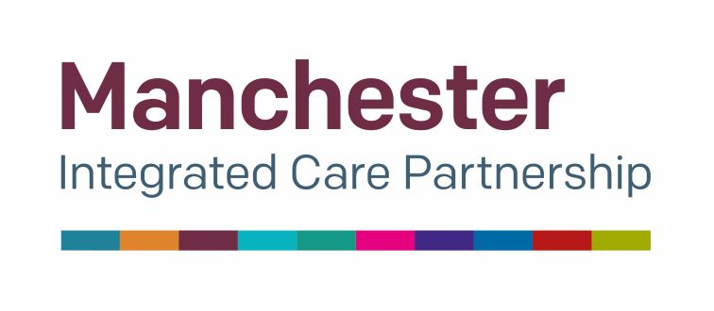

DR KHANS PRACTICE
How to make a complaint about your GP practice

August 2022

Clayton health Centre
89 North Road
Clayton
Manchester

M11 4EJ
Tel: 0161 223 1658
Email: gmicb-mh.practicemanager.khans@nhs.net

