DR. SINGH’S SURGERY
65 Clifford Road, Hounslow West, Middlesex. TW4 7LR
Tel: 0208 577 5304 Practice email: cliffordroadsurgery@nhs.net
___________________________________________________________________________________
Dr Raj K. Singh Dr. Rashmi K. Singh
MBBS DGM(Lon) BSc(Hons) MBBS(Lon) DFFP DRCOG MRCGP

Simple shoulder exercises
(Recommended by Chartered Physiotherapist)

One very powerful way of controlling your shoulder pain is to do daily range of motion exercises, putting your shoulder through full movement several times a day. This prevents stiffness developing and stretches all the attached muscles, making them less vulnerable to sudden demands.

Please note that exercises can make your pain worse as well as better. These exercises are meant to help you regain loss of movement in the shoulder region and control pain. They are simple and not magical in any way. However, with regular performance, you should find your problems are improved. If you have long term shoulder pain with some disability these exercises may help mobility but may not be very effective against pain.

Do each movement slowly five times, resting a short time in between each set of movements. Do two or three times a day although more often can be useful. You can increase the numbers over time as you get more confident.

1. Pendular exercises
This technique is most useful post-operatively or if you have a painful problem.

Lean well forward and lean on your good arm onto a low table or other support. Allow your affected arm to hang like a pendulum, without effort, and perform a backward and forward movement, moving your easily like a pendulum. A side to side movement and a stirring motion can also be performed in the same position.

2. Assisted flexion
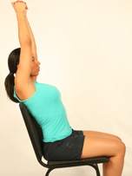Assisted flexion allows you to get the shoulder range of movement going even though you don’t yet have the power or pain control to do it with the one arm alone.The easiest way to start is to lie flat and clasp your hands together. Slowly lift your arms up, stretching them out away from you as you bring them gradually above your head if you can.

Don’t force the movement as it may well be painful to some degree and pushing into the pain won’t help.

3. Active Flexion
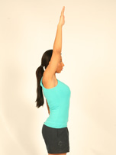Lift your arm up straight in front of you. It can help to lift your arm slightly across your body as this fits the natural anatomical movement better.

The socket of the shoulder joint faces inwards slightly so the slight movement across the body can be more comfortable and natural.

Shoulder flexion is one of the most important of our shoulder movements as it enables us to put our hands in front of our eyes, which is the major function of our arms.

You may not be able to get your arm up as far as our model can but this doesn’t matter, get it up as far as you can and gradually increase with time.

4. Hand behind back (medial rotation)
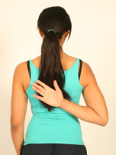Try and put your hand behind your back as far as you easily can. The distance we can get our hands round behind our backs varies enormously with how mobile or muscles we have.

Getting our hand behind our back is a useful movement for normal functional activities such as tucking our trousers in or doing up a bra.

This movement is a combination of three anatomical shoulder movements, shoulder extension, medial rotation and shoulder adduction (moving the arm in towards the centre). Sometimes it’s necessary to work on one or more of the individual movements if we are to improve the overall medial rotation movement.

5. Hand behind neck (Lateral rotation)
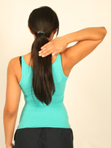Put your hand behind your neck, keeping your elbow out to the side.

This can be a difficult movement to do as it involves a lot of shoulder flexion too.

When you can get your arm up properly you could add this exercise to the routine. It’s very easy just to put your hand round the side of your neck and let your elbow come up in front of you. This avoids the stretch we are looking for in this exercise and, if you can, you should try and get your elbow out to the side as she is showing in the picture.

PRIVATE PHYSIOTHERAPY (recommended by other patients)
West Thames Physio (Ann); 31 Hounslow Road, Whitton TW2 7BX, 0208 893 8676
1st appt £45; £40 after that

