Annex A – Patient complaint form

SECTION 1: PATIENT DETAILS

Surname |  | Title
Forename
  Address
Date of birth
Telephone no. |  | Postcode

SECTION 2: COMPLAINT DETAILS

Please give full details of the complaint below including dates, times, locations and names of any organisation staff (if known). Continue on a separate page if required.

SECTION 3: OUTCOME

SECTION 4: SIGNATURE
Surname & initials |  | Title
Signature |  | Date

SECTION 5: ACTIONS

Passed to management Yes/No

Annex B – Third party patient complaint form

SECTION 1: PATIENT DETAILS

Surname |  | Title
Forename
  Address
Date of birth
Telephone no. |  | Postcode

SECTION 2: THIRD PARTY DETAILS

Surname |  | Title
Forename
  Address
Date of birth
Telephone No. |  | Postcode

SECTION 3: DECLARATION

I hereby authorise the individual detailed in Section 2 to act on my behalf in making this complaint and to receive such information as may be considered relevant to the complaint. I understand that any information given about me is limited to that which is relevant to the subsequent investigation of the complaint and may only be disclosed to those people who have consented to act on my behalf.

This authority is for an indefinite period/for a limited period only*.

Where a limited period applies, this authority is valid until ………./………./………. (Insert date).

(*Delete as necessary)

SECTION 4: SIGNATURE

Surname & initials |  | Title
Signature |  | Date

Annex C – Complaint handling desktop aide-memoire

* It may be necessary to liaise with external third parties such as hospitals to gather additional information or to formulate a joint response. Where this is the case, the patient or their representative must be advised accordingly

Annex D – Complaint leaflet
A patient information leaflet regarding complaints is shown overleaf.
Advocacy Support  - POhWER support centre can be contacted via 0300 456 2370  - Advocacy People gives advocacy support on 0330 440 9000  - Age UK on 0800 055 6112  - Local Council can give advice on local advocacy services  - Other advocates and links can be found on this PHSO webpage  Further Action  If you are dissatisfied with the outcome of your complaint from either Leicester, Leicestershire and Rutland ICB or this organisation, then you can escalate your complaint to Parliamentary Health Service Ombudsman (PHSO) at either:  Milbank Tower, Milbank  LONDON  SW1P 4QP  Citygate, Mosley Street  MANCHESTER  M2 3HQ  Tel: 0345 015 4033  www.ombudsman.org.uk | Woodbrook Medical Centre  28 Bridge Street  Loughborough, Leicestershire LE11 1NH | T: 01509 239166  W: www.woodbrookmedicalcentre.co.uk | The Complaints Process  - Woodbrook Medical Centre  
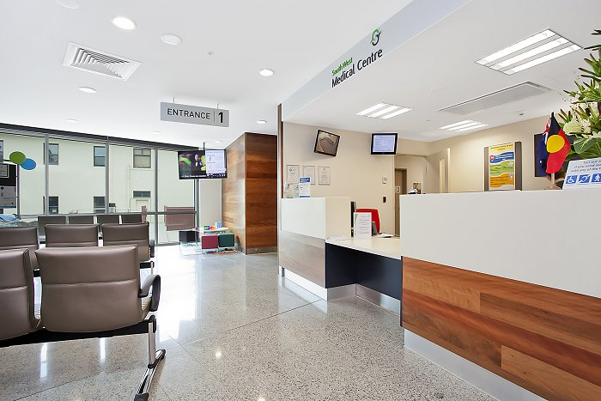  Talk To Us  Every patient has the right to make a complaint about the treatment or care they have received at Woodbrook Medical Centre.  We understand that we may not always get everything right and, by telling us about the problem you have encountered, we will be able to improve our services and patient experience.  Who To Talk To  Most complaints can be resolved at a local level. Please speak to a member of staff if you have a concern and they will assist you where possible. Alternatively, ask to speak to the complaints manager, Anne Jones, Practice Manager, but note this may need to be a booked appointment. | If for any reason you do not want to speak to a member of our staff, then you can request that the Integrated Care Board (ICB) investigates your complaint. They will contact us on your behalf:  NHS Leicester, Leicestershire and Rutland Integrated Care Board (ICB),  Room G30  Pen Lloyd Building  County Hall  Glenfield  Leicester LE3 8TB  Telephone: 0116 295 7572  Email: llricb-llr.enquiries@nhs.net  A complaint can be made verbally or in writing. A complaints form is available from reception. Additionally, you can complain via our website at www.woodmedicalcentre.co.uk  Time Frames For Complaints  The time constraint on bringing a complaint is 12 months from the occurrence giving rise to the complaint, or 12 months from the time you become aware of the matter about which you wish to complain.  The complaints manager will respond to within three business days to acknowledge your complaint. |  | We will aim to investigate and provide you with the findings as soon as we can and will provide regular updates regarding the investigation of your complaint  Investigating Complaints  We will investigate all complaints effectively and in conjunction with extant legislation and guidance.  Confidentiality  We will ensure that all complaints are investigated with the utmost confidentiality and that any documents are held separately from the patient’s healthcare record.  Third Party Complaints  We allow third parties to make a complaint on behalf of a patient. The patient must provide consent for them to do so. A third-party patient complaint form is available from reception.  Final Response  We will issue a final formal response to all complainants which will provide full details and the outcome of the complaint. We will liaise with you about the progress of any complaint.

Annex E – Acknowledgement of a complaint letter (example)
[Complainant’s name] [Date]
[Complainant’s address]

Dear [name]

Acknowledgment of complaint

Thank you for your letter [dated] regarding your complaint. We are sorry that you have felt that the standard of service at Woodbrook Medical Centre warranted your complaint. Please be advised that, whilst complaints are infrequent, when received we will thoroughly investigate and will always manage these in line with the NHS contract.

Our promise to you includes that we will:

- Keep you [or your advocate] up to date with the progress of your complaint

- We will attempt to investigate and provide a detailed response as quickly as possible. Some complaints may take longer than others, so we do not want to offer any specific timescale. However, throughout the investigation, this organisation will keep you up to date with the progress and this can be by telephone, email or letter and will be as agreed with you

- You [or your advocate] can expect to receive a quality response

- Should there be any learning outcome, you [or your advocate] will be provided with what actions have been taken to prevent any future recurrence

We are aware that you would wish for a response as soon as possible and we will endeavour to conduct a full and thorough investigation in the shortest period possible.

Please find enclosed a copy of the Complaints Leaflet. This details what you should expect, a list of advocacy services should you need any support and what to do should you not be content with the findings of this complaint.

Yours sincerely

[Signed]
[Name]
[Role]

Enc: Complaints Leaflet

Annex F – Final response to a complaint letter (example)
[Complainant’s name] [Date]
[Complainant’s address]

Dear [name]

Final response to complaint

Further to my letter dated [enter], please see below the findings following a full investigation into your complaint dated [insert].

[Detail, although the response is to include the following as per section 2.19]

- Be professional, well thought out and sympathetic
- Deal fully with all the complainant’s complaints
- Include a factual chronology of events which sets out and describes every relevant consultation or telephone contact, referring to the clinical notes as required
- Set out what details are based on memory, contemporaneous notes or normal practice
- Explain any medical terminology in a way in which the complainant will understand
- Contain an apology, offer of treatment or other redress if something has gone wrong. The response should also highlight what the organisation has done, or intends to do, to remedy the concerns identified to ensure that the problem does not happen again.

Yours sincerely

[Signed]
[Name]
[Role]

Please be advised that this is the final response. Should you remain dissatisfied with the findings of this investigation, then you may further complain online or in writing to the Parliamentary and Health Service Ombudsman (PHSO) at either:

Milbank Tower  Millbank  LONDON  SW1P 4QP | Citygate  Mosley Street  MANCHESTER  M2 3HQ

The PHSO may be contacted via telephone on 0345 015 4033 or by using their secure online form. Further details on how to make a complaint to PHSO can be sought at www.ombudsman.org.uk.

