


Personal Profile of Reasonable Adjustments
This will be added to your summary care record with your consent. An alert will be added to your patient details at the GP practice so they can help you.
Please hand this in to your GP practice who will add the information to your record.

Personal Details  Name  DOB  NHS No  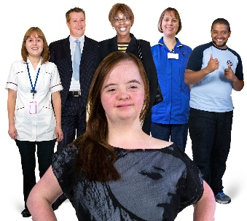 | GP Practice | Reasonable adjustments I would like.  
GP Practice only
For further information on how to use this information please email ashley.murphy@cntw.nhs.uk

