Reference details

Dear ………..

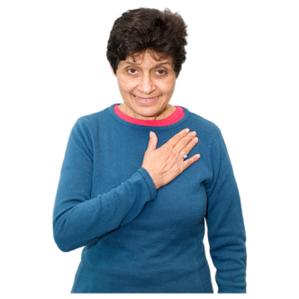 | An appointment has been made for you to go for breast screening. This is called a mammogram.
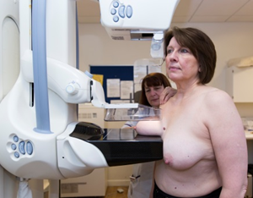 | An x-ray picture will be taken of your breasts.  This will be taken by a woman.
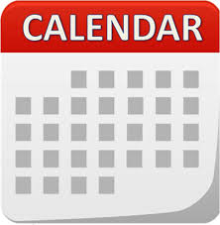  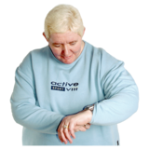 | Your appointment is  on:  at:
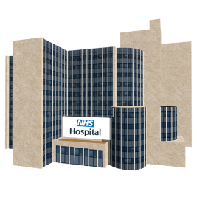 | Please go to:  Picture of Screening Centre or mobile unit can be used to replace stock image and address
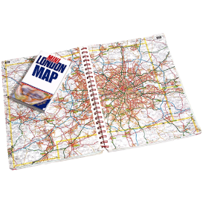 | How to get there:  Map of location, transport details?
  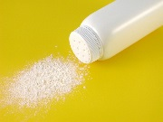 | Do not wear talcum powder or spray deodorant when you go for screening.  You can wear roll on deodorant.
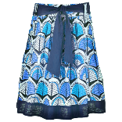  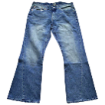  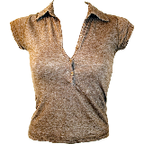 | It will be helpful if you wear a top and trousers or skirt.
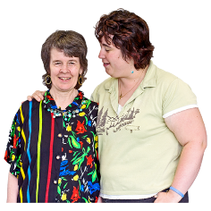 | You can bring someone with you.
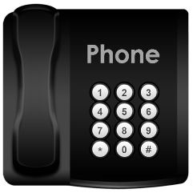  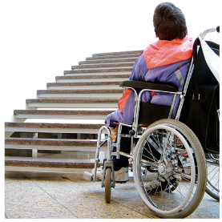 | Please contact us if you do not want your appointment or if you need to change this.  You may also want to tell us about any other needs you have so we can plan for these. For example, if you need more time for your appointment or have a physical disability.  Phone: Number to call
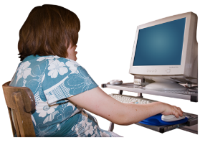    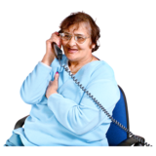 | For more information about breast screening:  - Call the screening centre.  - See the information leaflet  - Talk to your doctor or community learning disability team  - Look online at www.nhs.uk/conditions/breast-cancer-screening

Yours sincerely

