Reference details

Dear ………..
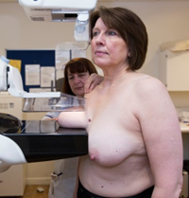 | Thank you for coming to your breast screening appointment.  This is called a mammogram, when x-ray pictures are taken of your breasts.
 | The pictures showed that everything looked okay.
     | You will get a letter asking you to have the pictures done again in 3 years time.  It is important that you go for this appointment to make sure that you stay healthy.
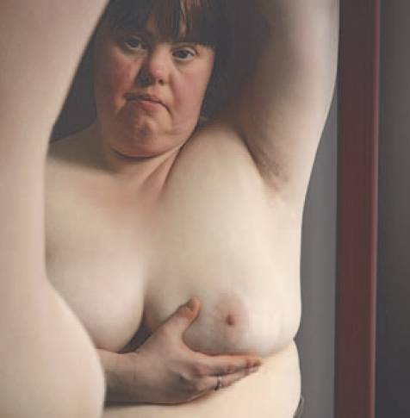 | Until then, check your breasts regularly for any changes.  Go to see your doctor if your breasts start to look different or feel different. You can talk to them if you are worried about your breasts.
 | If you have any questions you can talk to us on:  Centre phone number
     |  | For more information about breast screening:  - Call the screening centre.  - See the information leaflet  - Talk to your doctor or community learning disability team  - Look online at www.nhs.uk/conditions/breast-cancer-screening

Yours sincerely

