Changing your Details
This explains how to change the personal and contact details held for you by your GP practice. You can do this from within Patchs by submitting an Admin Request.
Simply follow these steps:
- Log into Patchs.
- Click on your name in the top right corner to reveal a dropdown menu.
- Select the Change My Details link.
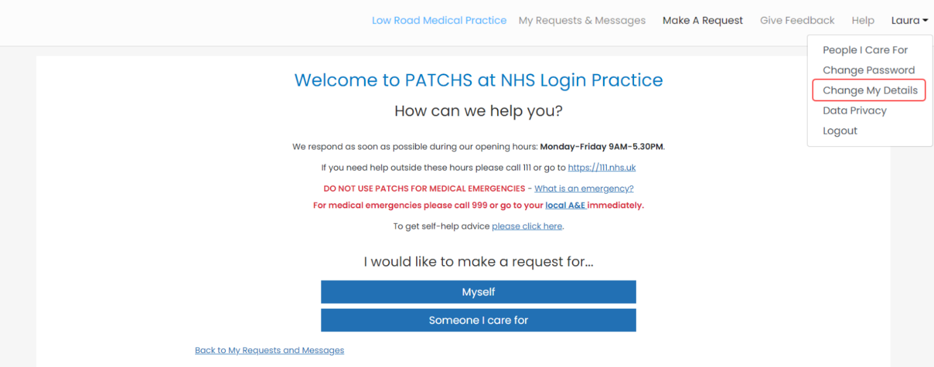
This will load the Change My Details page.
Here, you can amend your details.
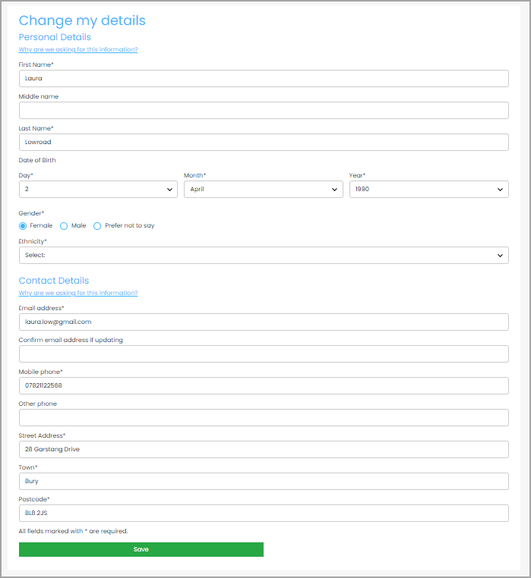
When you have finished, click the Save Button.

