Contacting your practice via the NHS App

Asking for help for a medical issue via the NHS App
To contact the practice for help with a medical issue, load the NHS App and then:
- Choose Services from the lower left of the screen
- Select Contact your GP about a health problem
- Then select Continue to access Patchs
- Then choose either:
  - New health problem - for something you haven't contacted your GP practice about before.
  - Ongoing health problem - for something your GP practice already knows about.

Having chosen your request type, you will need to answer a few questions and confirm your answers to submit your request.
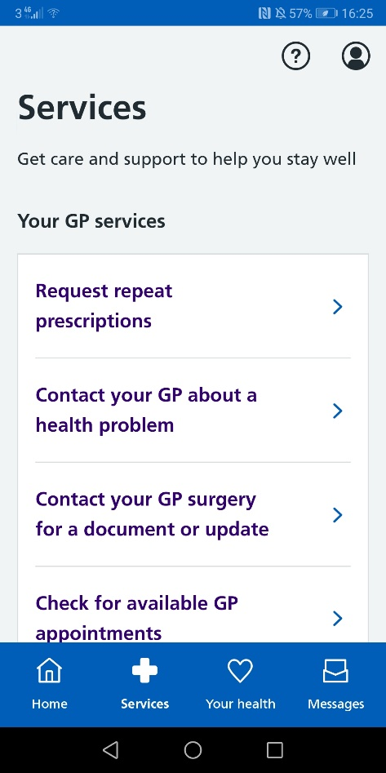
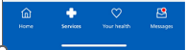
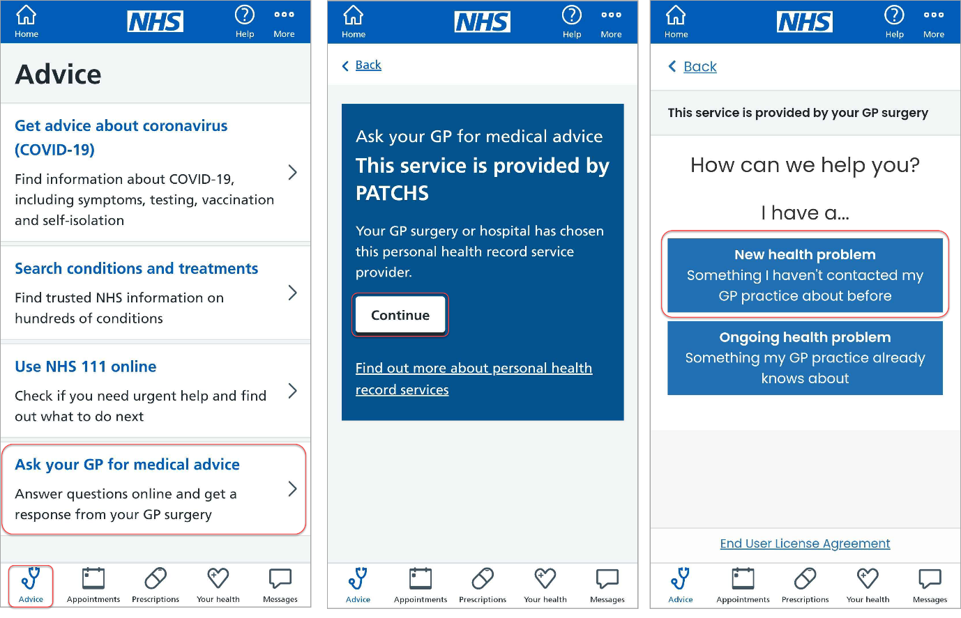
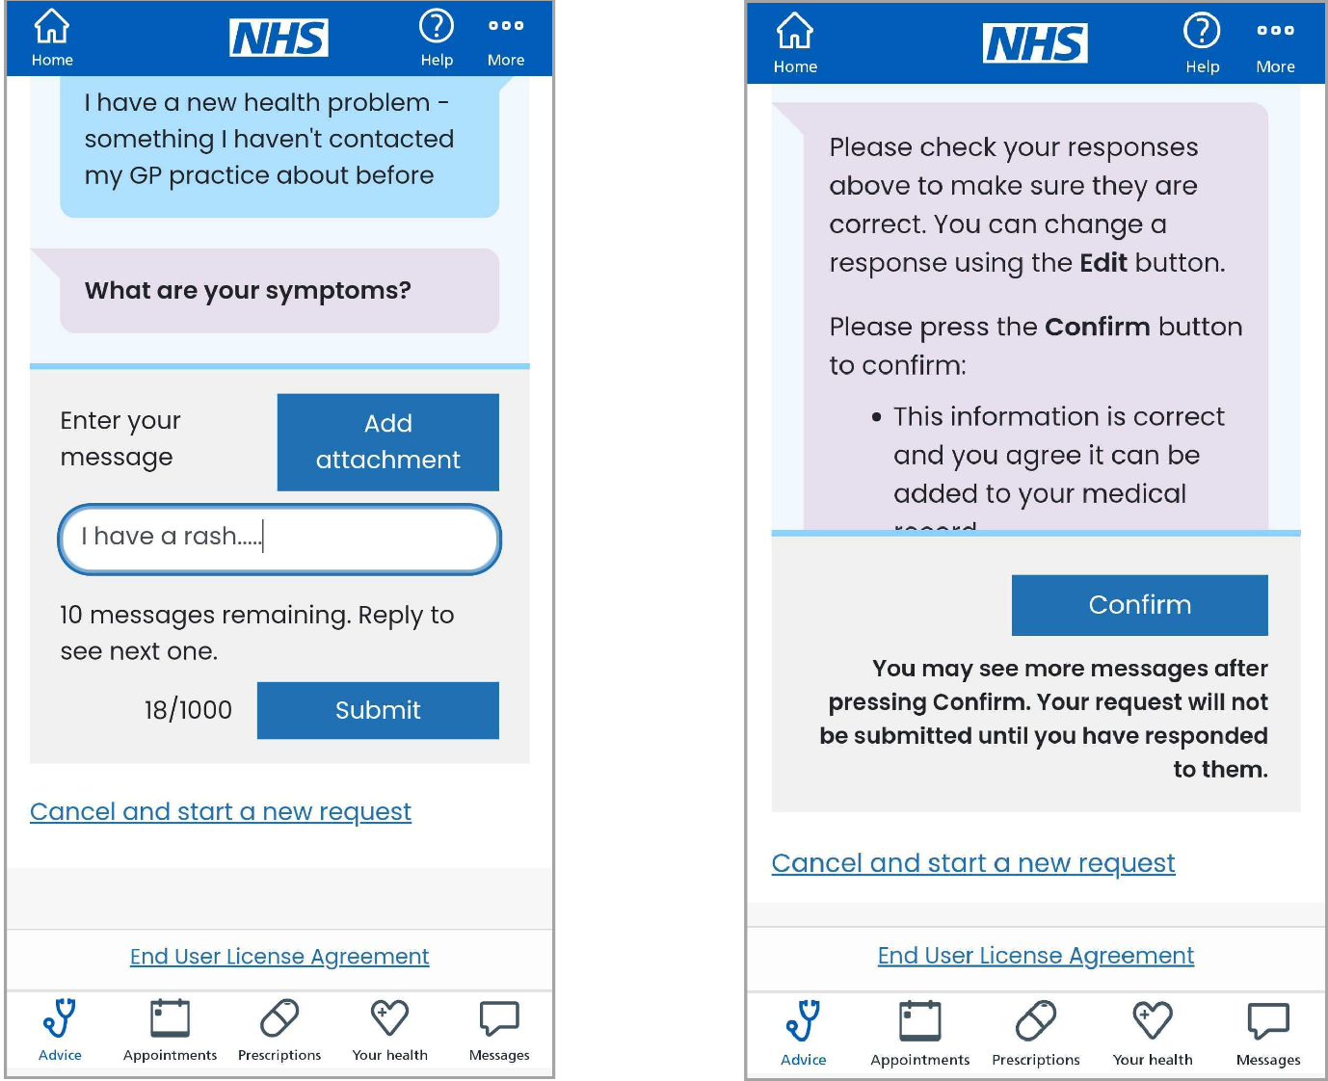
Once you have successfully submitted your request you'll be taken to a confirmation page.
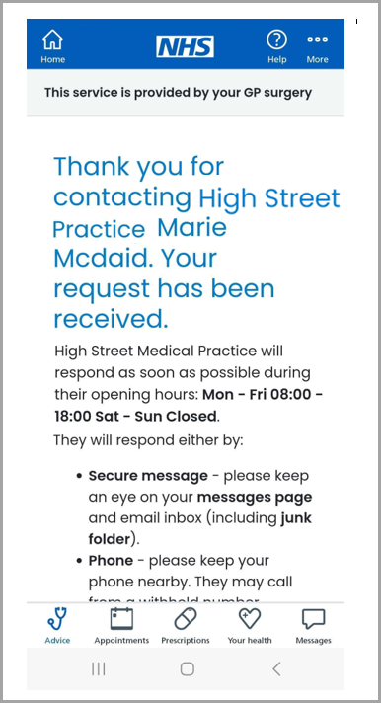

Asking for help with an admin query via the NHS App
To contact the practice for help with an admin query, load the NHS App and then:
- Choose Messages from the lower left of the screen
- Select View responses, check your past requests or send a new request
- Click Continue to access Patchs
- Choose Ask for a fit note (sick note), or other documents to submit an admin query.

Having chosen to ask your GP practice a question, you will need to answer a few questions and confirm your answers to submit your request.

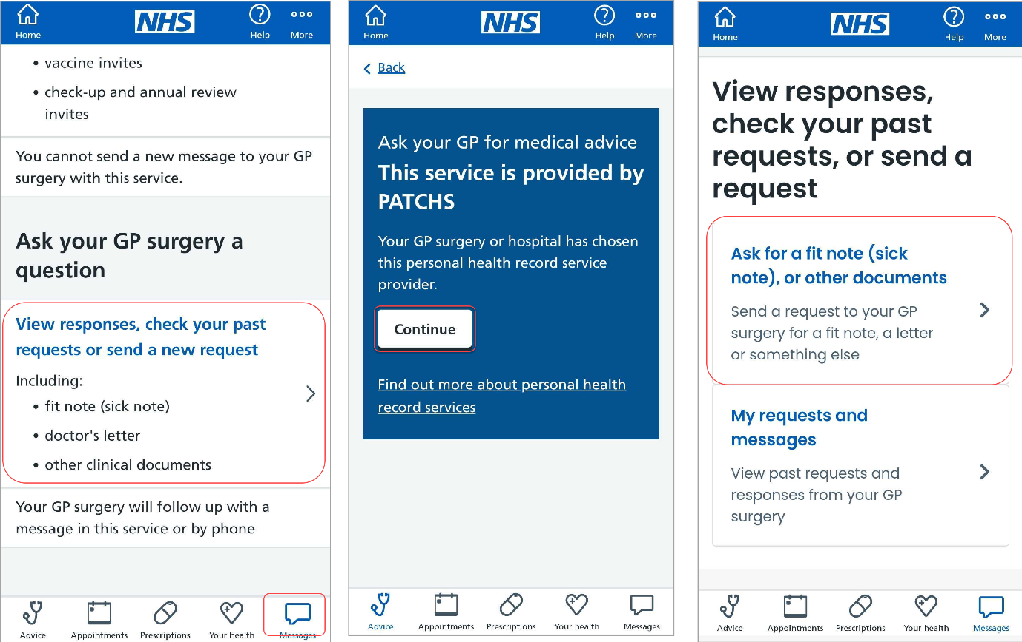

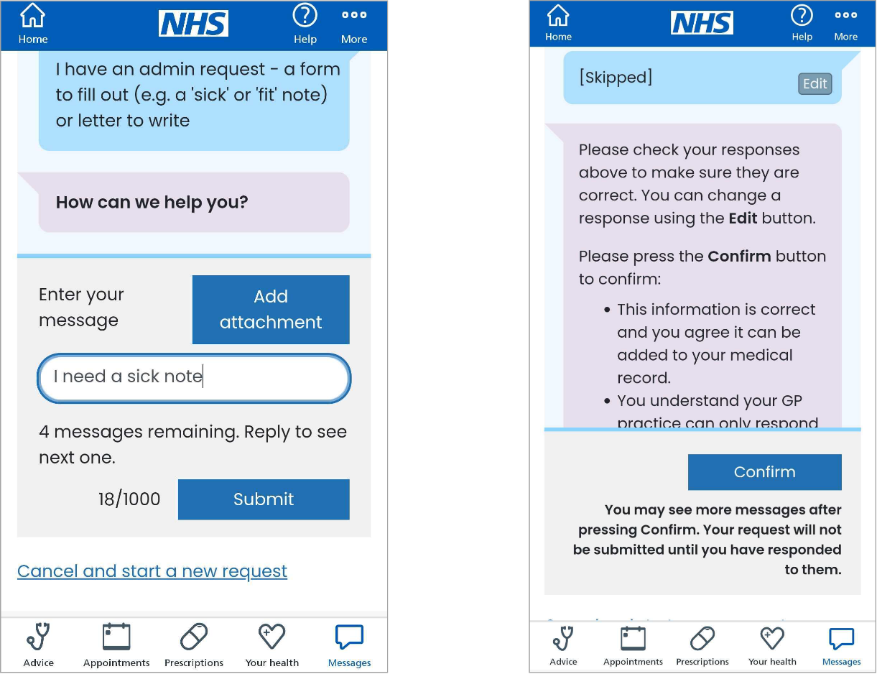
Once you have successfully submitted your request, you'll be taken to a confirmation page.

Reading and responding to a Patchs message via the NHS App
To read and respond to a Patchs message, load the NHS App and then:
- Choose Messages from the bottom left of the screen
- Select View responses, check your past requests or send a new request
- Click Continue to access Patchs
- Choose My requests and messages to view past requests and responses from your GP practice
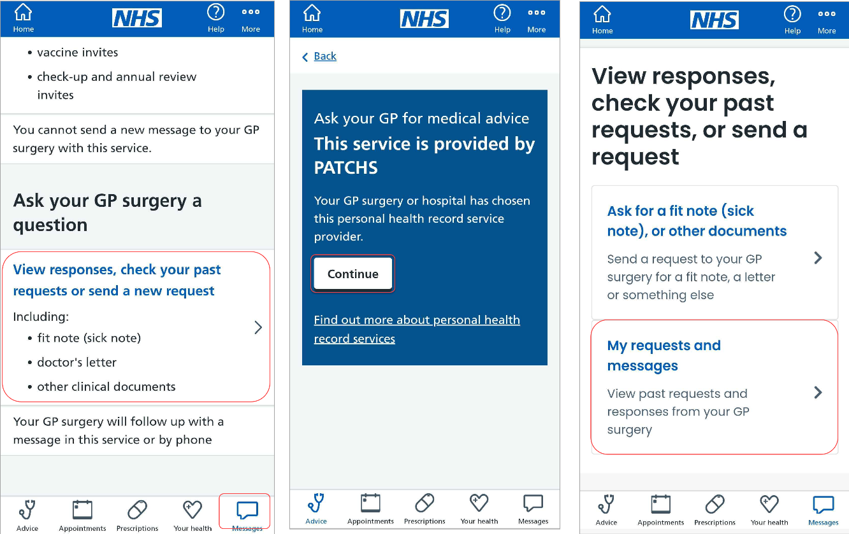
You will then be taken to My Requests and messages, where you can view your past requests and respond to any messages.
