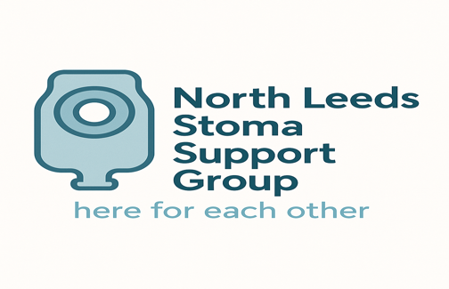

Our next bi-monthly meeting will be held on

WEDNESDAY 26TH NOVEMBER 2025
5pm-7pm

In the
Beverley Kite Room, First Floor
North Leeds Medical Practice
355 Harrogate Road
Leeds LS17 6PZ

If you’ve got a stoma (ileostomy, colostomy, urostomy)
or are a relative, parent or carer of someone with a stoma -
please come along to share your experiences or worries
or simply to chat with others who know exactly how you feel.

Stoma Nurses will be in attendance to answer any queries you may have and also to explain the new prescribing guidelines.

Refreshments available

We look forward to seeing you!

For further information or any enquiry, please telephone : 07776 296319

Alternatively, contact the Ileostomy & Internal Pouch Association on 0800 0184 724 and they can put you in touch with a suitable support volunteer.

