💙 Need Help with the NHS App?
We are Here for You! 💙
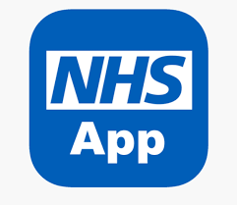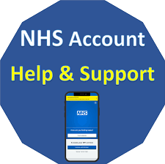

Our Digital App Champions will be around at the following Flu clinics to help patients set up their NHS App and demonstrate how they can use it. Please spread the word to any patients you think might find this useful! No appointment needed, simply attend at the flu clinics listed below between10am - 3pm
🕒 When? During our Flu Clinics
1st October – 📍 Marsh Street Surgery 🕒 10am – 3pm
6th October – 📍 Swillington Health Practice 🕒 10am – 3pm
8th October - 📍 Swillington Health Practice 🕒 10am – 3pm
9th October – 📍 Oulton Medical Centre10am 🕒 10am – 3pm

Learn how to:
✅ Book appointments online? ✅ Order repeat prescriptions?
✅Stay connected with your healthcare? ✅ View your medical records?

Come and speak to our Digital Champion!
We'll help you get started with the NHS App and show you how to make the most of it.

Oulton Medical Centre

