The Practice

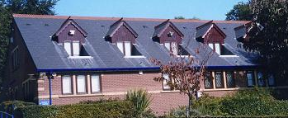
Burley Park Medical Centre was opened in June 1988 and is owned and run by the partners (it is not a limited partnership, and all partners are general partners). The practice is contracted by NHS England to provide medical services to registered patients. We are a teaching practice and regularly support student nurses and GP Registrars (qualified doctors in training to become general practitioners).

The Doctors

In addition to the three partners, the practice employs a team of four salaried GPs.

Name | Position | Qualifications | Date of UK Registration
Dr Nigel Mayers (M) | Partner | MBChB (Leeds) MRCGP | 1988
Dr Neil Lawton (M) | Partner | MBBS (London) MRCGP | 1995
Dr Catherine Lough (F) | Partner | MBChB (Leeds) MRCGP | 1998
Dr Heather Coxall (F) | Salaried GP | MBChB (Birmingham) | 2008
Dr Lee Cuthbertson (F) | Salaried GP | MBChB (Leeds) MRCGP | 2008
Dr Jenny Carrick (F) | Salaried GP | MB ChB (Leeds) | 2011
Dr Thusitha De Silva Amarasekera (F) | Salaried GP | MBChB (Manchester) | 2010
Dr Niall Robinson | Salaried GP | MB ChB (Leeds) | 2017
Dr Charlotte Coffey | Salaried GP | MB ChB (Bristol) | 2010
Dr Alex Fox | Salaried GP | MB BS (Newcastle) | 2007

The Nursing Team

Our three Advanced Nurse Practitioners are experienced in dealing with many common ailments as well as management of chronic diseases. They are also able to prescribe most medications. Our three Practice Nurses are qualified to carry out a wide variety of treatments and manage patients with chronic diseases such as diabetes, asthma, chronic obstructive pulmonary disease, high blood pressure, etc.

Name | Position | Qualification
Sara Lane | Advanced Nurse Practitioner | RGN 1994, MSc Nurse Practitioner in Primary Care 2005
Amy Linstrum | Advanced Nurse Practitioner | RGN 2006, MSc Nurse Practitioner 2016
Karen Murphy | Practice Nurse
Caroline Lawton | Practice Nurse | BSc (Hons) Nursing Studies 1997
Sharon Shelborn | Health Care Assistant
Sarah Barker | Health Care Assistant

The Practice Team

The Practice Manager is responsible for the organisation of the practice. She is supported by an Assistant Practice Manager, and a Data Quality Manager. There is a full complement of receptionists, led by a head receptionist, administration staff and secretaries who will endeavour to deal with your requests in an efficient, confidential and courteous manner.

We provide the NHS services on behalf of NHS England, PO Box 16738, Redditch, B97 9PT Telephone: 0300 311 2233 and email: England.contactus@nhs.net

Opening times

Burley Park Medical Centre is open: Monday to Friday from 8 am – 6.30 pm, with extended access on a Tuesday and Wednesday when we open at 7am for pre-booked appointments.
Hub services will run at Burley Park Medical Centre on Sunday: 8 am - 1 pm and on a Saturday at Hyde Park Surgery, Woodsley Road, Leeds LS6 1SG between 8 am and 4 pm. Tel: 0113 2001090.


Appointments

All consultations with both the doctors and nurses are by appointment and can be arranged either by telephone or using our online service. For same day appointments, please ring as soon as possible after our opening time. All other appointments can be booked anytime during our normal working hours.
In addition to on-the-day appointments we also offer various alternatives including:
- emergency telephone consultations
- after-hours appointments
- weekends appointments.
Whenever possible we will place you with the doctor of your choice, however all doctors and locums have full access to your complete medical records. Unfortunately there maybe occasions when your ideal appointment time will not be available, but our reception team will endeavour to offer an alternative. Our receptionists have a demanding and difficult job but they will always do their best to assist you. We have a number of appointments that can be booked online directly into the clinical system. To learn more about this please see the “Online Services” section below, which can save you time when booking an appointment.

Timetable:

Monday: Dr Lawton, Dr Cuthbertson, Dr Fox, Dr Coffey, Dr Robinson, Sara Lane.
Tuesday: Dr Lawton, Dr Coffey, Dr Fox, Dr Robinson, Dr De Silva, Sara Lane.
Wednesday: Dr Lawton, Dr Lough, Dr Carrick, Sara Lane, Dr Robinson Amy LInstrum.
Thursday: Dr Lough, Dr Cuthbertson, Dr De Silva, Dr Edwards(Locum GP) Dr Coxall, Dr Robinson, Sara Lane, Amy Linstrum.
Friday: Dr Lawton, Dr Lough, Dr Fox, Dr Carrick, Dr Coxall, Amy Linstrum.

Online services
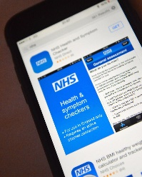

The NHS App is a simple and secure way to access a range of NHS services and information on your smartphone or tablet. You can book appointments, request medication using the app. The App makes it easy to access your appointment information and manage your hospital appointments. You can also find out your NHS number and access NHS 111 online to get instant advice or medical help near you.

Repeat Prescriptions

Please allow 48 working hours for a repeat prescription to be produced.

We accept repeat requests in person, by post, or via our online service. You can also instruct a chemist on your behalf to order, collect and deliver your medication. The practice uses the Electronic Prescribing Service, which means you will not have to attend the surgery to collect prescriptions. We will endeavour to accommodate urgent medication requests, but ask that patients please order their medication in good time


Home Visits

To request a home visit please call the surgery before 10 am. Home visits are at the discretion of the doctors and for patients who have serious illnesses or who are housebound. Please note that we have better facilities and equipment available in the surgery than the doctor can provide on a home visit, and attendance at the surgery is generally a better option.
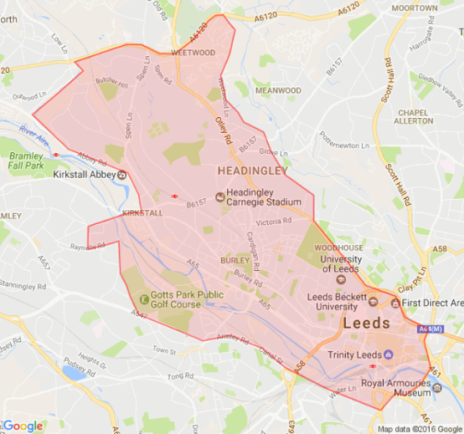
Practice Area/New Patients

To register with the practice you must be resident in the local area as shown on the map in our reception (Leeds postal districts 1,2,3,4,5 and parts of 6,9,10,12,&16). A summary of the area we cover is shown. If you are a registered patient and you move house, you may be able to remain a patient at the Practice if your address is within our extended Practice Area. A map of the Practice Area is also available on our website www.burleyparkmedicalcentre.co.uk and in our waiting room. Please ask at reception if you require clarification about the Practice Area. You can register at reception by using a registration form and supplying us with proof of identity and address. All new patients are eligible for a new patient health check with the Health Care Assistant and for enrolment into our online services.

Services in addition to GP surgeries
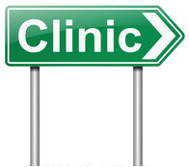
Our Nursing team offer clinics for:-
- Patient Health Checks
- Chronic Disease Monitoring, such as Diabetes, Asthma, COPD
- Contraception, Cytology and sexual health services including implant and
I.U.C.D (coil fitting)
- Minor Surgery
- Baby immunisations

Other services available at the surgery are:-
- Ante and Post Natal Checks
- Healthy lifestyle services
- Alcohol misuse
- Mental health
- Advocacy services and many others.
- Physiotherapy
- Podiatry
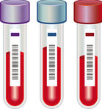

Blood and Test Results

Please telephone our reception staff to obtain the results of tests. To protect patient confidentiality, results will only be given to the person concerned or their parent/guardian. Please call after 10:30 am.

Patient Responsibilities

We will treat you with respect, care and courtesy and ask that you do the same. Please be on time for appointments and cancel ones you cannot attend. We ask that you notify us of any change to your address or telephone numbers. If you are under the care of a hospital or are awaiting an appointment, please notify them too.


Confidentiality

We hold your patient records in the strictest of confidence, regardless of whether they are electronic or on paper. We take all reasonable precautions to prevent unauthorised access to your records, however they are stored. Any information that may identify you is only shared with the practice team, or, if you are referred to hospital, to the clinician who will be treating you. We will only share information about you with anyone else if you give your permission in writing

ALL patient information is handled confidentially according to NHS guidelines. You have the right to access any personal information held under the Data Protection Act and GDPR. We will not disclose any details to other agencies unless we have your written consent.

Access to Patient Information
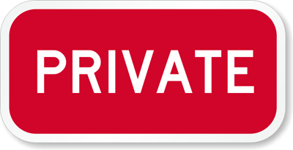
You have the right to keep your personal health information confidential. Any information given to anyone in this Practice is considered confidential. All employees are trained in information
Security and confidentiality. There are strict codes of conduct in place to ensure your information is safe, whether it is on paper or computer files. Where data is stored electronically we comply
with the Data Protection Act 2018 and GDPR. Any information shared (confidentially) with other specialist NHS organisations is also bound by strict regulations of confidentiality. Whenever we can we shall remove details which identify you.
Medical information requested by other sources e.g. employers, insurance companies and solicitors will only be provided with your written consent. Your medical details will not be disclosed to your family, friends or colleagues unless we have your written consent to do so. You are entitled to receive a copy of any letter that the Practice writes about you. This is usually in the form of referral letters to hospitals.
Under the Data Protection Act 2018 and GDPR, you are legally entitled to access your clinical records. If you wish to access your records, please ask at reception for the appropriate form. All requests to view medical records should be made in writing to the surgery. Under GDPR these will no longer be chargeable.

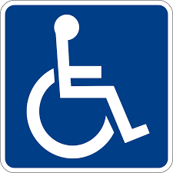
Patients with disabilities

The medical centre has been modified to allow use by patients with physical disabilities. There are parking spaces for disabled drivers, ramp access to the building, automated external and internal doors and disabled toilet facilities. We also abide by the Accessible Information Standard and will endeavour to provide information to patients in the most suitable format e.g. large print, braille etc. We are also able to, by prior arrangement, provide BSL interpreters

Complaints and Suggestions


We constantly review the way the Practice operates and would, therefore, welcome any
suggestions for improvement. The Practice has its own in-house complaints procedure. Complaints should ideally be put in writing and addressed to our Practice Manager who will ensure they receive our full attention. Please contact our Practice Manager if you are unable to provide your complaint in writing

We hope that you will allow us the opportunity to respond to your complaint, but if you
feel unable to discuss this with the Practice, you can contact Advonet who provide independent health complaints advocacy services on 0113 2440606 or email to office@advvonet.org.uk or by post at Unity Business Centre, 26 Roundhay Road, Leeds, LS7 1AB.
The Complaints Department, NHS Commissioning Board, PO Box 16738, Redditch, B97 9PT. NHS England can also undertake the complaint handling on your behalf. Alternatively, you also have the right to approach the Ombudsman, whose contact details are: The Parliamentary and Health Service Ombudsman, Millbank Tower, Millbank, London SW1P 4QP Tel: 0345 0154033.
The Patient Advice and Liaison Service (PALS) provide confidential advice and support to assist
you through the complaints procedure. They can also provide information about the different NHS services available from the NHS. You can contact PALS by telephoning 0800 0525270. Information about Burley Park Medical Centre’s complaints procedure is available from reception or on our website, www.burleyparkmedicalcentre.co.uk

Teaching and Training

We are a teaching Practice which involves medical and nursing student placements. A student may be present during your consultation but your permission will always be obtained first. If you do not wish a student to be present, please inform reception.
We also train doctors who have already worked as hospital doctors and are completing further training to become a GP.

Patient Participation Group


The Practice operates a Patient Participation Group (PPG). This representative group of patients
helps influence the services the Practice provides. If you would like to join our friendly group, please ask at reception or visit our website for more information. Members receive about four
e-mails or letters each year asking patients about their views on matters important to the PPG.


Zero Tolerance

We operate an NHS approved Zero Tolerance policy on any issues of abuse, whether verbal or physical, towards any member of staff or person on the premises. We have the right to remove a patient from our list and to inform the police of any such incident. The Practice will report the incident to NHS England and a request made for the removal of the patient from the Practice list with immediate effect. Please be informed we operate CCTV cameras within the public areas of this surgery.

Private Fees

Charges will be made for non NHS Services. These include private certificates of incapacity, x-rays and bloods for either employment or travel purposes etc. In addition, some immunisations for travel purposes are not available on the NHS which means that we are required to charge for this service. Our tariff in respect of these services is advertised in the waiting room, or is available upon request. Please note that, due to legislation, we are unable to sign passport applications.

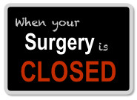
WHEN THE SURGERY IS CLOSED

Should you require URGENT medical attention when the surgery is closed, please telephone 295 3850 where you will be automatically directed to an answer phone message about the out-of-hours service.

If you have a medical problem that cannot wait until we re-open please call the NHS non-emergency number: 111

IN AN EMERGENCY, PLEASE CALL 999

Useful Numbers and Contacts- please ask for our signposting leaflet for more.
Pharmacy first


Many pharmacies across West Leeds offer a service called Pharmacy First to patients who are registered with a GP practice in West Leeds. The Pharmacy First service gives you the option of visiting your local pharmacist for self-care advice for common health conditions and encourages patients to self-care following advice from their pharmacist, reducing your need to see a GP. They can deal with the following ailments:

Sinusitis

Sore throat

Earache

Infected insect bite

Impetigo (a bacterial skin infection)

Shingles

Uncomplicated urinary tract infections in women.

They can also prescribe the contractive pill.

Any medication supplied by Pharmacy First is free of charge if the patient is exempt from prescription charges and less than the cost of a prescription if an over the counter medicine is recommended. No appointment is necessary so attending Pharmacy First service may save you time. If the Pharmacist considers your problem more serious, they will be able to recognise this and advise you to see a GP.
Welfare Rights

Welfare rights mean the rights of people to be aware of and receive their maximum entitlement to state welfare benefits. Leeds City Council welfare rights unit provides advice and casework for the general public at various venues across Leeds. They can be contacted on 0113 3760452 or email to welfare.rights@leeds.gov.uk

Drugs or Alcohol issues
Looking for help for yourself or someone else?
Get in touch with Forward Leeds. Forward Leeds is the alcohol and drug service in Leeds for adults, young people and families. They offer a range of services from 9am-5pm, Mondays and Fridays and 9am-7pm Tuesdays, Wednesdays and Thursdays. Call 0113 887 2477 or mail info@forwardleeds.co.uk

Citizens Advice
Citizens Advice provide free, confidential and impartial advice and campaign on issues affecting people's lives. Their goal is to help everyone find a way forward, whatever problem they face. They can be contacted on 0113 223 4400
Sexual Health

The Leeds Sexual Health service offers advice on all matters regarding sexual health including sexually transmitted infections (STIs), contraception and pregnancy. Appointments can be booked online via the website or by calling 0113 392 0333

Due to an increase of patients failing to attend their appointments and the strains on our service we have a Did Not Attend policy in place.
We regularly check patients that have DNA'd multiple appointments with our surgery and send out reminders/warning letters.
This states that if you don’t attend the surgery three times within the space of 6 months the patient will receive a warning letter stating if there is a further appointment missed there will be a removal from the surgery.

Cancelling appointments also need to be at least 15 minutes prior so we can then offer this to another patient who is in need of our service.
If this policy isn’t followed and the appointment isn’t cancelled within the 15 minutes, then this will go down as a did not attend on the record.

