BHR PCN Newsletter
April 2025
19th edition

Contents
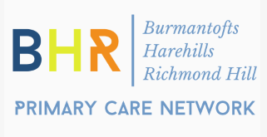
- Message from Dr Nadia Anderson CD/GP
- New Starters
- Staff updates/Leavers
- Personalised Care Team
- Community Room at The Shine
- Heath & Wellbeing Coaches
- Children’s Health Hub
- Heroes
- Health Population Management Hub
- Pharmacist Team
- Good News Stories
- BHR PCN Website

Message from Dr Nadia Anderson CD/GP
Hello All,
I hope you managed to have some downtime over the Easter Bank holidays and less pressure in practices with warmer days on the horizon. As we move towards the end of the 6th year of PCN’s, we have matured and evolved. We have workstreams working at a population health level in our priority areas with our population health hub team and pharmacy team, as well as holistic support from our patient centered hub. We recognise that governance and accountability is deeply important as we continue to grow and expand in multiple areas.
The next step in our evolution would be to incorporate into a limited company. The biggest motivation for this would be to provide a level of protection for business owners. Currently, liabilities are shared across member practices. As we have grown, risks attached to the PCN have also increased. A limited company would make our governance more robust and allow unifying of policies and procedures. Although costs will remain in running the company, there would be much more predictability and control.
Some of the previous barriers are now surmountable such as the NHS pension issue. There are also opportunities that the PCN limited company would be best placed to take advantage of. Like practices, the core budget of the PCN is stretched with rises in expenditure. Income streams outside of the PCN core contract will support additional or more appropriate tailored services for our patients. We strive to work together to continue to improve.
Dr Nadia Anderson – Clinical Director

New Starters
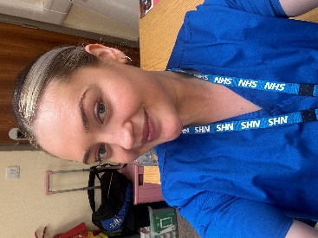
Danielle Stansfield joined BHR PCN in March as a newly qualified Nursing Associate to join the Health Population Management Team. Danielle has 8 years of experience within the NHS, she began her NHS journey in general practice as a receptionist before progressing to her current role as a clinician. Danielle is excited to embark on this new chapter and looks forward to seeing her clinics up and running soon!

FCPs update
Some of you may have met our 2 FCP trainees, Mel Coates and Vince Burnham who joined our team a couple of months ago. They are still training and following an induction plan, so are currently shadowing the FCPs.
In June there will be a few changes made within the team. Mat will be leaving the role of FCP, Stephen will be reducing his hours, Mel & Vince will have their own clinics and the service may be delivered from other practices, depending on room availability. However, further comms will be circulated with more detail, nearer the time.
Personalised Care Team

Hub Referral Data - Jan/Feb/Mar
All services: 713
Patient Ambassador Service = 415
Social Prescribing Drop-in = 21
Groupwork = 91
HWBC = 21
CHH = 33
Empowering Women Through Culture and Learning English Language
Women 4 Women (W4W) Group
Meeting every Wednesday during term time at Shine from 9.30-11.30 Randa, Sadie and Sharon continue to welcome women to the W4W group to connect share and learn. The mission of W4W is to uplift and empower women by embracing and preserving cultural heritage. Through workshops, events, and discussions, the group provides a safe space for women to connect, learn, and grow. We are proud to have women attending from various nationalities, including Syria, Sudan, Eritrea, Turkey, Azerbaijan, Egypt, Romania, Palestine, Iraq, Yemen, Kurdistan, Iran, South Africa, Somalia, Saudi Arabia, Libya, Pakistan, Afghanistan, Bangladesh, England, and the Roma community. Over the past few months, W4W has hosted a variety of engaging activities, including:
DEFRA Funded ‘Everyone’s A Seed’ project – The workshop was delivered by poets Amina Alyal, Oz Hardwick from Leeds Trinity University and Plant Scientist Charles Lane. The women explored plant health and biodiversity through creative writing, looking back at their own agricultural heritage and their relationship with nature. The women were very engaged, particularly around the international vegetables brought in, describing how they tasted and traditional ways to prepare and cook them. The stories and recollections were transformed into beautiful poems, curated by Amina and Oz (excerpt below) which will be showcased in the future in our Shine Community room.
- Dance Workshop with Tricia from RJC Dance – Women learned graceful movements using scarves, celebrating self-expression through dance.
- End of Year Celebration - the women enjoyed a session with a Henna Artist, getting pampered as well as having a go at learning designs themselves, and taking part in sewing/crochet activities
- Visit from Cllr Salma Aref (Harehills and Gipton) –she was very interested in the W4W sessions and all that we do in the sessions, it was a delight to meet her. Salma was delighted to meet members and expressed great interest in the group’s work and impact.
- Educational Session on Menstrual Health – Zoe, Lauren and Lindsey, from the PCN Population Health Management team, delivered an informative and well-received session on menstrual health.
- Fit 2 Learn Workshop – Tomatis Consultant, Charlotte Davies led engaging activities that the women thoroughly enjoyed, providing practical, science-backed strategies to help people streamline their motor-sensory skills, making everyday tasks easier and enhancing overall well-being.
- Eid- Al- Fitr Celebration – To celebrate the end of the Islamic month of Ramadan, we held an Eid celebration at our Shine Community room with the women each bringing in a dish from their country of origin – we had an impressive total of 11 different countries being represented!
Ongoing Support and Activities
- English Learning with Sadie – Every Tuesday morning, Sadie offers one-on-one or small group sessions to help women improve their English skills through the Empower Her English program.
Creative and Fun Monthly Activities – Each month, W4W organizes engaging, hands-on sessions to foster creativity and community building. As a space of empowerment, cultural exchange, and learning. We invite all women in the community to join us in celebrating our heritage and supporting one another.
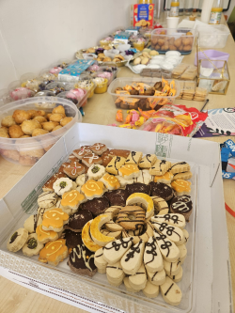
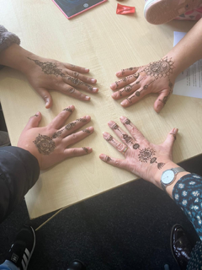
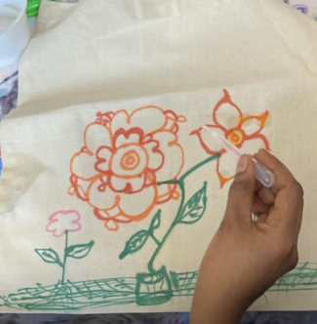
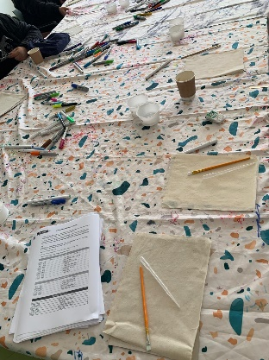

Eid Al-Fitr Celebration
Creative Engagement Sessions

Menopause support we offer in BHR.
Our sessions are held in practices and at the Shine, aiming to have easy access for everyone.
We’re also delivering workshops in the community for local groups and offering sessions aimed at staff education and awareness in the workplace.
What We Cover:
- Our groups cover both perimenopause and menopause, discussing the physical and psychological symptoms experienced during these transitions.
- We explore both medical and non-medical treatments to help manage symptoms effectively.
- Enjoy an opportunity to engage in yoga movement and guided meditation as part of our sessions, designed to promote overall well-being.
In addition, we have:
- A menopause walking group: For those who enjoy staying active, join our walking group for some fresh air and supportive conversation, they meet each Tuesday 10.30 am at the Compton Centre.
- Our Menopause Cafe, we meet the Third Thursday of the month at the Shine, from 5:00 pm to 6:30 pm. BHR staff are very welcome to join us for a relaxed and friendly chat about everything that is menopause.
The Menopause groups workshops and café have been created to support women in a safe space for sharing experiences and learning new ways to manage the journey of menopause.

Community Room at Shine
As part of a Near Neighbour’s Project, on Monday 3rd March 2025, BHR PCN, The Harehills action Team and Wellsprings Together (Faith in action transforming communities together across the Anglican Diocese of Leeds) hosted a community discussion at the Shine which explored the disturbances and riots that occurred in summer 2024, reflecting on their impact of, and what promotes community cohesion.
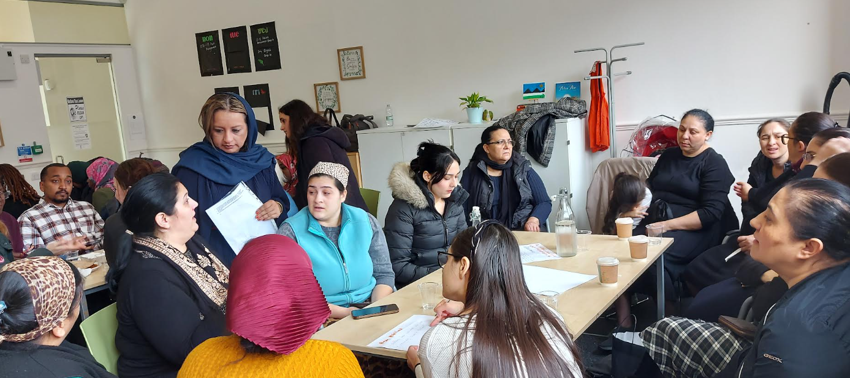
The BHR PCN room at The Shine hosted the Migrant Access Project's health-themed consultation on March 18th, 2025. The agenda included information from a research project led by Leeds University called ‘My First 1000 Days’ https://www.leeds.ac.uk/working-region/news/article/5475/leeds-launches-landmark-early-years-research-project. "My First 1000 Days" is a Leeds-based project focused on improving health and social outcomes for parents and children during the first 1000 days of a child's life, from conception to age two, through a community-based, group-centered model of care. Sohail Asmat will meet with Marcus to discuss how BHR PCN may be able to collaborate with the project.
Visit to the Shine by Nicoleta Teodorovici, Consul General of Romania in Manchester, 3rd April 2025.
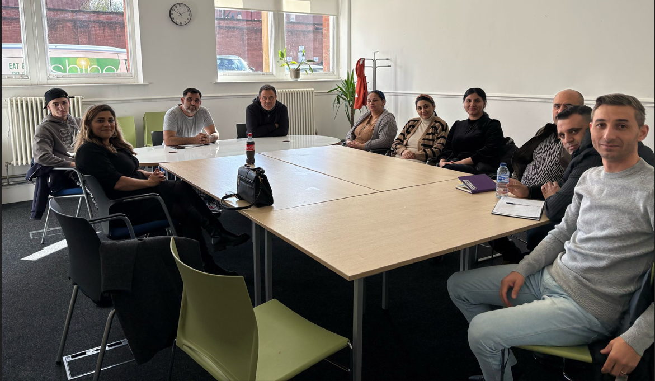
In July 2024, the Harehills area of Leeds experienced significant unrest following the removal of four children from a Romanian Roma family by social services, sparking protests and rioting. The disturbances led to the overturning of a police car and the setting ablaze of a double-decker bus.
In response to the unrest, Leeds City Council initiated an urgent review of its child protection procedures and engaged with various community organisations, including the Honorary Consulate of Romania in Manchester. During this period, the Romanian Consulate maintained communication with the affected family and British authorities.
These events highlight the complex interplay between local social services, community dynamics, and international diplomatic channels, underscoring the importance of cultural sensitivity and effective communication in addressing such incidents.
BHR PCN is committed to improving the well-being of marginalised communities. In the wake of the incidents in July 2024, BHR PCN has collaborated with a member of staff from Davren, Daniela Mailat, who now delivers Basic English Classes at the Shine every Tuesday and Thursday from 9 to 11.30 a.m. for the Roma–speaking community. At enrolment, we had 10 students attend, and now around 15-20 students attend each class.
Being proficient in English helps communities navigate various aspects of life, including the healthcare system, where cultural sensitivity and language barriers often result in unequal treatment. It can also empower Roma individuals to advocate for their rights and seek better health outcomes.
HWBC
Tony, our Health and Wellbeing Coach, is actively engaged in delivering Health and Wellbeing Coaching sessions. Tony helps patients improve their overall mental and physical well-being by providing personalised coaching. These sessions focus on setting realistic health goals, managing stress, promoting healthier lifestyle choices, and offering support to enhance both physical and emotional resilience. Tony has also been appointed as a Health and Wellbeing Coaching supervisor and is now in the process of completing his training.
Tony continues to be involved in delivering a Pain Management Group alongside his colleague Shaun, a Patient Ambassador. This group is for individuals who want to learn more about living with chronic pain and coping mechanisms. Additionally, there is a plan to run a session on 19th May 2025 at the Shine, where the Pain Management Group and the Man Talk - Men’s Wellbeing Support Group will merge. The session will provide a blend of guidance on pain management along with a supportive space for participants to chat openly and share their thoughts in a non-judgmental environment.
Children’s Health Hub
Our Child Health Hub team have been busy developing a group programme, designed to support parents with the day-to-day challenges of parenting. This is a 6-week course of group workshops to support parents in managing their child’s emotions, mental health, challenging behaviour, communicating effectively, and looking after themselves in a demanding yet rewarding role. We also have a session to inform parents of the importance of healthcare and how they can access our services and other services across the city.
Our first group programme began in March, and we have partnered with the Children’s Society for the delivery of these sessions. Please see our attached flyer for details on how to book onto this fantastic group programme.
Heroes
Kiran and Sharon have just completed their first cohort for 2025 and they continue to deliver the groups. The next cohort begins on Wednesday 23rd April at HC2 and Thursday 24th April at Bellbrooke surgery.
PHQ-9 from the 15 patients that completed the HEROES groupwork programme from January to March 2025:
- Overall group score at the start of the programme= 255
- Overall group score on the last session = 144

These results show that overall patients mental health has improved by = 111
See quotes from our patients:
"Thank you for walking this path.... you heal so we heal.... you are a special facilitator filled with love and compassion”.
"Thank you for everything, you are amazing keep using your talent, I know who I am now. I have the true vision of myself”.
"I was extremely nervous about coming to the group, but it has been so brilliant."

Health Population Management Hub
NHS health checks
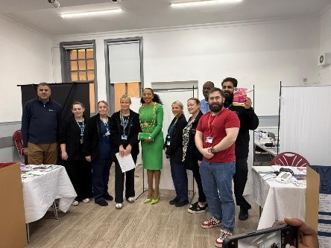
The team put on an event for the Senegalese community on Saturday 22nd February at St Aidan’s church. The event was well attended, and the team gave talks on various health subjects, the team offered Hypertension Case finding and NHS health checks for those who were eligible. Colleagues from Extended Access also attended to support individuals from other PCN’s to book cervical screening appointments and other relevant appointments on the day too. The Mayor of Leeds also attended the event to show their support for our community.
We are also offering listening groups about NHS health checks for our African Community.

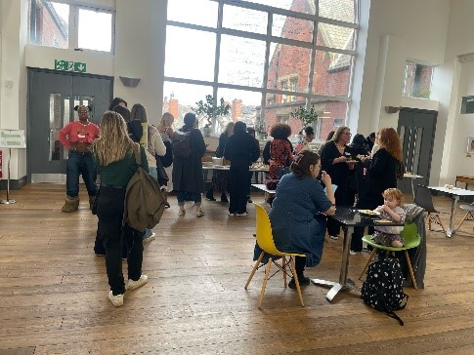
International Women’s Day – The team did a pop-up stall at the Shine alongside “She can Shine team” They also attended St Vincent’s Women’s Day event to network.

Women's health update:

Endometriosis groups will be available to refer into via the orange triangle from May. The groups look at what endometriosis is, symptom management – medical and non-medical, diet and lifestyle and alternative therapies.
We continue to offer general menstrual health groups, PMS & PMDD groups and PCOS groups so please do refer for these via the orange triangle.

NHS health check update:

The health population management team have completed 5 NHS health check events and completed 23 NHS health checks on patients within our PCN.
The team have regular monthly clinics at the Compton or Reginald centre to see patients who are unable to have their NHS health check on the day.

Pre-Diabetes group:

The Team have completed 2 prediabetes group with East Park patients. All patients that attended both groups were enthusiastic and are looking forward to the next follow up group in 6 months’ time.
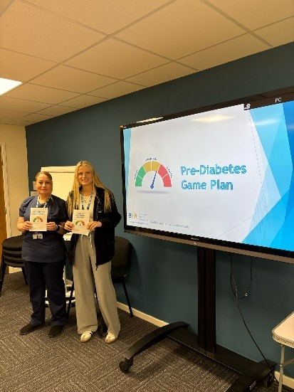

They are now moving onto inviting Bellbrooke patients.

Hypertension groups:

We are still accepting referrals into the Hypertension group sessions. We are planning the next group to take place in May.

Learning Disabilities beyond words book club:

Serrina and Sarah are working alongside Beyond Words to open the first Beyond Words book club in West Yorkshire, the book club will take place on the second Monday of the month between 10 am and 12 pm at The Compton Centre library starting on Monday 12th May – anyone with a learning disability over the age of 14 is welcome.
Future events:

12th May working with NIRH targeting our black communities with a joint initiative for "Improving Black Health Outcomes". Joint initiative for research for Sickle cell Anaemia and NHS Health Checks
13th May Inviting our carers from BHR PCN Supported by Carers Leeds
16th May with the Jamaican society on Chapeltown Road
17th May is World hypertension day - The team will be going out into the community offering Hypertension and Arterial Fibrillation Case Finding and education on hypertension awareness.
21st May is World menstrual hygiene day - we will be hosting a women’s health event. See attached posters, please print out to display and circulate to make patients aware of this event.
29th May at Banstead park - The team will attend and be offering a wide range of health services and education.

Serrina and Sarah are working alongside Beyond Words to open the first “Beyond Words book club” in West Yorkshire. The book club will take place on the second Monday of the month between 10 am and 12 pm at The Compton Centre library starting on Monday 12th May – anyone with a learning disability over the age of 14 is welcome.

Pharmacy Team

Aysha and Kimberley have been with the team for nearly six months and are now well-integrated. Zayba, Issy, Hamza, and Hanya are all in the process of completing their independent prescribing qualifications and have finished all required university study days. Starting soon, they will be returning to practice on Tuesdays, which will help increase both the capacity and expertise available.
The pharmacy technicians continue to run a monthly Medicines Support Group. This has typically been held on the last Tuesday of each month at the Shine, but the day will be changing moving forward. More details will follow soon. Please continue to refer via the orange triangle.
Aamina has successfully completed her 12-month secondment with LCH, where she led the pilot CKD project across four PCNs in Leeds and collaborated with the LCH diabetes team. She is eager to bring these valuable skills back to the PCN for the benefit of our population. As part of the CKD pilot, a second abstract was written for submission to the UKKW annual conference, and it was successfully selected.

CKD Joint Working Project
Now complete with just a 6-month period of data collection and reporting remaining on what has been a successful project even if the numbers envisaged were always unrealistic. Thanks to Aamina and Liz’s team for the input. Summary of the project as follows:
Project Achievements:
- As of the end of December 2024, we have achieved 323 initiations against the original target of 1250.
- A total of 992 patient reviews have been completed.
- January's numbers will be shared once finalised within the next week or two.

Good News Stories
“I just wanted to say how brilliant the Health Population Management Team were with the pre-diabetes groups, which I know you already know but the way the information was delivered was so easy to understand, relatable and engaging and you could see there was a real sense of trust between the patients and the team. We are so fortunate to have a PCN with a team that can support such a personalised approach to prevention at a local level like this so just wanted to pass this on and thank you and the team for everything you do.”
Georgia Blaney – Public Health - Health Improvement Specialist – Long Term Conditions
On completing HEROES Groupwork Programme, patient A.M wrote in to let us know of what a meaningful impact Kiran had made in his recovery from substance misuse, low mental health, and his journey in trying to ‘be a better dad’. The letter was comprehensive in detailing all the way Kiran guided and supported, but below is little extract:
“I highly appreciate the services Kiran has provided and wish to continue sessions in future. Please may you also forward this compliment to West Yorkshire/Leeds Council and Health Services as well as the NHS board and Harehills Community Health Centre…. I therefore, thank Kirandip Bath and the NHS on behalf of myself and the involved community that all enjoy working alongside Kiran. Thank you kindly for your services and being such a delight to work with.” Thank you, Kiran.
Dr Ostler from Chapeltown Family Surgery retires from practice on 31/3/25 after many years of dedication and hard work.
Dr Jayasinghe from Chapeltown Family Surgery and 3 other colleagues have been nominated for an award for their hard work creating a template. They have been chosen out of hundreds of applicants UK wide as finalists in the Innovation in Reducing Health Inequalities category of the mj awards.
BHR PCN Website
Please remember to check our website https://www.bhrprimarycarenetwork.co.uk/

