Diabetes Comms Pack
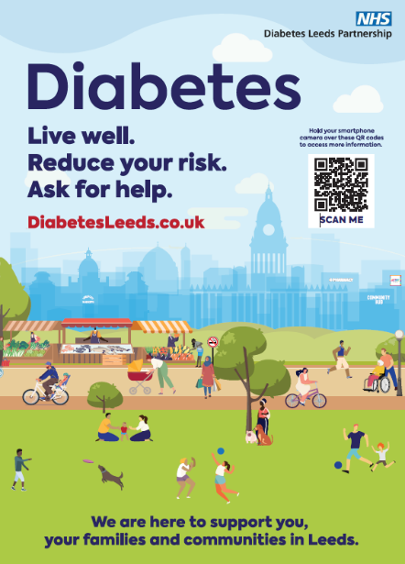
Diabetes Leeds is committed to improving information delivery across the city, and we need your help to make a difference.
This communications pack includes a variety of public-facing resources designed to support individuals at high risk or living with type 2 diabetes. Inside, you’ll find: The Diabetes Leeds website, social media assets, informative videos, physical resources.
These materials have been thoughtfully developed by Leeds Public Health and Leeds Community Healthcare to ensure you have the best tools at your disposal.
Call to Action:
- Update your websites
- Display media on your practice screens
- Share on your social media
- Display posters in your practice
- Identify target populations directly using clinical searches
Reaching people and targeting communications is important and can be done through clinical searches. If you need support with searching for patients in the clinical system and targeting health messages, please contact us.
Let’s work together to enhance diabetes care in our communities.
For any feedback or queries, please contact: ninadavies2@nhs.net or Georgia.Blaney@leeds.gov.uk

Thank you for your continued support.
The Diabetes Leeds Partnership

- Diabetes Leeds Website
The DiabetesLeeds.co.uk website has been created as a central source of all public facing diabetes information in Leeds. It directs to the Leeds Health and Care Partnership webpage. There people can find information on reducing their risk of type 2 diabetes, managing type 2 diabetes and where to go for more support, including the NHS Diabetes Prevention Programme and the LEEDS Programme. It also includes Leeds’ five-year Diabetes Strategy.
Call to Action: Share website with patients through general practice comms and with patients when discussing diabetes risk or support in Leeds
- Diabetes Awareness Videos
To raise awareness about type 2 diabetes, four short videos in five languages have been produced in English, Bengali, Arabic, Punjabi and Roma.
You have permission to use them for your diabetes work in Leeds, this can include signposting to patients, social media, websites, GP practice screens and presentations.
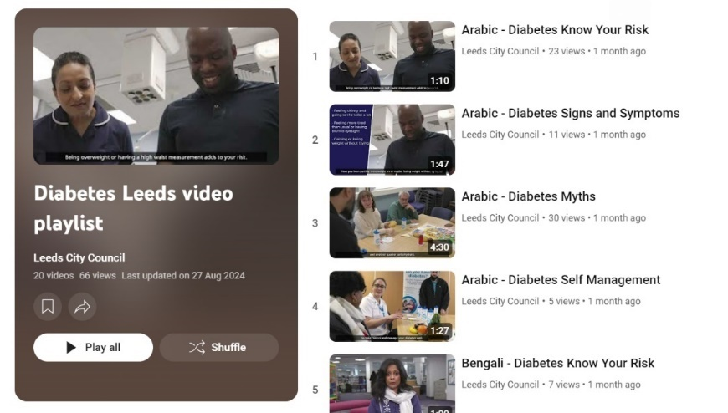
Topics:
- Know Your Risk
- Signs & Symptoms
- Self-management
- Myths
The videos can be accessed via the diabetes Leeds website and here: Diabetes Leeds video playlist
Call to action: Share relevant video link with patients via general practice comms or tailored messages to patients via SMS

- Social Media Resources
These assets are suitable for all social media platforms and practice screens. They are universal and can be used in the context of prevention or management.
You may want to schedule posts to coincide with
- World Diabetes Day: November 14th (2024, 2025)
- Diabetes Week: June (2nd week)
- Hypo awareness week: October (2nd week)
- Diabetes Alert Day: 4th Tuesday in March
Image | Suggested captions
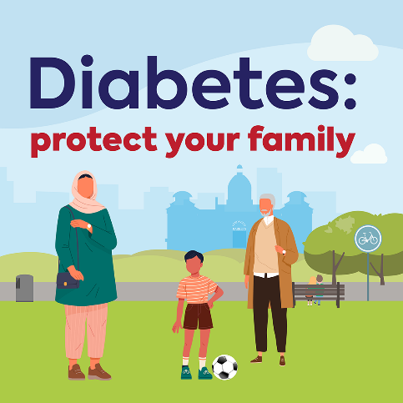 | Post 1:  Did you know you’re 2-6 times more likely to get type 2 diabetes if you have a parent, brother, sister or child with diabetes? Find out if you are at risk by answering a few simple questions on the ‘Know Your Risk’ tool at riskscore.diabetes.org.uk
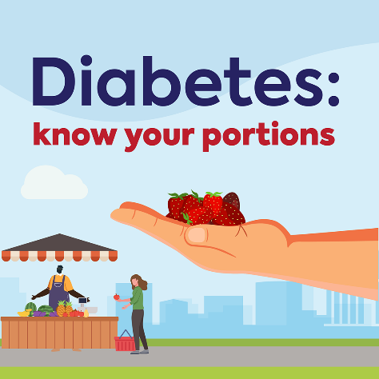 | 🍽️ Struggling with Portion Sizes? We’ve Got You Covered! 🍽️  Getting portion sizes right can be tricky, and it can make managing your weight and blood sugar levels more challenging. Whether you have Type 1 or Type 2 diabetes, staying informed about carb portion sizes is key.  Diabetes UK has created a fantastic guide filled with tips and tricks to help you along the way. Check it out and take control of your health today!  👉 Learn More Here! - https://www.diabetes.org.uk/guide-to-diabetes/enjoy-food/eating-with-diabetes/portion-sizes
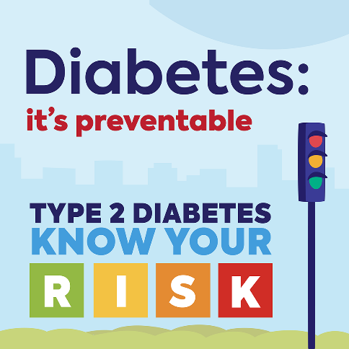 | 🔍 Discover Your Risk of Type 2 Diabetes Today! 🔍  It only takes a few minutes to find out your risk of type 2 diabetes, and it could be the most important thing you do today. Answer a few simple questions on the ‘Know Your Risk’ tool and take control of your health.  👉 Check Your Risk Now at riskscore.diabetes.org.uk
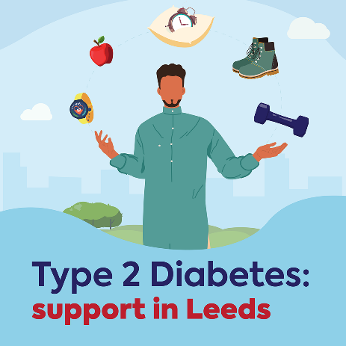 | 🌟 Take Control of Your Diabetes with Support in Leeds! 🌟  Living with diabetes? You have more control than you think! Leeds offers fantastic support to help you manage your diabetes effectively. 💪  Introducing The LEEDS Programme (Learning, Empowering, Enabling Diabetes Self-Management) – designed for anyone with type 2 diabetes and registered with a Leeds GP. Carers are welcome too.  📅 Join Us! Book your place today and find out about the nearest venues and upcoming dates. Let’s take this journey together!  👉 Get in touch now! Tel: 0113 843 4200 lch.leedsprogramme@nhs.net
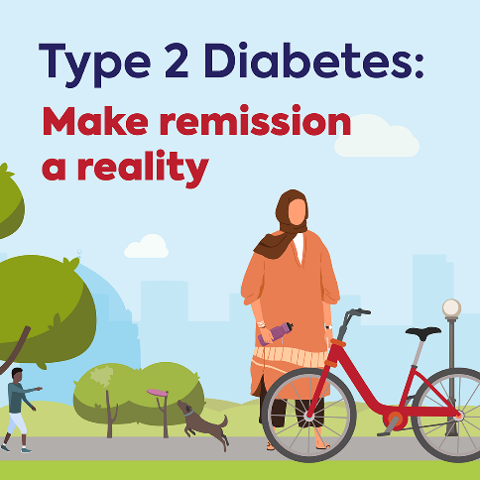 | 🌟 Understanding Diabetes Remission 🌟  Did you know that remission means your blood sugar levels are below the diabetes range, often without needing diabetes medication?  Achieving weight loss can significantly increase your chances of remission, especially if you are living with obesity or overweight. 💪  For more information, visit Diabetes UK. https://www.diabetes.org.uk/diabetes-the-basics/type-2-remission
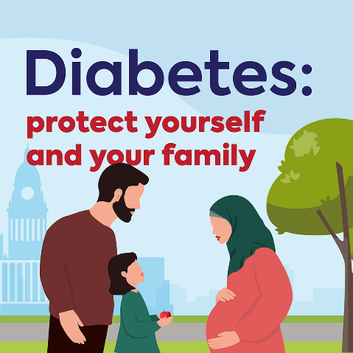 | 🌟 Protect Yourself from Type 2 Diabetes! 🌟  If you’ve experienced gestational diabetes, you have up to a 1 in 2 chance of developing type 2 diabetes. But there’s good news! The Healthier You: NHS Diabetes Prevention Programme can help you protect yourself from this risk. 💪  You can register for the Healthier You programme here: https://healthieryou.reedwellbeing.com/gestational-diabetes/
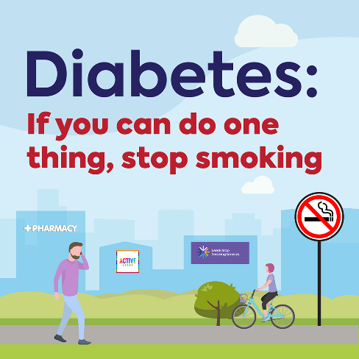 | Did you know that people who smoke cigarettes are 30-40% more likely to develop type 2 diabetes than those who don’t? It’s never too late to quit and improve your health. 🚭  For support and resources, visit Leeds Stop Smoking. https://leedsstopsmoking.co.uk/
- Physical Resources
This poster is available in these formats:
- A3 poster (Order Code: P834)
- Pull-up banner (full sized and table-top)
- Digital screen
Copies of the posters can be supplied and banners can be borrowed from the Public Health Resource Centre by emailing phrc@leeds.gov.uk.
To access the image for the digital screen, visit Diabetes - Leeds GP Confederation
