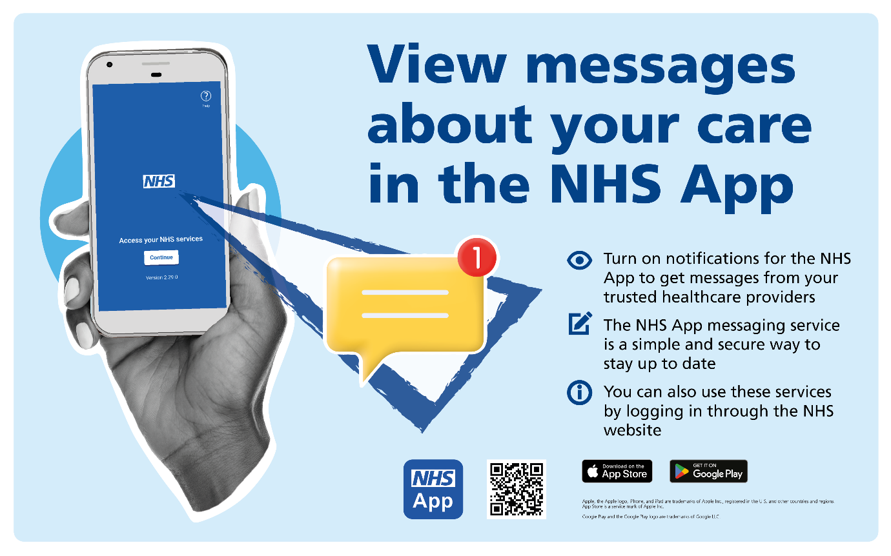
In the NHS App, you can see messages from your health care providers to make sure you get a notification when you have received a new message in your inbox.
Your notification settings need to be turned on in your phone.
To do this, go to your account and select Settings.
Then select Manage Notifications.
Select go to Device Settings.
Select Allow notifications.
Once you've enabled notifications on your device, you need to reopen the NHS App.
Doing this confirms that you have registered to receive notifications.
For more information, go to nhs.uk/nhs-app.

