Social Prescriber Newsletter
November Edition 25


Upcoming Christmas Events for your diary

Apologies for early festivities, but we like to be organised and give you all plenty of notice about any upcoming courses and events. We have dates for our Xmas coffee afternoon and festive wreath making.
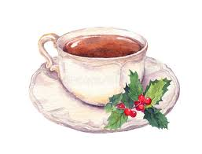
Christmas Coffee Afternoon

Our annual coffee afternoon is approaching; we would love it if you could join us.
We will be holding a Christmas raffle, any donations to the raffle would be much appreciated. All proceeds will be donated to the Alzheimer’s Society.

Non-alcoholic mulled wine, mince pies and festive music

DATE: Monday 8th December

TIME: 13:30- 15:30

VENUE: Cleveleys Health Centre community room 1st floor

Christmas Wreath making course

Nothing says Christmas like putting a hand-made wreath on your front door. With tuition from our teachers, you’ll be creating your own festive wreath, using greenery that you have gathered yourself from your garden or other accessible green spaces.

Learners must provide their own foliage.

DATE: Monday 15th December
TIME: 1:30-4PM
VENUE: Cleveleys health centre community room 1st floor
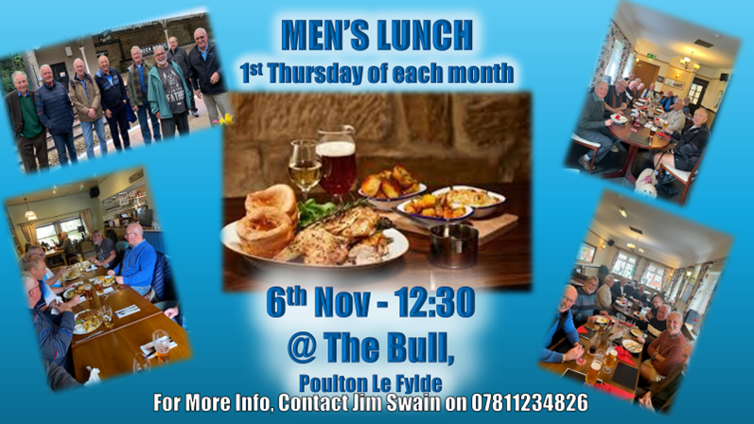
Other local Groups


FUN AND LEARNING

u3a is aimed at people no longer in full time employment who share an interest in, and a love of learning. Join today to make friends and develop new interests in a relaxed environment.


Find out what it is all about at the monthly meetings

VENUE Christ Church Thornton, Meadows Avenue, Thornton Cleveleys FY5 2TW.
DATE: Every second Thursday of each month

TIME: 2pm
Please see website for further information and list of groups available Wyre - Learn, laugh, live

Our next coffee afternoon will be Monday 3rd November @1:30pm @Cleveleys Practice
Guest speaker Marie Currie from Wyre u3a will be attending to talk about the groups in more detail. Please RSVP, If you can attend 01253 204171

