

How to take an accurate BP (Blood Pressure) reading
- In order for it to be an accurate reading it’s important that you’re resting and that you’re not feeling anxious or stressed.
- Sit upright in a chair, your back against the back of the chair, and place your feet flat on the floor.
- Rest your arm on a table if you have one and just make sure your hand and arm are relaxed on the table. It’s important that you don’t clench your fist when you’re taking your blood pressure.
- Place the cuff over your upper arm and tighten the cuff over your arm, making sure you can fit two fingers underneath the cuff. You want the cuff to be over the upper part of your arm with the tubing leading down the centre or slightly to the right of your arm.
- When you check your blood pressure, don’t talk and just relax. Press the on button, and then press the start button.
- You’ll feel the cuff inflate quite rapidly. It may temporarily be a bit tender or uncomfortable as the cuff inflates and deflates automatically, but this will only be for a short period of time. If it is too tender/uncomfortable you can just press the ‘Stop’ button and the cuff will instantly deflate.
- Once you get your reading, make a note of the reading on your form.
- A few minutes after you’ve taken your blood pressure, it’s a good idea to check it again, to make sure the readings are similar and accurate.
- Repeat the process twice a day for 4 days morning and night, when complete please return the form and monitor to the surgery.
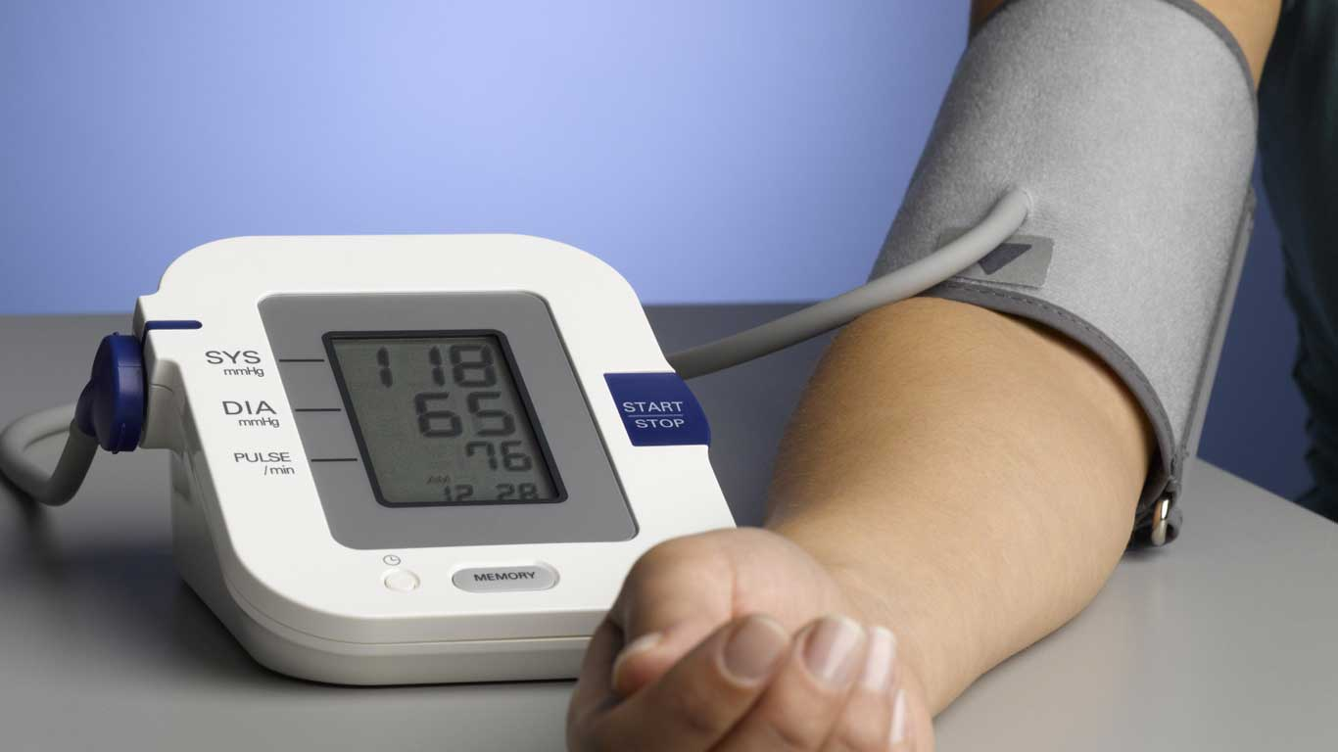

Monitoring Form

This is to be completed for at least 4 consecutive days and reported back to your GP Practice using the agreed method. This can be returned to the surgery via post, text or email.

Please note: If you record consecutive BP readings over 170/115 mmHg, you should contact the GP practice for advice.
Name: ___________________ NHS No.: ____________________
Date of Birth: ____/____/____
Address: _________________
Date | Time | Top Number (Systolic) | Bottom Number (Diastolic) | Pulse Rate/number (If Applicable)
e.g | (am)  8am | 130 | 78 | /70
e.g | (pm)  9pm | 145 | 86 | /82
Day One:
 | (am)
 | (pm)
Day Two:
 | (am)
 | (pm)
Day Three:
 | (am)
 | (pm)

Date | Time | Top Number (Systolic) | Bottom Number (Diastolic) | Pulse Rate (If Applicable)
e.g | (am)  8am | 130 | 78 | /
e.g | (pm)  9pm | 145 | 86 | /
Day Four:
 | (am)
 | (pm)
Day Five:
 | (am)
 | (pm)
Day Six:
 | (am)
 | (pm)
Day Seven:
 | (am)
 | (pm)
Comments:

Useful Contacts & Information

If you have any problems with your monitoring equipment, or any questions about the monitoring requirements / monitoring form, please contact your GP Practice who will be able to assist you.

If you need assistance on managing your blood pressure at home, the following links offer assistance and helpful videos:

Tool or resource | Description | Format
West Yorkshire and Harrogate Healthy Heart | Local resource for patients on understanding Blood Pressure, with links to relevant sites and videos.  https://www.westyorkshireandharrogatehealthyhearts.co.uk/blood-pressure | Webpage
How to measure blood pressure at home - video | Video of a BHF senior cardiac nurse demonstrating to patients how to measure blood pressure at home.  https://www.bhf.org.uk/informationsupport/support/manage-your-blood-pressure-at-home#measure | Online video
High blood pressure and coronavirus | BHF medical experts answer questions about how COVID-19 can affect people with heart disease, including hypertension.  https://www.bhf.org.uk/informationsupport/heart-matters-magazine/news/coronavirus-and-your-health#Heading2 | Webpage
Six tips for reducing blood pressure | Tips to help reduce your BP or control it following a diagnosis of BP.  https://www.bhf.org.uk/informationsupport/heart-matters-magazine/research/blood-pressure/blood-pressure-tips | Webpage
Understanding blood pressure booklet. | Booklet for people with high BP to help them understand the condition. Includies information on what high BP is and how to reduce it.  https://www.bhf.org.uk/informationsupport/publications/heart-conditions/understanding-blood-pressure | This is available to download or to order in print.
Manage your blood pressure at home hub | Central hub for all resources for high BP.  https://www.bhf.org.uk/informationsupport/support/manage-your-blood-pressure-at-home | Webpage

Additional Support
Abuse or neglect can often be prevented if concerns are raised as early as possible and in Leeds we call this early intervention.
If you or another person have been hurt, or made to feel unsafe or scared, it is important that you tell somebody you trust so that you can get the support and protection required. All healthcare practitioners have a responsibility to protect the people they work with from harm. You can also self-refer to any of the services below.
Adult services support people aged 18 years and over, with care and support needs. Adult social care can be contacted where there is an identified care need and to report abuse. More information can be found here: https://www.leeds.gov.uk/adult-social-care. Tel. Mon-Fri: 0113 2224401 / Out of hours: 0113 3780644.
Children’s services support children and young people, along with their families, up to the age of 18 years. More information can be found here: https://www.leeds.gov.uk/residents/health-and-social-care/keeping-children-safe. Tel. Mon-Fri 9-5: 0113 3760336 / Out of hours: 0113 5350600.
Leeds Domestic Violence Service supports anyone experiencing domestic violence and abuse. https://ldvs.uk/ 24hr Helpline: 0113 2460401.
Carers Leeds. https://www.carersleeds.org.uk/ Advice line Mon-Fri 9-5: 0113 3804300.

Feedback
If you have 2 minutes to spare, we’d really appreciate hearing your thoughts and ideas on how to improve. All answers are anonymous and will be used to help with the work around this programme going forward.

https://www.surveymonkey.co.uk/r/2RT6T6Q

