

LEAMORE GP
BLOXWICH
WALSALL
WS3 1ET
01922475015
www.leamoregp.co.uk
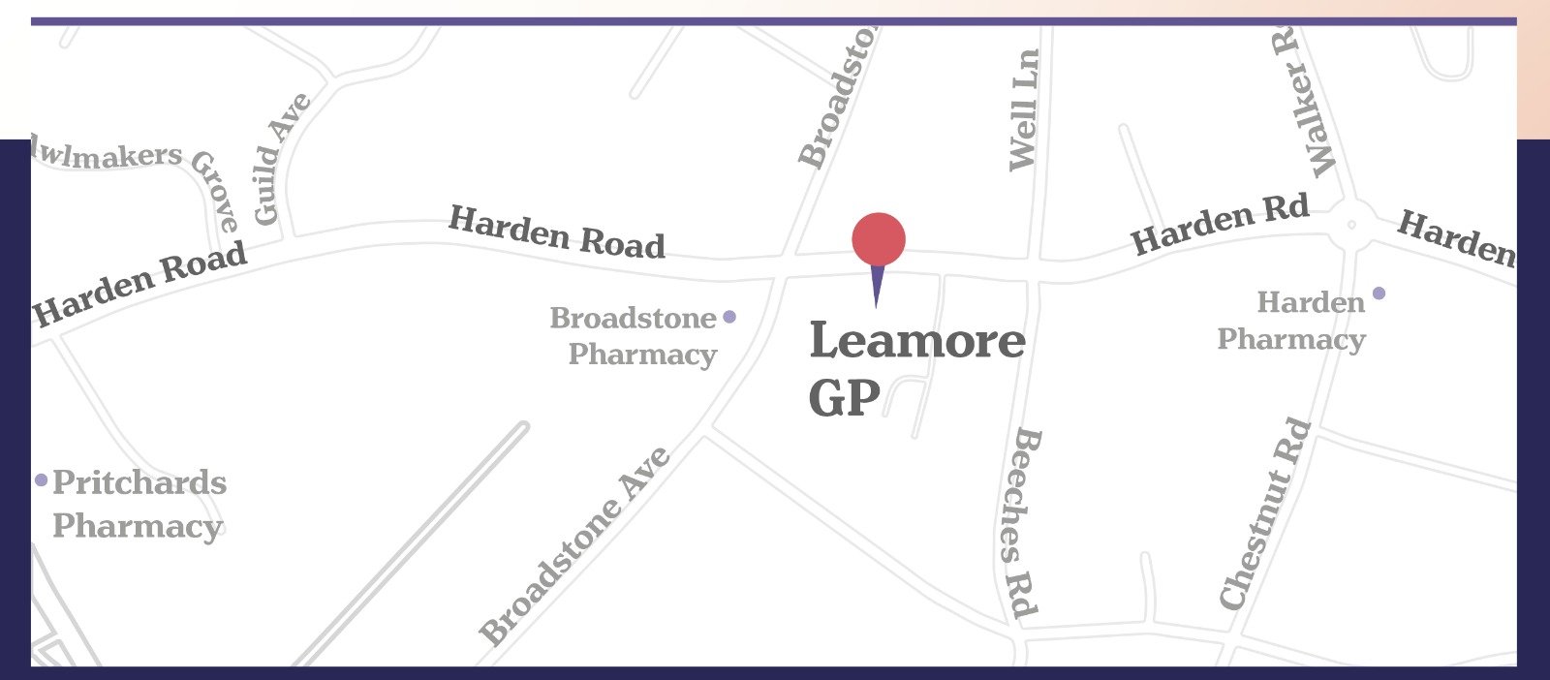

Leamore GP is a family-friendly GP Practice (NHS) serving population of Leamore, Blakenall & Bloxwich in Walsall.
The Practice is situated in modern purpose-built premises named Harden health centre. Three pharmacies are located in close proximity (within walking distance).
Ample free parking is available on site. Practice is a disability and wheelchair-user friendly.
GP Partners
Dr P L Kaul ( Male) MBBS
Dr S Kaul (Male) MBBS
Dr S Malhotra (Female) MBBS MRCGP (2017) DRCOG

Locum GP’s
- Dr Raiyna Dhinsa
- Dr George Abraham
- Dr Mary

Clinical Team
- Pradeep Prabhu (ICB pharmacist)
- Shalini Aggarwal (Practice Pharmacist)
- Susan Webb (Advanced Nurse Practitioner)
- Lorraine Hyde (Health Care Assistant)
- Elaine Richards (Advanced Nurse Practitioner)
- Cheryl Hinks (Practice Nurse)

Admin Team
- Varindra Panchhi (Practice Manager)
- Bridget Porter (Practice Secretary)
- Salma Arshad (Administrator)
- Debra Wooldridge (Senior Receptionist)
- Susan Steptoe (Receptionist)
- Michele Bayliss (Receptionist)

A variety of Primary Care Network staff which may include pharmacists, Social Prescribers, Paramedics, Physiotherapists and First Contact Mental Health Practitioners.
Community teams (on-site)
Midwife – Samantha Pailing
Diabetic Nurse- Rebecca Overton
Social Prescriber – Charlene Reece
Physio –Cindy
Surgery Hours
Monday 08:00 -18:30
Tuesday 08:00- 18:30
Wednesday 08:00- 18:30
Thursday 08:00-18:30
Friday 07:15 – 08:00 *
08:00- 13:00
**13:00- 18:30 **
*Extended hours
** Covered by Ournet -Please call 01922 501999
Additional GP Appointments are available by self-referral from 08:00 am onwards on weekdays and 10:00 on weekends via Ournet (01922 501999)
Clinic times
Weekdays 18:30 to 21:00
Weekends 10:00 to 15:00
Bank Holidays 11:00 to 13:30

Essential Contact Details
- PALS (Patient Advocacy and Liaison Service – 01922 656463
- Walsall Healthcare NHS Trust- 01922 721172
- Dudley and Walsall Mental Health Trust – 01922 607000
- Dental – Emergency Dentist Walsall- 01922 684421
- Dudley and Walsall Mental Health Trust- 01922 607000
- Drug and Alcohol Help (Beacon)- 01922 669840
- Family Planning and Sexual Health – 01922 270400
- NHS Go Smoke-Free- 0300 121044
- IRIS (Domestic Violence)- 01922 649569
- Walsall Bereavement Services- 01922 724841
- Walsall CCG – 01922 618338
- Walsall Registry Office- 01922 652268
- 24/7 Mental health Helpline- 08000086516
- New Cross Hospital-01902 307999

Training Practice
Leamore GP hosts 1st-year Medical students from Aston University on a regular basis.
Please speak to the receptionist if you prefer not to have a student present during your consultation.

Patient Registrations: How to Register?
Leamore GP accepts new patients who live in the catchment area.
Please see the website to check if you reside within the Practice boundary. https://www.leamoregp.co.uk/.
If you wish to register with the practice, please complete the registration forms that are available at the reception. Registration forms are also available to download from the website.

Services Provided:

Essential Services: Management of Chronic Illness, Management of patients who are terminally ill.
Additional Services: Cervical screening, Contraceptive services, Vaccination and Immunisations, Child health surveillance
Enhanced Services: ECG, Coils and Implants, Treatment room including wound management, suture removal, ear syringing, Zoladex injections, Near Patient Testing, Shared care drugs, NHS Health checks, Phlebotomy.

Chaperones:
A chaperone is an impartial observer present during an intimate examination of a patient. He or she will usually be a health professional who is familiar with the procedures involved in the examination. The chaperone will usually be of the same sex as the patient.
We respect your privacy dignity and your cultural and religious beliefs. If you would like a chaperone during your consultation, please ask at reception.

Interpreters:
It is imperative that no matter what language you speak, that every member of the public within the UK has equal access to public services. This may mean healthcare, social care and or education because it is your right.
If English is not your first language, please don’t worry ask a member of staff who will be happy to arrange this for you when booking your appointment so this can be arranged.

Named GP:
All registered patients will be allocated a named GP, though you may choose to see the practitioner of your choice.

Home Visits:
Home visits can be requested if the patient is on the Palliative register or housebound. We cannot visit you if you reside outside the practice boundary.

Repeat Prescriptions: Please note that in view of the demand on telephone lines we cannot accept prescription requests by telephone unless the request is for medicine to support palliative care/end of life.
There are many ways to request the prescription like:
- Online, via the NHS App.
- Bring your request into the practice and place your request in the box at the front door in the entrance area as the prescription box is located there.
- Request from your local Pharmacy.

Please allow for 48 hours (2 working days) for collection. If you leave a prescription request on a Friday morning, then it may not be ready for collection until Monday evening.

Comments & Complaints: The Practice has in place a ‘practice-based complaints system’.
If you wish to complain or have any suggestions positive or negative, please contact the Practice Manager (Varindra Panchhi) by phone or in writing if you prefer.
Please refer to our Complaints Policy for further information

Rights & Responsibilities of Patients: Patients have a responsibility towards the practice in terms of:
- Arrive on time for their appointment. Patients that are more than 10 minutes late may need to re-arrange their appointments.
- Inform the practice in advance if they cannot make an appointment or they no longer need the appointment.
This allows the practice to offer the appointment to another unwell patients.
- We request you not to make a request for home visits, unless absolutely necessary and the patient must either be housebound or palliative. If possible, any home visit requests must be made before 11 am and the request will be triaged by a clinician.
- Co-operate will the practice staff and give them the same level of courtesy that you would expect to receive yourself.

Violent and Abusive Patients: We do not tolerate any form of verbal or physical abuse, bullying or any other form of intimidation/threats.
Any patient displaying behaviour of this nature towards staff, doctors or other patients, will be removed from the list with immediate effect.
Access to Patient Information:
In order to provide care for you, we are obliged to keep records. We are obliged to comply with the GDPR General Data Protection Regulations, Data Protection Act 2018 and other guidance on privacy and data confidentiality.
In order to manage services and improve the quality of care we offer to you, we are required to share some information with the Clinical Commissioning Group (CCG) and the hospitals as well.
Information is not shared with any third party outside of the health service like insurance companies without the patient consent.

Non-NHS work includes:
Fees are always payable for medical services not covered by the NHS. If you require any of the following to be completed by the doctor, please be advised that there will be a fee payable for this type of service.

- Council tax exemption forms
- DVLA factual reports & Forms
- DWP/ATOS factual reports
- Employer/Occupational health reports, letters or forms
- Fostering or adoption forms
- Holiday cancellation forms
- Insurance Company reports (for life assurance, critical illness cover, etc.)
- Police requests for information in relation to Firearms/ Shotgun License

Please do not book a clinician appointment in the first instance regarding any forms or queries. Please contact the Practice Secretary, who will then pass on your query/forms to the clinician if needed.
Please allow 28 working days for the request to be completed. The secretary will call you when the doctor has completed your request. Please make sure that we have your correct contact details.

Patient Participation Group (PPG)
You can have your say!
All patients are welcome and encouraged to join our regular series of Practice Participation Group meetings.
Please contact the reception desk if you would like to join the group.

