Health Advice  Patients are encouraged to share the responsibility for their health both in preventing diseases or managing long term conditions. Many serious diseases can be prevented by changing to a healthier life style including diet and exercise. For more information on how to embed this in your day to day life style please speak with one of our reception team who will put you in touch with the right clinician.  Suggestions and Complaints  We try our best to provide high quality services and we welcome your suggestions and comments to improve and maintain these services. Should you wish to complain please speak with one of the team member. Complaints should be addressed to the Practice Manager or advice can be obtained from the Patients Advisory Liaison Service (PALS)NHS ENGLAND  NHS ENGLAND, PO Box 16738, Redditch, B97 9PT  Tel: 0300 311 22 33 OR CLICK  Patient Advisory Service LOCAL to you  NHS Zero Tolerance Zone  You have a right to be treated with respect and courtesy and so do we. We operate NHS Zero Tolerance Policy towards verbal or physical violence and abuse. We ask that you treat your GP and Practice Staff with consideration. Violent and abusive patients will be reported to the police and removed from the Practice List.  Rights and Responsibilities of Patients  Cedars Medical Centre is a Training Practice, therefore appointments may be offered with any qualified Doctors. Patients can choose to see a specific Doctor but they may have to wait for up to 2 weeks. They have a right to be treated fairly on the basis of need and not discriminated against on the basis of race, age, sex etc. Patients have a responsibility in keeping appointments, to arrive on time and if unable to keep appointments to inform the Surgery, so that someone else can use this appointment. Please inform the Surgery if you change your address or telephone number. We kindly request patients to switch off their mobile phones while attending surgery/consultations.  Use of Personal Information  Practice adheres to Data Protection Act 1998 Policy. All the personal health information is held in a secure manner. No personal health information is shared with a third party without patient consent. Please refer to the Practice website for further information. |  | Fees  Fees are required for certain non-NHS Services provided  by the Practice. These include private prescriptions, some  vaccines for travel, driving licenses and certain medical examinations, reports and letters. Please ask at reception for further information.  Confidentiality  All consultations and medical records are treated as confidential (regardless of age) by all members of the Primary Care Team.  No care or treatment will be given without the patient’s informed consent. Access to patients’ records is limited to those directly involved in patient care. We do not disclose patient identifiable information to any outside Agency without the patient’s consent or agreement. Statutory rights of access apply under the Data Protection Act.  Data Protection  For more information, please visit  Guide to the UK General Data Protection Regulation (UK GDPR) | ICO  OTHER TEAM MEMBERS  Administrator  Jayne England, Anna Rynkiewisz & Tak Ling Tsui  Receptionists/Admin  Alpana Patel, Diksha Shanker, Lobella De Freitas  & Samantha McLellan  Health Care Assistant &  Trainee Nurse Associate Nandika Dhawan  PRACTICE BOUNDARIES  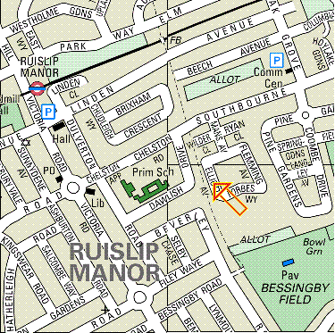 |  |  | 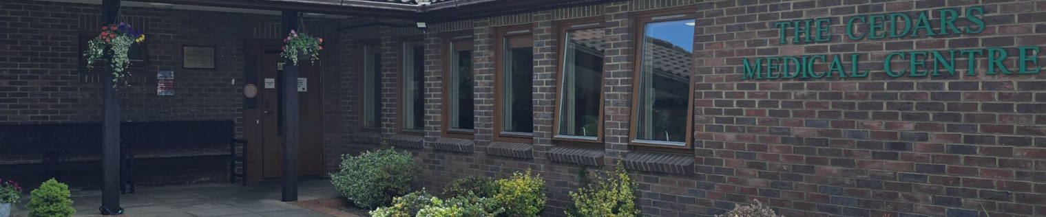  CEDARS MEDICAL CENTRE  118 Elliott Avenue  Ruislip  Middlesex  HA4 9LZ  020 8429 9595  Website: https://www.cedarsmedicalcentre.co.uk/  OOH  Access to the service is via the National 111 services  General Practitioners  Dr Ritu Prasad (Senior Partner)  Dr Vethuran Somas (Partner)  Dr Aman Gajree (Partner)  Dr Kinnari Joshi (Partner)  Practice Manager  Mohammed Anis  Practice Nurse  Mrs Nellie Nyoni (Senior Nurse & IPC Lead)  Eliza Grace Samson (Practice Nurse & Immunisation Lead)  Salaried GP  Dr Dhashi Thanapal
 | WELCOME TO OUR PRACTICE  Cedars Medical Centre is a Training Practice. The Practice is housed in purpose built premises which has been extended to provide facilities for training Medical Students and qualified Doctors. We have a strong and friendly Practice team. Our staff have been with us for a number of years and contributed to the development of the Practice. We aim to continue the tradition of providing the highest standard of quality care to you and your family.  HOW TO REGISTER  You are welcome to join the Practice, provided you  reside within the Practice boundaries. Please seek information on how to register from the practice reception team.  SURGERY HOURS  The surgery is open from 8:00am - 6:30pm Monday-  Friday Please note that these are not the clinic times. Please visit our website for more information https://www.cedarsmedicalcentre.co.uk/  APPOINTMENTS  We operate a total triage system of booking appointments. To manage our online triage and consultation system we use a system called PACO GP Blinx. Please visit our website at: https://www.cedarsmedicalcentre.co.uk/ and click ‘Blinx online consultation request’ found on the yellow banner on the home page. If you cannot keep your appointment, please let us know immediately as there are other people awaiting appointments that could benefit from your cancellation or use the booking link sent to you to reschedule or cancel your appointment. Please note minor ailments such as a cold, cough etc., we advise patients to visit their local pharmacy first for OTC assistance.  PLEASE NOTE- You can download and register for the NHS App. You can use the NHS App to request your repeat medications, see the status of your prescription request, access health records, receive notificationsfind help when the practice is closed, see the status of your hospital appointment and a range of other services, advice and guidance.  Disabled access and facilities available |  | Telephone Advice  If you wish to speak to a member of the medical team  Please call on 020 8429 9595 between 12:30pm and 1:00pm.  Home Visits  Please contact the surgery before 11:30 am on 020 8429 9595. Details will be taken to the GP to assess the urgency and priority of the visit. Please note you may be advised to book an appointment to see the GP at the Surgery after assessment by them.  PPG (Patient Participation Group)  We have established a PPG for our Practice and are actively involved with them for ongoing improvement. For more information, please contact Denise our PPG Lead.  FFT (Friends and Family Test)  The NHS friends and family test (FFT) was introduced in GP practices on December 1st 2014. It is an opportunity for our patients to provide feedback on the services provided by the Practice relating to their care and treatment. This can be undertaken by completing the FFT form which is available at reception, the findings of which are presented and discussed with our PPG with the view to improving services. Please visit our website and see the latest survey results of the FFT.  Repeat Prescriptions (Regular Medication Only)  We encourage online requests using the NHS App, however we also accept requests in writing or simply ticking the items on computer generated repeat prescription slips. Please allow 72 working hours before collection. This can be posted if you provide a stamped self addressed envelope. REQUEST FOR REPEAT PRESCRIPTIONS WILL NOT BE ACCEPTED OVER THE PHONE TO AVOID ANY ERRORS. PLEASE COME FOR YOUR MEDICATION REVIEW AS SOON AS IT IS DUE to avoid any delays in processing prescriptions.  Change of Details  It is vital that we have your correct details on our clinical system to provide care in an efficient and timely manner. Please inform us of any changes i.e. telephone number, mobile number, e-mail ID, change of address etc as soon as possible.  Named Accountable GP- All patients registered with Cedars have a named accountable GP.  Clinics and Services  NHS Health check  We also offer NHS Health Checks to patients’ who are eligible for one. Please ask reception or speak to our HCA for further information.  Well Baby/Immunisation  Immunisations are given by the Practice Nurse or by a GP via a pre-booked appointment. WE REQUEST YOU TO KEEP THE APPOINTMENT TIME/DAY unless THERE IS AN EMERGENCY. It is important that all babies and children are immunised. | Post-Natal  Post Natal examinations are carried out by the GP at 8 weeks together with baby checks and you will be contacted at the relevant time by one of our staff members.  Minor Surgery  Please contact the Practice for more information.  Family Planning, Well Women Screening, Smears and HRT  We offer a range of contraceptive services including IUCDs and emergency contraception. Cervical smears and well woman checks including pre conceptual advice & HRT are done during normal surgery hours by appointment.  Well Person Checks  All patients are offered a health check. If you are between 16-74 years of age a health check is available every three years, if over 75 years this is offered yearly. All checks by appointment.  Chronic Disease Management  This includes Diabetes, Asthma, Coronary Heart  Disease, Hypertension, TIA/Stroke, COPD, Epilepsy, Mental Health, Cancer and Obesity. Early detection and  appropriate management can reduce the risk of  complications. We proactive contact patients when they are due for their checks.  Travel advice and vaccinations  If traveling abroad, vaccinations and malaria prophylaxis may be required. You will be required to complete the travel questionnaire before booking an appointment with a Practice Nurse at least 6-8 weeks prior to travel  In-House Phlebotomy / ECG and 24Hr BP Monitoring  We offer in-house blood test service, ECG and 24hr BP monitoring services to patients registered with Cedars Medical Centre  Primary Care Network  Cedars Medical Centre is a part of CelandineHealth&MetroCare PCN. We are a group of 11 Practices working collaboratively to provide joint up services. For more information please visit  https://www.england.nhs.uk/primary-care/primary-care-networks/

