VDJR
Newsletter

Green Valleys Health
Abbotswood, Emersons Green and Leap Valley surgeries

Autumn 2024


What’s new?


Notification of test results

We have changed the way we communicate with patients after a blood test. We will be texting you with a “normal” result, to save you from calling the practice. If you have an up-to-date mobile number and have consented, you will start receiving messages: We would like to stress, if you have not been contacted, it DOES NOT mean your tests are abnormal. If something needs to be done, the practice will contact you in a timely manner. Your results will also be available via Patient access or the NHS app if you are registered for this.
Call back service
We have now had our new telephone system installed. You will now have the option to have a call back from our receptionist, instead of waiting in the telephone queue and you also have the facility to go straight through to other departments. Just listen carefully to the message. To receive a call back press option 1 for Appointments and the facility will be available if you are on hold for longer than 3 minutes; you will be called back in the same queue position. This option is not available if you have a withheld number.

- Missed appointments 
In the last few editions of this Newsletter, we have reported on the number of missed appointments. This is booked appointments where the patient hasn’t let us know that they are unable to attend, thus freeing it up for another patient.
Following feedback from patients concerning the difficulty of getting an appointment we are continually looking at different ways to improve this.
In July we had 224 missed appointments - equating to 60 hours. This has compelled us to try and reduce this. We have therefore set up a new protocol. A letter will be sent to patients that have missed an appointment and will explain how easy it is to cancel it and remind you of the benefit of doing so for other patients. Further letters will go out for patients that continue to miss their appointments.
In accordance with National Health Service policy, although we cannot charge for wasted surgery time, under their guidelines, patients that continually miss their appointments may not be entitled to further treatment through this practice and action may be taken accordingly.



Website: www.greenvalleyshealth.nhs.uk
Tel no: 0117 9576470
Facebook: Green Valleys Health

Meet the team- a few facts
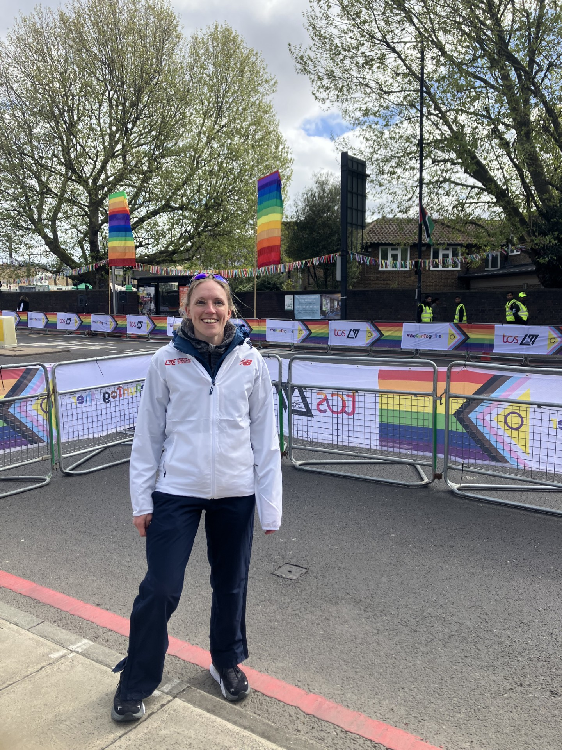
I am Emma Downie, one of the FCP’s (First Contact Physios) based at GVH (Green Valleys Health).
- I joined GVH three and half years ago, having come from North Somerset previously.
- I was around 18 years old when I decided I wanted to become a Physio. I wanted a medical career where I could help people without performing operations!
- The most enjoyable part of my job is being able to empower people to understand their conditions and manage them.
- The most common condition that we see as an FCP is knee arthritis. To prevent knee arthritis, I would recommend that patients remain active and manage their weight.
- I enjoy running and cycling and have just started completing triathlons.
- The above picture was taken when I attended the London Marathon, providing Physio support to the runners.
- As a reminder, the FCP’s have a lot of resources available to patients, they have good contact with the GP’s and are good at listening. Even if a patient has already previously seen a Physio.

Your questions answered.
We get regular feedback from our patients. Here are answers to the main questions we get.
Why do you run out of appointments so quickly?
Demand for appointments, over the years, has become greater. In previous years for example there was less Diabetes, ADHD and mental health awareness. People are also living longer so chances of developing illnesses within lifetimes have increased. Unfortunately, we do not have the resources to employ more clinicians and our current clinicians have full clinics.
Why do I have to tell a Receptionist my symptoms, they are not medically trained?
We need to ensure our patients are directed to the right source to get the best care possible. Our GP’s have devised a protocol for our Receptionists to follow. This involves the Receptionist asking a number of questions to be able to triage our patients correctly. If you wish to speak to a Receptionist in private then just ask.
I’ve had a blood test. Why haven’t I heard from you about the results?
See the article on the previous page
Can you chase the hospital for my referral?
Once a referral has been made our patients are normally provided with contact details for them to communicate with the hospital themselves. Our doctors can only send an expedite letter should there be a notable change in symptoms, a GP appointment will be required for this.

Thank you!
Thank you to Catherine Lombardo, one our PPG volunteers, and to other anonymous donators who very kindly raised funds to purchase a new fridge for our Leap Valley surgery. Much appreciated.
Coming soon…..
We have 2 Phlebotomists joining us in the next few months.
Text messages are going out to invite eligible patients for Covid/Flu vaccinations, with a link to book. No need to contact us, just wait for your invite.

MEET THE TEAM

Website: www.greenvalleyshealth.nhs.uk
Tel no: 0117 9576470
Facebook: Green Valleys Health

