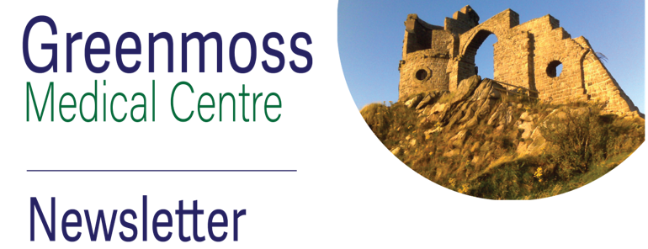
Patient Newsletter edition 26: September 2025

Deaf and sensory network (DSN)
DSN supports people who are deaf or deafblind in Cheshire. Their mission is to create a world where people with sensory loss can communicate effectively and live healthy, independent and fulfilling lives.
DSN will be at Greenmoss on Wednesday 17th September 2025 from 1pm – 3pm. They will have their information bus on our car park where you can find out more and also have a look at some of the equipment available – some of which is free. Please come along to find out more – no need to book.
Free events at Greenmoss
Dementia awareness information session – Monday 8th September 10.30am – 12noon
Please contact Janet.weaver@nhs.net to book a place or call in at Reception.
Samples
Please ensure that any samples being brought to the Practice for testing are with us before 1pm. Any brought in after this time may have to be discarded.
Flu and covid vaccinations
We are offering flu and covid vaccinations from early October for eligible patients. The NHS criteria this year is:
Flu only: aged 18-65 and clinically at risk or aged 65 - 75
Flu and covid: 18 – 75 and Immunosuppressed or aged 75 and over
We will contact you to book an appointment.
Practice closure dates

We are closed one afternoon each month (except August and December) for staff training. We close at 1pm and re-open the following morning. The remaining dates for this year are:
Tuesday 9.9.25
Wednesday 8.10.25
Tuesday 4.11.25
These are also advertised in the Practice.
Be more digital
We encourage patients to engage with us digitally:
Website: www.Greenmossmedicalcentre.nhs.uk
For information about the Practice and health-related topics.
Facebook:
Greenmoss Medical Centre | Stoke-on-Trent | Facebook
For current information and events held at the Practice.
If you are struggling to access us digitally, please get in touch via phone or in person and we will try and help.

Surgery Statistics for July 2025
