.
How to pass on a complaint.

We hope that most problems can be sorted easily and quickly, often at the time they arise and with the person concerned.
All written and verbal complaints made to the practice will be acknowledged within 3 working days unless it is resolved to the patient’s satisfaction by the end of the next working day.

Complaints should be addressed to:

Chris Moreton (Practice Manager)
or to:
Dr Hill (Senior Partner)

Alternatively the patient may ask for a complaint form, from reception, or request an appointment with the Practice Manager in order to discuss their concerns.
A complaint must usually be made within 12 months of an incident happening.
What we will do:

We will acknowledge receipt of the complaint within 3 working days and agree a time scale for investigating with the complainant.
We will aim to:-
• Establish what happened and what went wrong
• Make it possible for the complainant to discuss the problem
• Make sure the complainant receives an apology where this is appropriate
• Identify what we can do to avoid the problem recurring.
• Send the complainant a written response as soon as reasonably practicable after completing the investigation. This is usually within 28 days, from the receipt of the complaint.

Possible complaint next steps.
If the complainant feels that the matter has
not been resolved to their full satisfaction, they have a right to take the complaint to, any of the following:
-ALS and Complaints (South Cheshire CCG)
Bevan House
Nantwich
CW5 5RD
Tel: 01270 275390
complaints.nhssouthcheshireccg@nhs.net
Merseyside & Cheshire HealthWatch
(free independent service)
Tel: 0808 801 0389
merseysideandcheshire@healthwatchadvocacy.co.uk
-CB, MHS Cheshire and Merseyside.
Patient Experience Team,
No1 Lakeside,
920 Centre Park Square,
Warrington,
WA11QY.
Tel: 0800 132996
enquiries@cheshireandmerseyside.nhs.uk
-ICAS (Independent Complaints Advocacy Service)
North West
0808 802 3000 or
www.carersfederation.co.uk
Health Service Ombudsman
Millbank Tower
Millbank
London
SW1JP 4QP
Tel: 0345 015 4033
Phso.enquiries@ombudsman.org.uk
Care Quality Commission (CQC)
Citygate, Gallowgate
Newcastle upon Tyne
NE1 4PA
Tel: 03000 616161
enquiries@cqc.org.uk
Please note, complaints about care received from Mid Cheshire Health Trust (Leighton Hospital, VIN or Elmhurst) are directed to Customer Care Team, Leighton Hospital/ VIN Tel: 01270 612410
Email: customercareteam@mcht.nhs.uk

Complaint on behalf of someone else:

We keep strictly to the rules of medical confidentiality. If someone is complaining on behalf of a patient, the practice needs to be satisfied that there is reasonable ground for this method of representation, and that the third party is genuinely acting in the best interests of the individual and has their written consent (unless there is incapacity through illness).

Compliments or complaints about our service
Haslington Surgery

Haslington Surgery is a partnership providing NHS Services under an NHS England General Medical Services Contract.

Crewe Road, Haslington, Cheshire. CW1 5QY.

Telephone No.01270 275900

Website:
www.haslingtonsurgery.nhs.uk

GP services are provided
to the following areas:

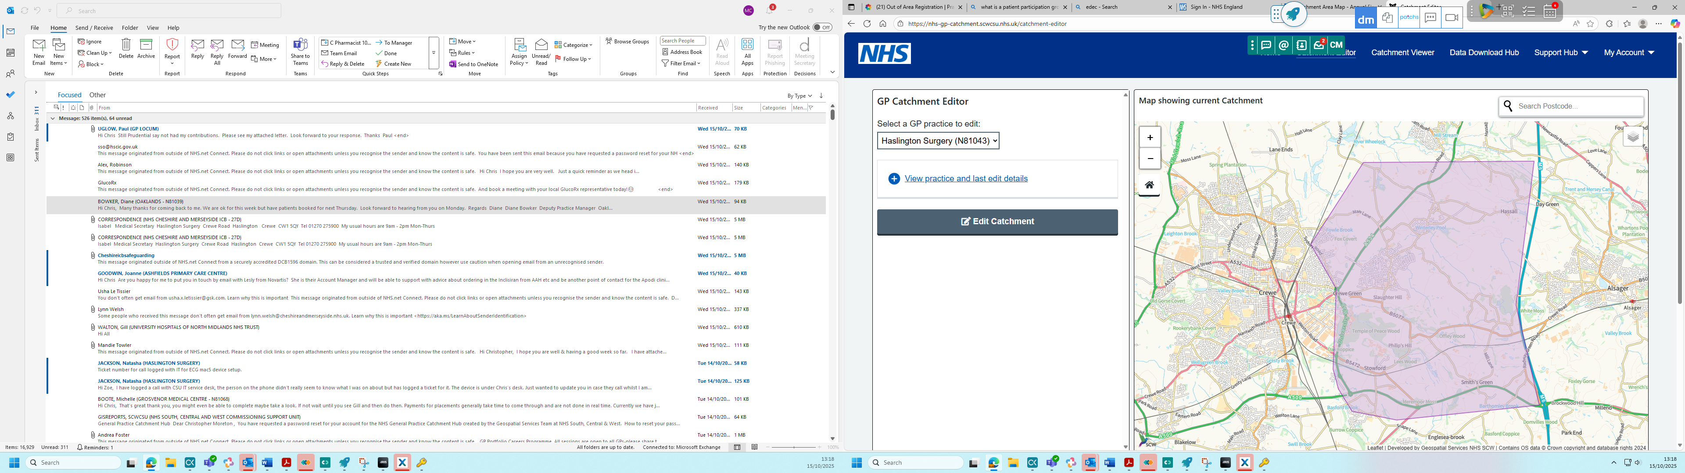
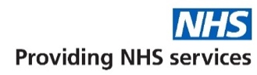

Further information can be sought from www.nhs.uk

The practice team:
Partners
]Dr Jonathan Hill
MB ChB University of Manchester.
Full registration: 1990, Male.

Dr Anthony Entwistle.
MB ChB University of Liverpool.
Full regustration: 1991, Male.

Salaried GPs
Dr Elisabeth Findlay-Domes
MD LRCP LRCS LRCPS.
Full registration: 1996, Female.

Dr Paul Uglow.
MB BS University of London.
Full registration: 1999, Male.

Dr Almas Kashif
MB BS 2006 University of Karachi.
Full registration: 2011, Female.

Nurses
Gillian Hughes, Laed Nurse.
Registered 03/01/1988, Female.

Zoe Poynton, Practice Nurse.
Registered 20/07/2021, Female.

Natasha Jackson, Nurse Associate.
Registered 01/10/2024, Female.

Practice Manager
Chris Moreton, B.A. (Hons), PGCE, MPMA.

Our
Mission Statement:

Dedicated to providing
a high quality caring service
to all
our
patients.

How to pass on a compliment.

We are happy to receive feedback in many ways.

This could be through:

Friends and Family feedback, where patients are sent an sms message following an appointment with the clinical team.

By letter.

Using the annual patient surveys.

Verbal feedback to the team.

We really appreciate your feedback!

Could you please provide as much detail as possible, including staff names, involved in your care on the day in question.
This information will be used to guide best
practice in the Surgery and for the development of staff members.
We feel that this is a very useful and important tool for the Surgery.

Compliments should be addressed to:

Chris Moreton (Practice Manager) .
or:
Dr Hill (Senior Partner).

