.
Opening hours
Mon – Fri 8am to 6:30pm
Extended hours.
We deliver extended hours surgeries on some evenings and Saturday mornings. Please ask at reception for more information.
Our
Mission Statement:

Dedicated to providing
a high quality caring
service to
all our
patients.

Teaching practice
The practice is a teaching practice and occasionally trainee Nurses, or Paramedics, may, as part of their training, be required to sit in with their trainer Nurse or Gp during consultations with patients.

You will always be asked if you consent to this prior to your consultation. If you do not consent, the trainee will not sit in on your consultation.

How to register at the practice
The quickest way to register is to use the practice website. You must live within the practice area which is shown on the website. If you are unable to use the website, please contact the practice for information about how to register.

Access and support for disabilities
The practice offers step free access to the premises. Additionally, there is a hearing loop on the reception desk, large print leaflets are available, and we also have dementia friendly signs.

We welcome Assistance Dogs although animals are not permitted in any clinical areas.

Patients’ rights and responsibilities
When registering, you have a right to express a preference to be seen by a particular GP. This will be recorded on our clinical system and, where possible, you will be allocated appointments with that clinician. All patients will be assigned an accountable GP.

Further information about your rights and what we expect of our patients are detailed within the NHS Constitution.

Services we provide
In addition to the routine services that are provided, this practice also offers the following:

- Family planning – We offer a full range of family planning services
- Immunisations – The clinical team administers vaccines for both adult and child immunisations.
- Minor surgery – Your GP will advise on minor operations
- Cervical smear testing – For women aged 25 – 65 and these tests are undertaken by the nursing team.
- Chronic disease management – We hold a range of clinics to help our patients to manage their long-term medical problems including asthma, diabetes, hypertension, kidney disease and heart disease.
- Health checks – A health check will be offered to any new joiners to the practice. Furthermore, NHS health checks are offered every 5 years after a patient’s 40th birthday dependent on whether they have any chronic disease.
- Other clinics – The practice also offers antenatal, baby, post-natal, smoking cessation.

Details of all clinics are available from reception and are also listed on the practice website.

From time to time, other services may be available such as raising awareness of a particular disease or condition. We will advertise this information.

Practice Information Leaflet
Haslington Surgery

Haslington Surgery is a partnership providing NHS Services under an NHS England General Medical Services Contract.

Crewe Road, Haslington, Cheshire. CW1 5QY.

Telephone No.01270 275900

Website:
www.haslingtonsurgery.nhs.uk

GP services are provided
to the following areas:

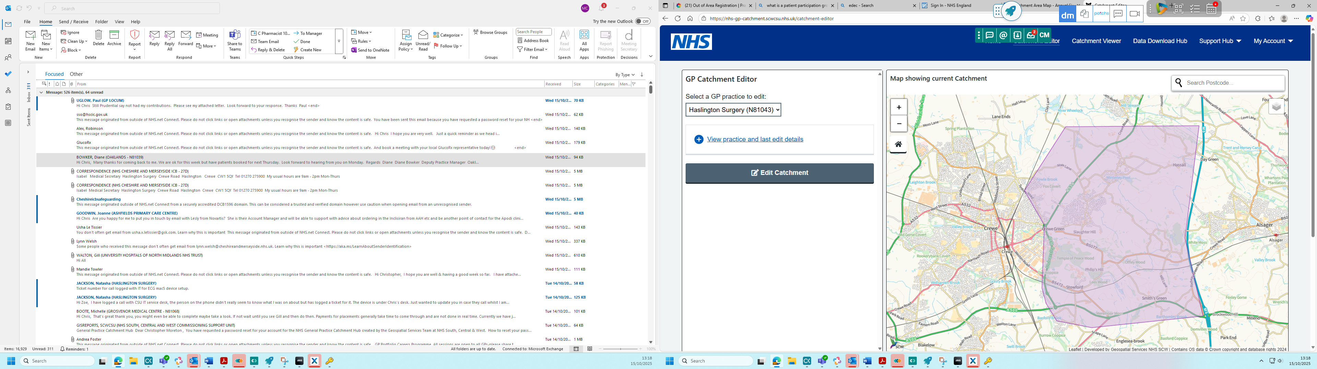


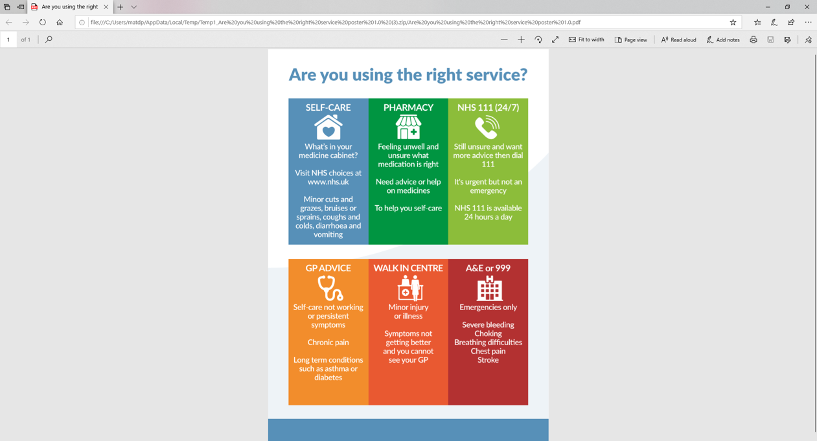

Further information can be sought from www.nhs.uk

The practice team:
Partners
]Dr Jonathan Hill
MB ChB University of Manchester.
Full registration: 1990, Male.

Dr Anthony Entwistle.
MB ChB University of Liverpool.
Full regustration: 1991, Male.

Salaried GPs
Dr Elisabeth Findlay-Domes
MD LRCP LRCS LRCPS.
Full registration: 1996, Female.

Dr Paul Uglow.
MB BS University of London.
Full registration: 1999, Male.

Dr Almas Kashif
MB BS 2006 University of Karachi.
Full registration: 2011, Female.

Nurses
Gillian Hughes, Laed Nurse.
Registered 03/01/1988, Female.

Zoe Poynton, Practice Nurse.
Registered 20/07/2021, Female.

Natasha Jackson, Nurse Associate.
Registered 01/10/2024, Female.

Practice Manager
Chris Moreton, B.A. (Hons), PGCE, MPMA.

Preference for a named practitioner
The practice will attempt to ensure that any patient is seen by the same healthcare professional although please note that this may not always be an option.

Comments, suggestions and complaints
Our aim is to give the highest possible standard of service. We would like you to tell us what you think about the service we provide.

If you would like to offer a comment or suggestion or raise a complaint, this can be raised with any member of the team. Further information about this can also be found on the practice website or within the complaints and compliments leaflet.

Home visit requests
Home visits are at the discretion of the GPs and are usually for those patients who are housebound or have significant health issues. Should you require a home visit, please contact reception. A member of the team will then telephone you to discuss your request.

Home visits are usually conducted between 12:30 pm and 1:30 pm Monday to Friday.
When we are closed
When the practice is closed, if you urgently need medical help or advice and it is life threatening, dial 999. If it is not life-threatening, contact NHS 111 by calling 111 or via www.nhs.uk

NHS England Contact
The practice provides NHS services on behalf of NHS England

PO Box 16738, Redditch, B97 9PT.
Telephone: 0300 311 2233
Email: england.contactus@nhs.net

Prescriptions/repeat prescriptions
Your GP will initiate any prescription that they determine you require. Repeat prescriptions can be ordered in the following ways:

- In person – By ticking the required medications on your prescription and placing it in the dedicated box, located in the foya.
- By telephone
Please allow 72hrs for collection (excluding weekends and bank holidays) when ordering repeat prescriptions.

Appointments and accessing practice services
To make an appointment to see your GP or any member of our healthcare staff or to access any other of our practice services, please call reception, or please log on to the practice website.

The practice website contains all relevant practice information that you are likely to require.
Threats of violence or abuse of our staff
Our staff work hard to provide you with the best possible service. Please treat them with the courtesy and respect they deserve. We operate a zero-tolerance policy and may refuse to provide services to individuals or those accompanying individuals who are violent, threaten violence, commit or threaten to commit a criminal offence

Patient Participation Group
We have an active Patient Participation Group (PPG), ensuring that our patients are involved in decisions about the services provided by the practice.

Further information about our PPG is available online at www.haslingtonsurgery.nhs.uk
Applications to join the PPG are available at reception.

Patient data
All clinical and administrative staff have an ethical as well as a legal duty to protect patient information from unauthorised disclosure and in accordance with the Data Protection Act 2018.

The patient privacy notice is available on the practice website.

