Cherry Tree Surgery Limited 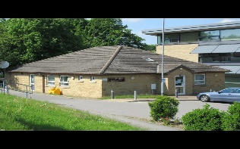
132 Upper Commercial Street
Batley
WF17 5DH

York House Surgery
284A Oxford Road
Gomersal
Cleckheaton BD19 4PY

Our practice ethos is to strive towards a partnership between patients and health professionals based on the following key facets:

Mutual Respect
We endeavour to treat all our patients with dignity, respect and honesty. Everyone at Cherry Tree Surgery is committed to deliver an excellent service.
We ask all patients to highlight any discrepancies and to offer the same commitment in return.
‘Holistic’ Care
We treat patients and illnesses. This means that we are equally interested in the physical, psychological and social aspects of your individual care. We focus on Person Centred Care and involve you with any planning and decisions.
Continuity of Care and the ‘Therapeutic relationship’
Building and maintaining a strong relationship between doctors, health professionals, and patients is essential to the way we work. This is especially so in the management of ongoing problems or long-term illness. In these circumstances we would encourage you to continue seeing the same health professional and wherever possible we will facilitate this through our appointments system.
However, if you have a new problem, the doctor or nurse that you normally see is not available, or you would like to see someone else then we would encourage you to see any of the doctors or nurses at the practice.

Learning and Training
We believe in "life-long learning" and all the health professional and administrative staff undergo an annual appraisal where learning and development needs are identified.
We also recognise the benefit of supported learning for our patients and families in enhancing your ability to manage and deal with both self-limiting and long-term illnesses.

Open List
The Practice has an open list policy and accepts patients who are residents and newly residents in the identified practice area.

