Version | Date Published |  | Review Status | 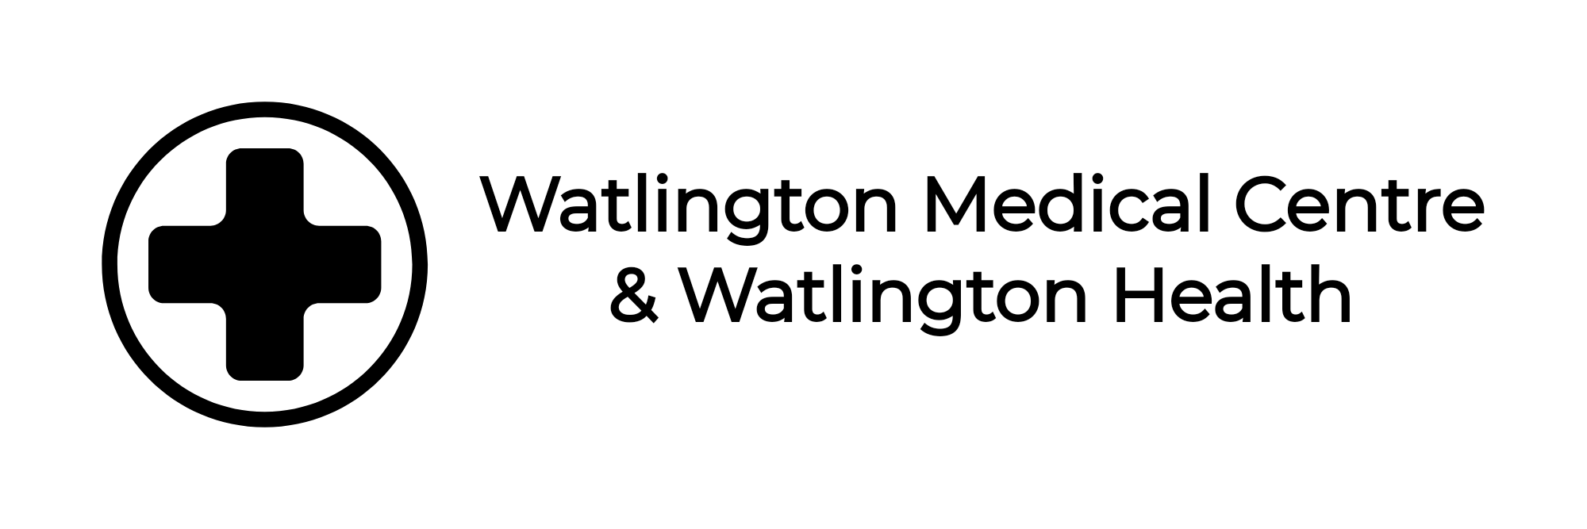
1.0 | July 2021 | Annually

WMC Shared Care with Private Providers
Due to Patient Quality Standards Watlington Medical Centre will not consider taking on Shared Care prescribing with a non-NHS provider unless the following conditions are met:
- The prescribing is in line with the GMCs Good Medical Practice guidance.
- The advice on prescribing has come from a Medical Practitioner who is based in the UK and not subject to any GMC prescribing conditions.
- The shared care provider is acting under an NHS contract.
- Norfolk & Waveney CCG has commissioned General Practice to provide this service as an additional service and the Practice has agreed to take on this service.
- A copy of the shared care guidance is hosted on Knowledge Anglia and is referenced in the request to the Practice.
- All prescribing requests have been reviewed and agreed by the Therapeutics Advisory Group and the LMC.
- Written evidence that the provider indemnifies Watlington Medical Centre for any prescribing issues that may come to light in perpetuity and provides documentary evidence of this.
If the above conditions are met, then the surgery will review the information within it's governance meetings before reaching a decision.
The responsibility for prescribing in the meantime falls to the original prescriber.

