

**SURGERY OPENING TIMES**

MONDAY 08.00 to 18.30

TUESDAY 08.00 to 18.30

WEDNESDAY 08.00 to 18.30

THURSDAY 08.00 to 18.30

FRIDAY 08.00 to 18.30

We have Saturday clinics every 5th Saturday at the health centre.

For all **medical emergencies** outside normal opening hours please contact the NHS **111** service.



**PLEASE WELCOME OUR NEW HEALTHCARE ASSISTANT AND MEDICINES COORDINATOR**

We have 2 new starters who are experienced members of staff, and I am sure you will join us in giving them a warm welcome to the practice, Welcome, Leonie and Katy.

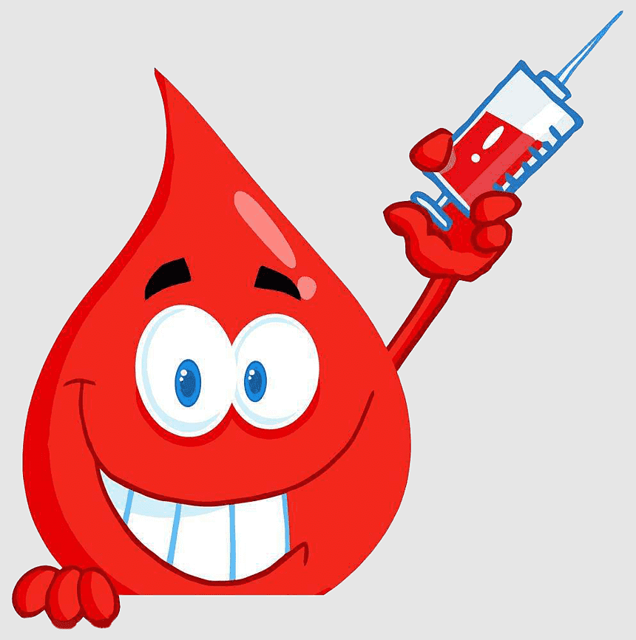

**BLOOD CLINICS**

Like many areas of the NHS the blood clinics can be extremely busy and booked up for weeks in advance. For information, community blood clinics are being held here at Chorley Health Centre.

**Sunday 8.30am-12.30pm** and **Monday 5.30pm-8.00pm**.

Please ensure you have your blood form with you to take to the clinic.



**SOCIAL PRESCRIBER**

Social prescribing enables people to access support to improve their wellbeing. This can include providing access to community groups such as knit and natter, gardening, educational activities, and volunteering opportunities. As well as struggling with family life, caring responsibilities, support with diet and exercise, any issues with education, employment, and housing. Please ask the doctor, nurse, or receptionist to be referred.

**DO WE HAVE YOUR E-MAIL ADDRESS AND UP TO DATE CONTACT DETAILS****?**



Please inform reception of your e-mail address, so we can provide you with on-line access, so you can:

* Make appointments
* Order medication
* View your medical record
* View test results



**MEASLES VACCINATION**

* Measles cases are on the rise, with unvaccinated children and young adults at risk of becoming seriously unwell.
* The NHS in the North-west has launched a call/recall of young people aged 16 to 25 who have

missed one or both doses of the MMR vaccine. Letters and texts are being sent to around 450,000 people, inviting them to come forward for the vital vaccination at a pharmacy or their GP practice.

* It follows on from a drive earlier this year to get more children aged 5 to 11 protected with the MMR vaccine amid rising measles cases and declining MMR vaccination.
* Children and young people are being invited to get their MMR vaccinations in a pharmacy and a list of participating pharmacies is here: [NHS England — North West » Measles and MMR vaccines](https://gbr01.safelinks.protection.outlook.com/?url=https%3A%2F%2Fprimarycare.lancashireandsouthcumbria.nhs.uk%2Fmailster%2F20011%2F510064bd2550fc67c61ff115cac0beeb%2FaHR0cHM6Ly9nYnIwMS5zYWZlbGlua3MucHJvdGVjdGlvbi5vdXRsb29rLmNvbS8_&data=05%7C02%7Ckelly.kos%40nhs.net%7C1f25c92033974a57891708dca7d8bce2%7C37c354b285b047f5b22207b48d774ee3%7C0%7C0%7C638569796533034759%7CUnknown%7CTWFpbGZsb3d8eyJWIjoiMC4wLjAwMDAiLCJQIjoiV2luMzIiLCJBTiI6Ik1haWwiLCJXVCI6Mn0%3D%7C0%7C%7C%7C&sdata=El1jlc5LvhlT1MpAsULxZpITuf4YecHG3Hlb42uq5z0%3D&reserved=0)



If you have young children or a baby check out the Children and Family Wellbeing Service who offer a wide range of FREE groups. Find us on Facebook 'Chorley Family Hub'



**BOOK YOUR APPOINTMENTS!**

If you have been contacted by the Breast screening programme to attend breast screening but have not attended or need to change your appointment, contact the team on **01942 774752**

Similarly, if you have been contacted by the bowel cancer screening programme and you have not sent your kit back or have lost it you can contact them on **0800 707 60 60**



If you are over 40 and have been contacted by us about a CVD (cardiovascular disease) health check, you can call the surgery to book this. Part of this check involves assessing your individual CVD risk and advising you how to reduce it if necessary.



**STAY HEALTHY AND COOL THIS SUMMER**

**Whether you are heading on your daily exercise, or relaxing in the garden**

* Stay out of the sun between 11am and 3pm, when the sun is the hottest.
* If you must go out in the heat, walk in the shade, apply sunscreen, and wear a hat and light scarf.
* Drink plenty of cold drinks, and avoid excess alcohol, and caffeine.

](https://www.google.co.uk/url?esrc=s&q=&rct=j&sa=U&url=https://www.manorcommunity.co.uk/staying-safe-in-the-sun&ved=2ahUKEwjW09Cpkb72AhVmQ_EDHXgBAYkQqoUBegQIExAB&usg=AOvVaw23ahj81zHI7t_IXPjRj6yB)

Thank you for reading our newsletter – if you would like to suggest anything that you would like to see on our newsletters, please contact the reception team to inform them.