**Date Thursday 19/09/2024**

**Time 1 pm – 3 pm**

**Venue Olive Family Practice Admin Office**

**Meeting Title Patient Participation Group September 2024 (Face to Face)**

**Attendees Dr Abdul-Wahid Atcha, Brian Smith (Practice Manager), Vanessa Hamer (Reception PPG main contact), Brendan Sharples (MHP), David Lilley (Health Improvement Practitioner Team leader), Dr Lateefah Oloyede (Palliative Care Lead for Olive Family Practice).**

**Patient representatives AS, MK, DH, DL, AP & RH**

**1 Welcome and Introductions**

Dr Atcha welcomes everyone to our PPG meeting. Everyone introduced themselves and refreshments were offered to all.

**2 Friends and Family Results 2023-2024 / Patient Survey**

BS discussed the recent results from our friends and family results and the GP Patient Survey results.

**Friends and Family Results**

Friends and family indicate that results from January to August 2024 are 5% higher (likely and extremely likely to recommend) compared to January – December 2023. The surgery has also received more friends and family due to Olive Family Practice’s team explaining the importance of anonymous feedback. BS action to discuss friends and family results with all staff members to try and improve results.

BS finished the discussion regarding friends and family results. BS to continue to ask all patients to leave feedback so we can improve as a surgery.

**Friend and Family Test Results – Olive Family Practice Jan 24 – December 24**

|  |  |  |  |  |  |  |  |  |  |  |  |  |  |  |
| --- | --- | --- | --- | --- | --- | --- | --- | --- | --- | --- | --- | --- | --- | --- |
|  | Jan 24 | Feb 24 | Mar 24 | April 24 | May 24 | June 24 | July 24 | Aug 24 | Sept 24 | Oct 24 | Nov 24 | Dec 24 | Total | Total as a % |
| Extremely Likely | 14 | 25 | 60 | 24 | 25 | 39 | 75 | 42 |  |  |  |  | 304 | 59.25 |
| Likely | 14 | 14 | 20 | 20 | 15 | 19 | 32 | 11 |  |  |  |  | 145 | 28.26 |
| Neither Likely or Unlikely | 3 | 0 | 4 | 10 | 1 | 5 | 4 | 1 |  |  |  |  | 28 | 5.45 |
| Unlikely | 0 | 2 | 2 | 2 | 1 | 4 | 1 | 3 |  |  |  |  | 15 | 2.92 |
| Extremely Unlikely | 0 | 0 | 4 | 1 | 1 | 3 | 9 | 3 |  |  |  |  | 21 | 4.09 |

For the 8 months from January 2024 to August 2024, the surgery received 513 Friends and Family questionnaires. 87.51 % of Patients would be extremely likely/likely to recommend us to their friends and family.

**Friend and Family Test Results – Olive Family Practice Jan 2023 – December 2023**

|  |  |  |  |  |  |  |  |  |  |  |  |  |  |  |
| --- | --- | --- | --- | --- | --- | --- | --- | --- | --- | --- | --- | --- | --- | --- |
|  | Jan 2023 | Feb 2023 | Mar 2023 | April 2023 | May 2023 | June 2023 | July 2023 | Aug 2023 | Sept 2023 | Oct 2023 | Nov 2023 | Dec 2023 | Total | Total as a % |
| Extremely Likely | 15 | 13 | 6 | 4 | 6 | 21 | 23 | 24 | 32 | 22 | 60 | 29 | 255 | 55.19 |
| Likely | 3 | 4 | 5 | 1 | 6 | 12 | 15 | 4 | 14 | 26 | 27 | 10 | 127 | 27.48 |
| Neither Likely or Unlikely | 2 | 0 | 1 | 0 | 2 | 2 | 2 | 0 | 4 | 3 | 6 | 2 | 24 | 5.19 |
| Unlikely | 3 | 1 | 1 | 0 | 1 | 1 | 4 | 4 | 3 | 4 | 1 | 1 | 24 | 5.19 |
| Extremely Unlikely | 3 | 1 | 2 | 0 | 0 | 3 | 2 | 2 | 3 | 5 | 10 | 1 | 32 | 6.92 |

For the 12 months from January 2023 to December 2023, the surgery received 462 Friends and Family questionnaires. 82.59 % of Patients would be extremely likely/likely to recommend us to their friends and family.

**GP Patient Survey Results and Actions**

The GP 2024 patient survey results were discussed by the entire group. Some positives for the practice but also room for improvement.

‘Overall experience of this practice’ was 71% which was lower than the national average of 75%. BS advised that this contradicts the anonymised feedback from friends and family results. All patients present (AS, MK, DH, DL, AP & RH**)** advised they had good experiences with Olive Family Practice throughout. BS will discuss the results with the admin and clinical teams during monthly and weekly meetings. BS to monitor random phone calls and the reception team in general and feedback on the results to the admin team. Dr Atcha will increase clinical supervision for all clinicians and feedback every month with examples of possible improvement. Both BS and Dr Atcha expect an improvement in the next GP survey.

‘Ease of use of the practice website’ was at 40% compared to the national average of 48%. BS advised we have now switched the website provider to IATRO meaning the new website is easier to use and should ensure any enquiry should be just one click on the new website. AS asked if the new website was accessible to all including patients with disabilities. BS advised that a full accessibility audit has been undertaken we have passed in all areas.

‘Helpfulness of reception team’ was at 77% which was lower than the national average of 83%. AS MK & DL all said they had received fantastic service from our reception team. BS advised that our reception desk is very busy and we currently have patients who speak above 20 different languages, which makes the job our our reception team harder. BS advised we have recruited 2 reception teams who speak 6 languages between them to try and improve the overall experience on the desk. BS also will work with the reception team to try and improve the results for the next GP survey.

‘Next steps from clinician’ was at 85% which was lower than the national average of 93%. BS has already discussed with all clinicians the importance of giving clear instructions at the end of a consultation and documenting everything. Dr Atcha also undertakes monthly clinical supervision and auditing consultations for all staff members and feeds back when improvements are needed.

‘Healthcare professional was good at listening’ was at 81% which was lower than the national average of 87%. Dr Atcha gave examples of good practice from within a consultation and has met with all clinicians to explain the importance of listening and documenting consultations. Dr Atcha showed 2 examples of consultations (anonymised) both for the same problem but documented very differently. Dr Atcha during clinical supervision will again speak to all clinicians to ensure we listen to what the patient has to say.

‘Healthcare professional was good at treating the patient with care and concern’ was at 81% which was lower than the national average of 86%. AS MK & DL said they had all had recent consultations and had been pleased with the entire process from booking the appointment. Dr Atcha will speak to our clinical team to ensure they improve our they treat patients and will audit this from clinical supervision.

‘The patient was involved as much as they wanted to be in decisions about care and treatment’ was at 84% which was lower than the national average of 91%. Dr Atcha explained that with increased clinical supervision and an increase in feedback from patients we would expect this figure to match the national average by the next GP patient survey.

‘The patient had confidence and trust in HC professional’ was at 86% which was lower than the national average of 92%. Dr Atcha explained that with increased clinical supervision and an increase in feedback from patients we would expect this figure to match the national average by the next GP patient survey.

‘The patient’s needs were met’ was at 82% which was lower than the national average of 90%. BS will discuss the results with the admin and clinical teams during monthly and weekly meetings. BS to monitor random phone calls and the reception team in general and feedback on the results to the admin team. Dr Atcha will increase clinical supervision for all clinicians and feedback every month with examples of possible improvement. Both BS and Dr Atcha expect an improvement in the next GP survey.

BS finished the discussion of the GP survey results. All patients (AS, MK, DH, DL, AP & RH) are happy with the results and actions for the practice to try and improve the results for the next GP survey.

**3 Armed Forces Veteran Friendly Practice**

VH informed the meeting that Olive Family Practice had become an Armed Forces veteran-friendly accredited practice in August 2024. VH confirmed we ask all patients if they have served in the armed forces and we ensure this is coded appropriately. VH also confirmed that veterans are offered priority treatment for any medical condition which has been caused by their military service, subject to the clinical needs of other patients. We also ensure that if veterans are referred to secondary care we will let them know a patient is a veteran so they understand your health and wellbeing.

DH (patient) advised he is a military veteran and during consultations, the clinician spoke about his military service and helped the patient access services appropriate for him. DH said that Olive Family Practice had far exceeded his expectations and he now recommends us to everyone. BS and Dr Atcha thanked DH for his military service and the feedback and will ensure we carry on the work with our military veterans.

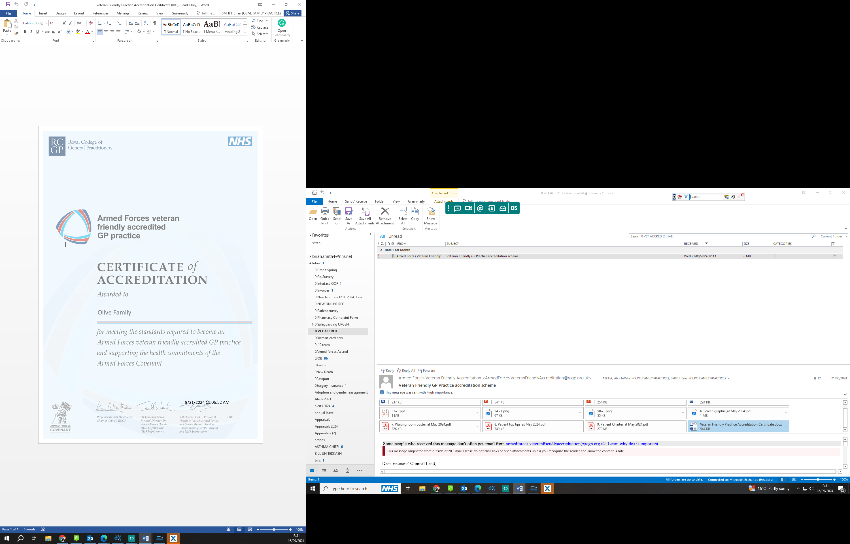

**4 New roles Staff at Surgery since the previous patient participation meeting**

BS asked the clinical staff present to explain their roles and the services they offer (Brendan Sharples – Mental Health Practitioner, David Lilley – Team Leader Health Improvement Practitioner & Ray Doyel – Physician Associate).

**5 New Online Consult and New Website**

BS showed the group a demonstration of our new website which is fully compliant with the NHS Vision of a Modern Practice. All services are available from the home page with 1 click. BS confirmed that our website is checked to ensure it is accessible for all patients including patients with visual disabilities.

BS showed the group how our online consultations from our website work. BS informed the group that this service would save patients ringing and queuing at 8 am. BS also confirmed this would free our phone lines for vulnerable patients who cannot use our online services. AS, MK, DH, DL, AP & RH all tried the online consultation and all would try and use it in the future when contacting the surgery.

**6 Coming soon – new telephone system.**

BS informed the group that Olive Family Practice have procured a new telephony system which should go live in the next 10 weeks. This service will allow call back which would save you position in the queue and ring you back when at a time suitable to you. The service will also identify vulnerable patients (from codes in their record such as dementia, patients with cancer etc) and put them at the front of the telephone queue.

BS asked the entire group ‘Which vulnerabilities do you think should enable a caller to be placed at the front of the telephone queue?’ The group decided that the following groups of patients should be used to move the front of the telephone queue:-

Patients with a recent diagnosis of cancer coded in their record

Patients with a diagnosis of learning disability coded in their record

Patients with dementia coded in their record

Patients with any safeguarding risks are coded in their records.

BS will liaise with our new telephony supplier and feedback at our next PPG and confirm that this has been actioned.

**7 Central Primary Care Network and Extended Hours**

BS explained the important role of Primary Care Networks (PCNs) and how they form a key building block of the NHS's long-term plan to bring general practices together for a range of reasons, including the ability to provide a wider range of services to patients and to integrate with the wider healthcare system more easily including mental health, social care, pharmacy, hospital and voluntary services in their local areas. BS explained that Olive Family Practice is part of the Bolton Central Primary Care Network. BS confirmed that through our PCN links, we have obtained additional staff at the surgery including Mental Health Practitioners, MSK practitioners, Pharmacists and Physician Associate.

**8 Patient Survey**

BS asked all patients present to fill out the patient survey that we have done from August 2024 to September 2024. BS confirmed that 59 had already been completed by patients via our admin team when patients had finished a consultation. The results will be emailed to patients and actions will be discussed at our next PPG meeting.

|  |  |  |  |  |  |
| --- | --- | --- | --- | --- | --- |
|  | **Excellent** | **Ok** | **Fair** | **Poor** | **N/a** |
| **Getting an appointment within a time slot and date suitable for me (in person, by phone or online):** | **58** | **5** | **2** | **0** | **0** |
| **Ability to see my chosen doctor or other medical professional e.g. nurse, phlebotomist:** | **47** | **13** | **5** | **0** | **0** |
| **Call Waiting time on the telephone and ease of getting through** | **42** | **20** | **0** | **3** | **0** |
| **Ability to book, request and contact the surgery online** | **35** | **5** | **20** | **0** | **0** |
| **Ability to book an appointment over 2 weeks in advance for reviews and ease of routine** | **61** | **4** | **0** | **0** | **0** |
| **The non-clinical staff are friendly and helpful to me** | **48** | **12** | **4** | **1** | **0** |
| **The practice keeps me up to date and informed of any changes that might affect me** | **61** | **4** | **0** | **0** | **0** |
| **The Medical Professional saw me at my booked time** | **39** | **12** | **11** | **3** | **0** |
| **The Medical Professional listens to me, explains my treatment and answers my questions** | **45** | **10** | **5** | **5** | **0** |
| **The waiting room and other areas are clean and tidy** | **61** | **4** | **0** | **0** | **0** |
| **The waiting room and other areas are accessible** | **59** | **6** | **0** | **0** | **0** |

**The Surgery opening hours are easy for me:**

Yes 63

No 2

**I would recommend this Surgery to someone new to the area:**

Yes 64

No 1

**I am aware that the Surgery can provide a social prescriber, Physio (MSK), Pharmacists and Mental Health services:**

Yes 57

No 8

Date of next Meeting 09/01/2025