**Anaemia**

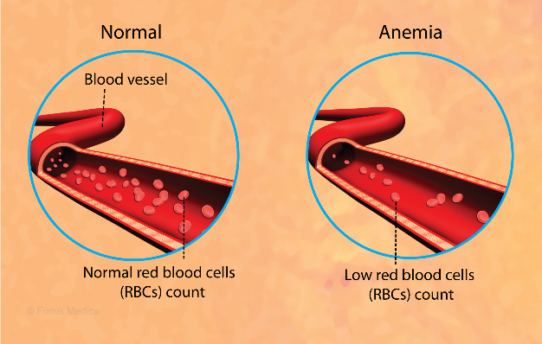

**Iron deficiency** is the most common cause of anaemia, it is where the body has low iron levels, and it is thought to effect around 500 million people world-wide it is usually found in women of childbearing age due to menstruation and pregnancy. Diets can also be a contributing factor how ever this is rarely the only cause, Iron is mainly found in meat, seafood and vegetables, other factors include malabsorption, increased blood loss and increased requirements – for example, growth in children, adolescence, and pregnancy.

Signs and symptoms of iron deficiency are.

* Tiredness and lack of energy
* Shortness of breath
* Noticeable heartbeats (heart palpitations)
* Pale skin.
* Less common side effects are, sore tongue, hair loss, dysphagia, and restless leg syndrome.

**Vitamin B12 and folate deficiency** leads to abnormal development and production, they preform several important functions in the body, including keeping the nervous system healthy. There are a number of problems that can lead to vitamin or folate deficiency. These can include Pernicious anaemia where your immune system attacks healthy cells in your stomach, preventing your body from absorbing vitamin B12 from your food. A lack of vitamins in your diet this is uncommon but can happen if you have a vegan diet and do not take Vitamin B12 supplements or eat foods fortified with vitamin B12, follow a fad diet, or have a generally poor diet for a long time. Certain medications such as anticonvulsants and proton pump inhibitors, can affect how much of these vitamins your body absorbs. Both vitamin B12 deficiency and folate deficiency are more common in older people, affecting around 1 in 10 people aged 75 or over and 1 in 20 people aged 65 to 74.

Signs and symptoms of Vitamin B12 and Folate deficiency are.

Vitamin B12 deficiency:

* Mild Jaundice
* Glossitis (smooth and sore tongue)
* Mouth ulcers
* Changes in gait
* Irritability
* Depression
* Numbness and tingling in feet and hands.

Folate deficiency includes:

* Reduce sense of taste

**Anaemia** is a deficiency of the healthy red blood cells in blood. Red blood cells are essential to carry oxygen to all parts of the body.

Anaemia can be caused by nutritional deficiencies such as Low Iron, vitamin B12 or folate, and there are a number of factors that can contribute to someone becoming Anaemic such as Age, sex, Smoking Status and Pregnancy.

* Diarrhoea
* Numbness and tingling in the feet and hands
* Muscle weakness
* Depression.

If your diet is partly causing your Anaemia, your GP will tell you what foods are rich in iron so you can eat them more, such as:

* Dark-green leafy vegetables like watercress and curly kale
* Cereals and bread with extra iron in them (fortified)
* Meat
* Dried fruit like apricots, prunes, and raisins.
* Pulses (beans, peas, and lentils)

Eat and drink less:

* Tea, coffee, milk, and dairy.
* Foods that have a high level of phytic acid, such as wholegrain cereals, which can stop your body absorbing iron from other foods and pills.

Other types of Anaemia include.

**Aplastic anaemia** this often develops spontaneously or in associate with another condition, this is usually a rare disease in which the bone marrow does not produce adequate number of new blood cells. This causes tiredness, shortness of breath, rapid heart rate unexplained bruising, nose bleeds, headaches, and fever.

**Hemolytic anaemia** is defined as premature destruction and hence a shortened red blood cell life span, this is also when the bone marrow cannot sufficiently compensate for the loss of red cells, leading to a fall in the red cell count, these cells can be broken down in the bloodstream or in the spleen. It may be due to a leaky heart valve or aneurysms.

**Anaemia of chronic diseases** it is thought that the inflammation that is usually present in chronic disease leads to decreased red blood cells, some of these conditions include things such as Cancer, Crohn’s disease, and long-term infections such as HIV

**Sickle Cell anaemia** is an inherited Hemolytic anaemia with abnormal haemoglobin protein that causes red blood cells to be rigid and clog circulation through small blood vessels.

If left untreated Anaemia can cause serious complications and risks illness and infection, it can also increase your risk of developing complications that affect the heart or lungs such as an abnormally fast heartbeat (tachycardia) or heart failure.

**Resources**

[Anemia: Causes, Symptoms, Nutritional Requirements & More (healthline.com)](https://www.healthline.com/health/anemia#causes)

Iron deficiency anaemia - NHS (www.nhs.uk)