Supporting Armed Forces Day at PICS.

Armed Forces Day took place on June 29th 2024. Having signed the Armed Forces Covenant in 2022, PICS continue to support Armed Force Personnel, both those who are patients and those who are employees.
Parades were hold across Nottinghamshire and some of our staff attended to show their respect. Jo Fleming (Clinical Pharmacist), herself a veteran, attended the Newark parade. Pictured below are Joanne Greenwood and Charlotte Shaw (Senior Social Prescribing Link Workers) who attended the Armed Forces Day event in Ashfield district. Joanne said ‘it was very well attended and a really lovely service to honour veterans and those still in service, forces families and service support agencies.
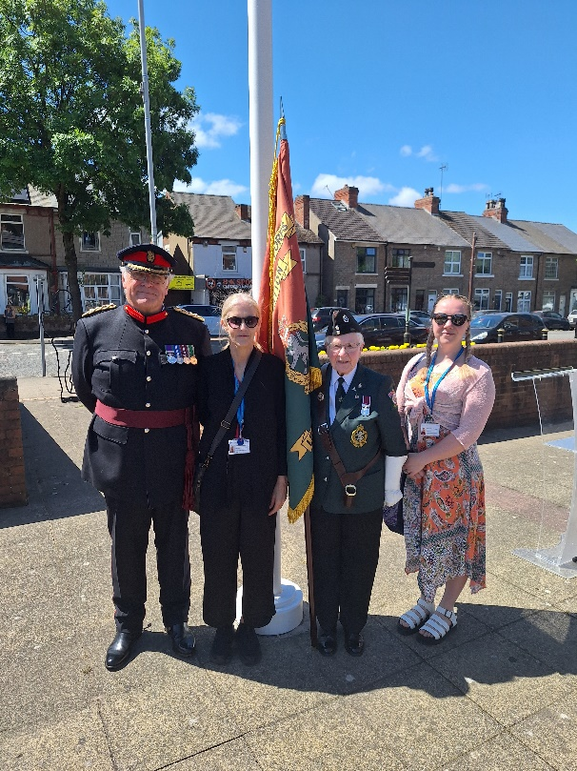
Representatives from PICS were also invited to attend Nottinghamshire Police Big Brew Event, hosted by their Armed Forces Network. Emma Alder (Quality and Clinical Governance Lead Nurse), Rose Severn and Andy Simpkiss (Senior Social Prescribing Link Workers and Andy also a veteran) attended the event with Gillian Welch (veteran), who are pictured below. They joined many other guests including civic dignitaries, serving soldiers, veterans, police officers and other staff. The event celebrated the enduring links between the armed forces and policing.
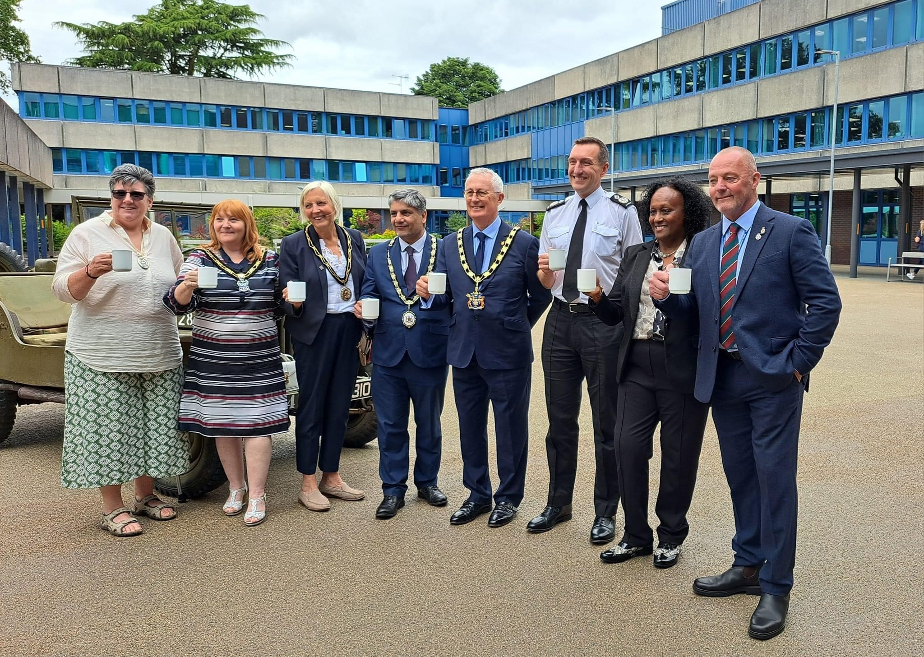
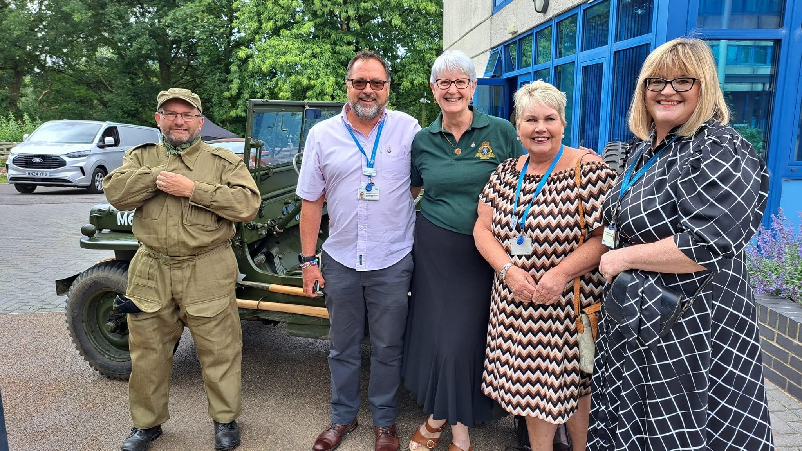

Staff from across PICS also took time out during Armed Forces Day to pay tribute to the British Armed Forces Community by posting photos on social media of themselves, friends and families saluting. Below are a selection of photos from staff paying tribute #SaluteOurForces.
#SaluteOurForces
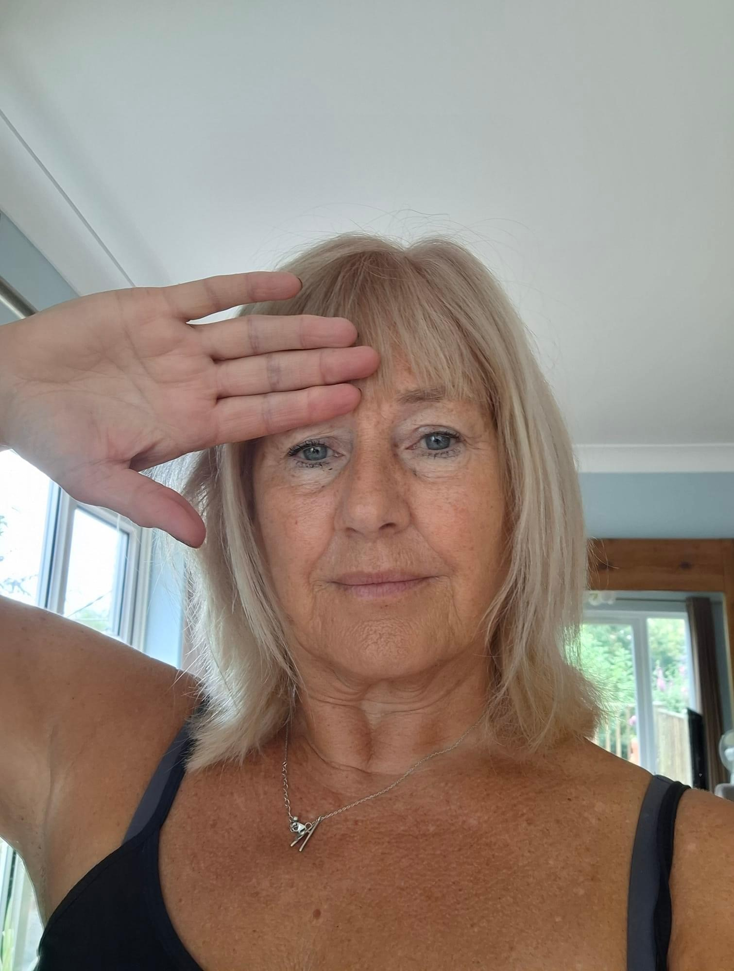
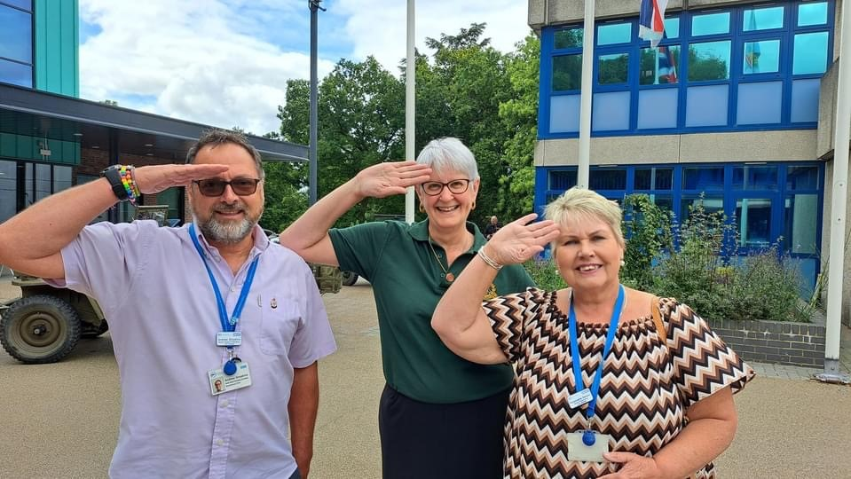
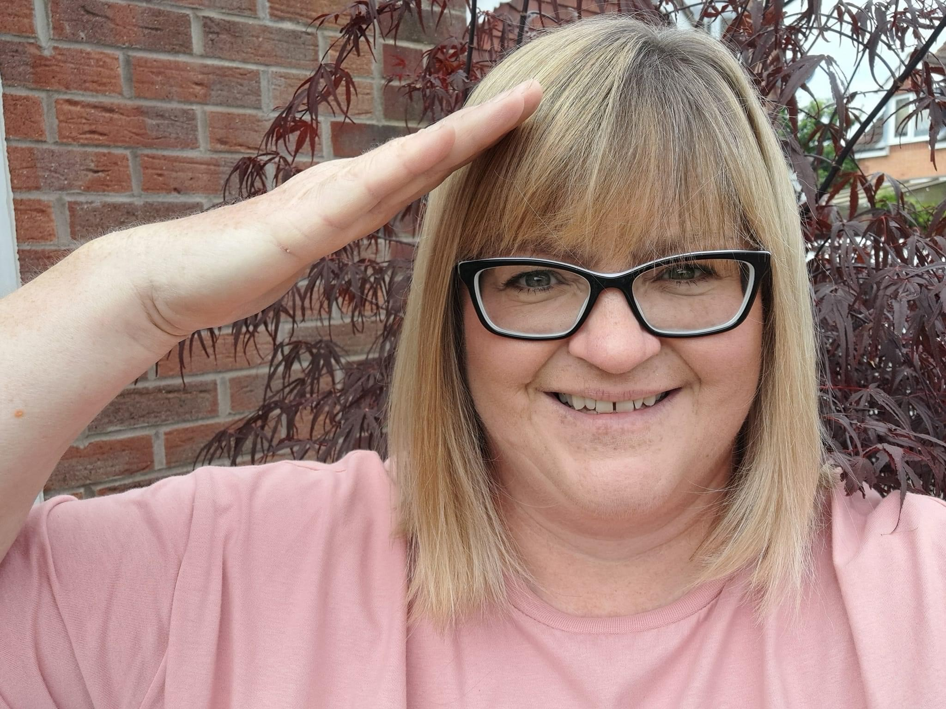
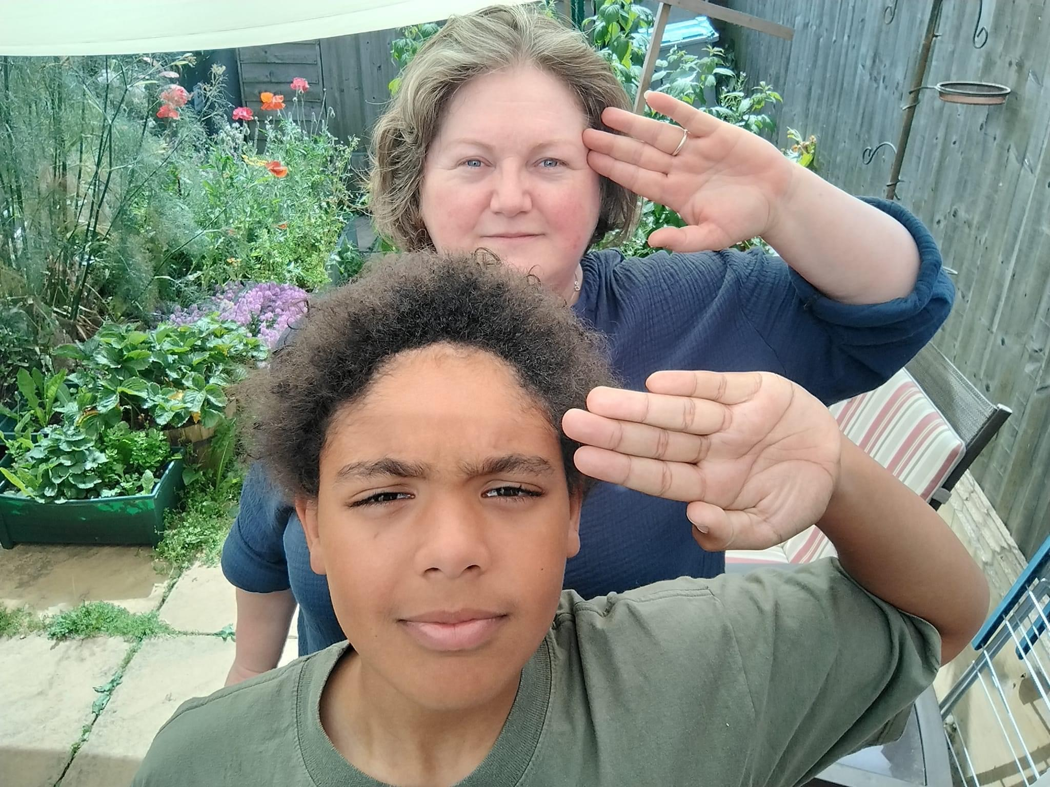
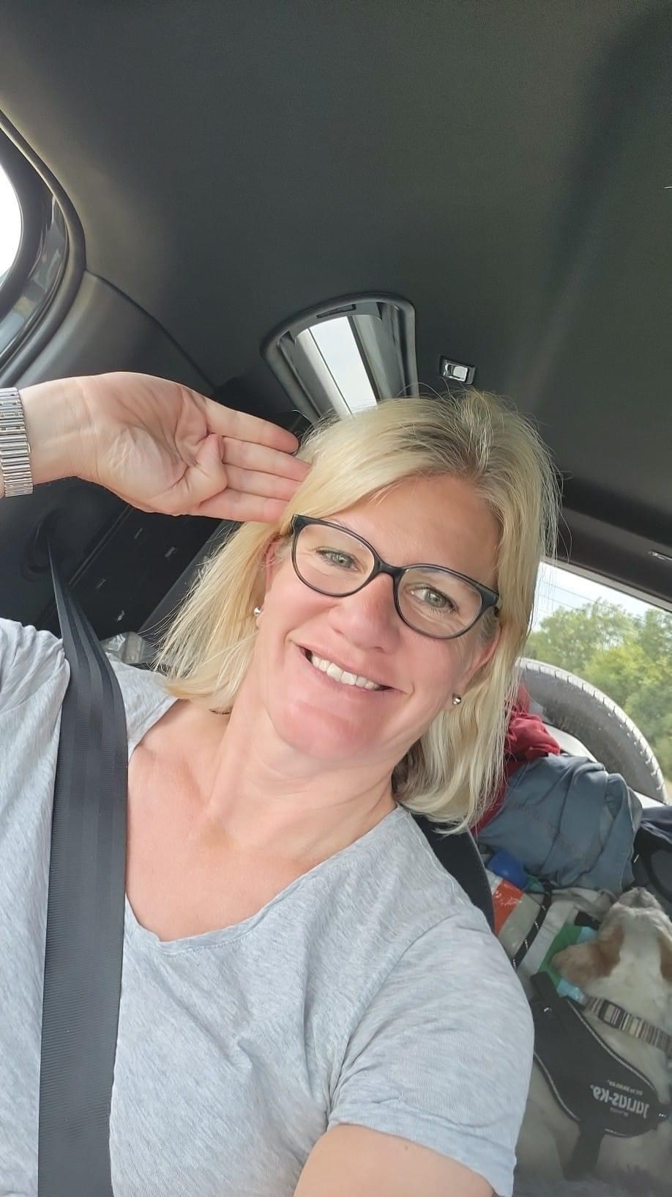
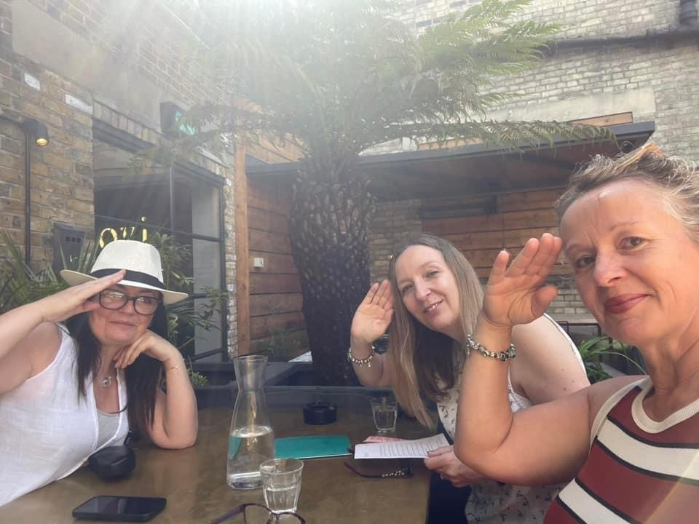
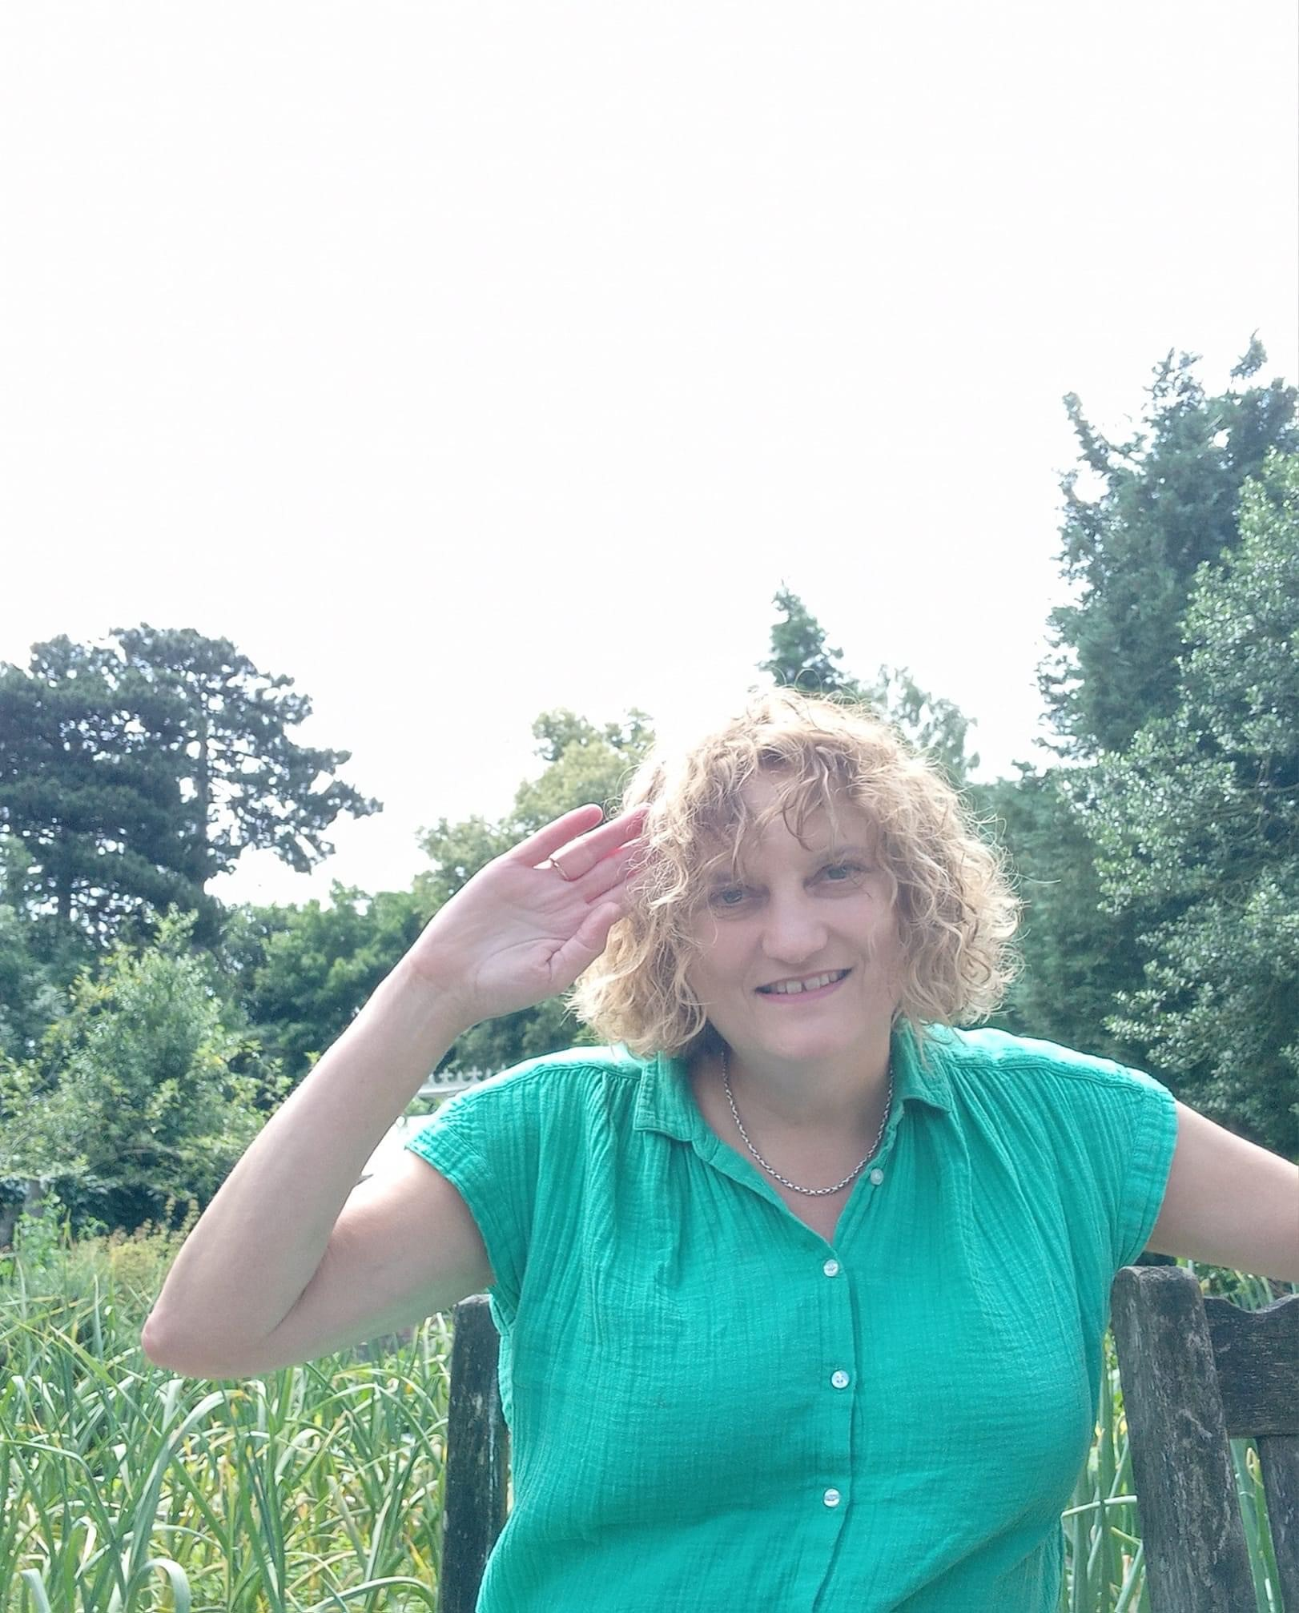

All staff who took the time to submit a photo were entered into a prize draw and a name was drawn at random. The winner is Andy Simpkins….congratulations. Thanks to all that submitted a photograph

