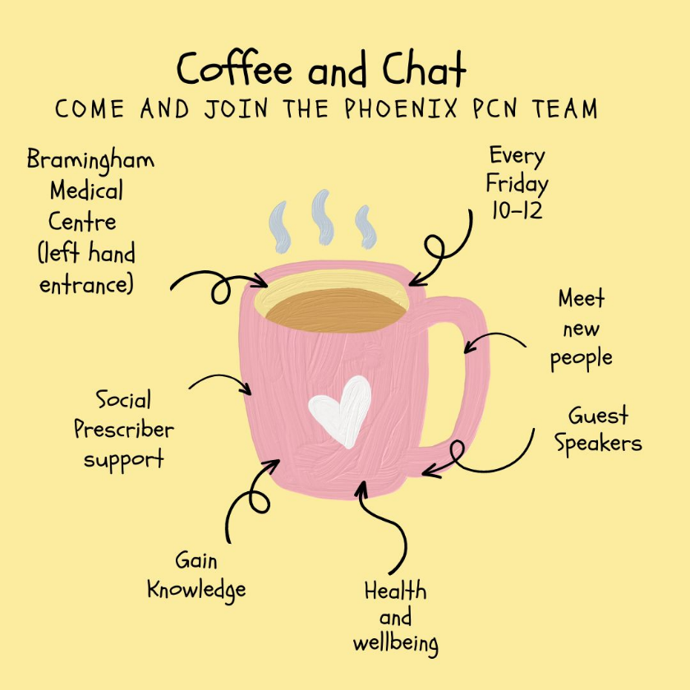

**February 2025 Timetable**

7/2/25- Luton Libraries talk

14/2/25- Ability Net- help with Tech

21/2/25 – TBC

28/2/25- The Lewis Foundation TBC