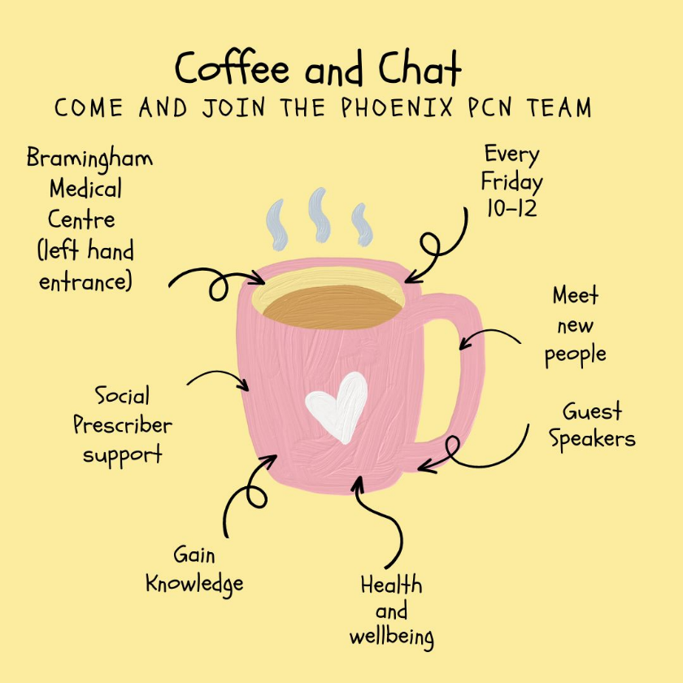

**January 2025 Timetable**

3/1/25- No session

10/1/25- Nutrition Talk-Beth from LTFC

17/1/25 – Coffee and Chat

24/1/25- Skin Care Talk- Naturally TIWA

31/1/25- PCSO’s Claire and Maisie Beds Police